Secular Franciscan Order February 2020 Newsletter

The Secular Franciscan Order was established by St. Francis of Assisi more than 800 years ago. Our purpose is to bring the Gospel to life where we live and where we work. We look for ways to embrace the Gospel in our lives and try to help others to do likewise.

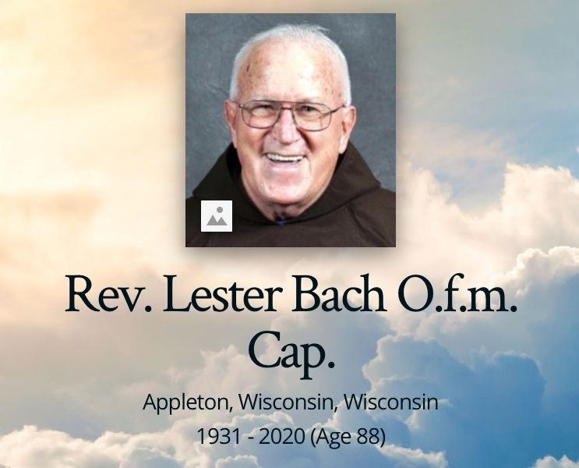
Pray for the repose of the soul of Fr. Lester Bach, OFM Cap
10-15-1931 - 2-2-2020
Rev. Lester Bach O.F.M., Cap. died on February 2nd at the age of 88. Fr. Lester was born on October 15, 1931 in Sherry, WI, the son of the late Frank & Amelia (nee Long) Bach. He was invested in the Capuchin habit in 1949, perpetually professed in 1953, & ordained in 1957. For most of his religious life, Fr. Lester was involved in ministry to the Secular Franciscan Order. He was also involved in formation ministry in the 1960’s, as well as the preaching ministry beginning in the 1970’s. His ministries took him to Huntington & Crown Point, IN, Saginaw, MI, Madison & Marathon, WI & Chicago, IL. Fr. Lester would have celebrated 70 years of religious life this summer. The Liturgy of Christian Burial for Fr. Lester will be celebrated at 10:00 a.m. on 2-10-2020 @ St. Joseph Catholic Church, 404 W. Lawrence St., Appleton, WI 54911. Internment will be in Holy Cross Cemetery, Mt. Calvary, WI.
our Gathering
February 1st, 2020 Dora led us in the prayer of the Liturgy of the Hours. Ryan led us in our lighting of the candles prayer. Fabiola read excerpts from: The Rule of the Secular Franciscan Order is approved and confirmed~Pope Paul VI by John Cardinal Villot, Secretary of State, pg. 2 of our Rule. Interesting discussion followed. This reading was a reminder of our name change from Franciscan Third Order to Secular Franciscan Order. Mike led us in the opening prayer found on pg 35 of the Ritual.

Mike shared a reading from A History of the Secular Franciscan Order in the United States, Volume III 1979-2007, William Wicks, OFS. It was a great reminder that Formation is an ongoing lifetime process. We then participated in a PowerPoint presentation on What Is Spirituality? From “Franciscan Spirituality from St. Joan of Arc Region, Secular Franciscan Order from January 11, 2020.” A lively dialogue ensued on what this presentation evoked in us as individuals and as a fraternity. We were unable to view the entire PowerPoint presentation and hope to continue it at a later date. Dora can email it to anyone who requests it for further reflection.

We had a quick discussion on the Secular Franciscan Lenten Day of Prayer on March 7th, 2020. It is necessary to register so a proper accurate headcount can be made to accommodate food preparation. Ryan has made available an easy sign-up sheet. Refer to secretary.StMaxSFO@gmail.com, or call Mike @ (713) 299-0224 before 2-28-2020!

We will not have our typical Gathering in the Outback next month. Instead, we will be meeting at the Parish Activity Center (PAC) at St. Jerome’s Catholic Church. The entrance to the PAC is off Hollister, not Kempwood.

Mike led us in the closing prayer and Fr. Mike gave the final blessing.

And another Spirit filled Gathering was had by all who attended!

Greetings Good People

As St. Augustine wrote “We are an Easter People, and Alleluia is our song”.
The Paschal Mystery leads us from suffering and sadness into joy.

Our seraphic father Francis lived every day as if it were Lent, and he actually practiced three long periods of Lent. Lent is a time of conversion. We as Secular Franciscans are called to daily conversion. In Article 7 of Our Rule we read:

“United by their vocation as “brothers and sisters of penance” and motivated by the dynamic power of the gospel, let them conform their thoughts and deeds to those of Christ by means of that radical interior change which the gospel itself calls “conversion”.
Human frailty makes it necessary that this conversion be carried out daily.

On this road to renewal the sacrament of reconciliation is the privileged sign of the Father’s mercy and the source of grace”.

There are numerous resources out there that can help us this season through works of fasting, prayer, and abstinence.
I hope everyone has had the opportunity to go through the information that was forwarded to you which came from our National JPIC Animator Carolyn Townes. Additionally we purchased the pamphlet “Lent with Maximilian Kolbe Daily Reflections” from Franciscan Media which was mailed to those who requested, more will be brought to Caritas Day for those coming, and also at our Lenten Day of Reflection.
A great big thank you came from the men in the Ellis unit of the Texas Dept. of Criminal Justice. Our fraternity (even before we were an emerging fraternity the Annunciation Fraternity) has been serving these men for decades. We finally received, three months later, approval to bring pizza and soft drinks in for a Christmas Party. It was amazing…the day after Valentine’s Day…a Christmas party to celebrate Love becoming flesh.
Our God is an amazing God!
We watched the first video in the Wild Goose series from Fr. Dave Pivonka TOR “God is Love” and gave the men the Lent with Maximilian Kolbe booklet.
There are no coincidences…..
Peace
Michael

Next Meeting: March 7th, 2020 beginning @ 9:30 a.m. in
St. Jerome Catholic Church: In the Parish Activity Center on KEMPWOOD
Early Birds: An opportunity to join together in The Holy Mass @ St. Jerome @ 8:15 a.m.
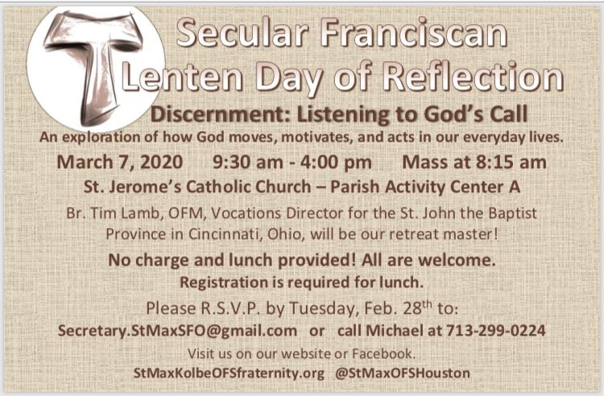

The Rite of Profession of Phyllis Prince & Eileen Ike Colleton into the Secular Franciscan Order has been rescheduled due to a previously unknown scheduling conflict. It is now set for April 4th, 2020 to be held at the 8:15 a.m. Mass
St. Jerome Catholic Church Day Chapel

See secretary.StMaxSFO@gmail.com for list of items!

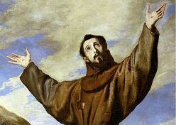

Every 2nd Saturday of the Month, folks from TFP (Tradition Family Property) gather at two locations to pray the Rosary to be a visible sign & witness to our precious Lord Jesus and our Blessed Mother Mary. If your schedule allows, come & pray the Rosary on the corner of San Felipe & Sage from 12noon to 1pm. The other location is on the corner of Briar Forest and Eldridge. Everyone is welcomed to join in the prayer.

T-Shirts are available in many different colors. If you’re interested in purchasing one, please contact Alba. They are $20/ea. Alba ordered some F.U.N. Manuals (For Up to Now – Foundational Topics for Initial Formation). They do not come with a binder. Purchase price is $13/ea.

$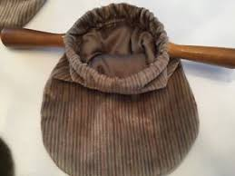$$ Our contribution bag will be made available at all gatherings. Cash or checks.
Make checks payable to: St. Maximilian Kolbe Fraternity.

Happy Valentine’s Day Jesus Loves YOU!

Co-Cathedral Caritas Day of Service
February 29th, 2020

Day of Reflection
March 7th, 2020
9:30 a.m. – 4:00 p.m.
@ St. Jerome’s Parish Activity Center (PAC) room “A”.
Join us for 8:15 a.m. Mass. Your help is needed!

St. Joan of Arc Regional Retreat
April 24-26, 2020
St. Charles Retreat Center
Moss Bluff, LA
(April 1, 2020 DEADLINE)

FOR MORE INFORMATION ABOUT EVENTS & FORMS, PLEASE REFER TO E-MAILS FROM secretary.StMaxSFO@gmail.com

Loved, Just Because

“I will be a Father to you, and you will be My sons and daughters, says the Lord Almighty.”
2 Corinthians 6:18 (NIV)

My husband and I woke early one winter morning to prepare for a five-hour trip to Bangor, Main, to pick up the newest member of our family – a poodle puppy. Our boys, then seven and eight years old, were in for a surprise. We’d organized a scavenger hunt that morning for the big reveal.
It was still dark outside when we nudged them awake, started them on their hunt. They scurried around, finding a scrap of paper in a cabinet, then a clue hidden in a desk drawer. Finally, they came to the last box, which they unwrapped. Inside was a picture of our new puppy and an ID tag in the shape of a bone with the name HOWIE engraved on the front.
From that moment – the moment they knew the poodle was theirs, my boys loved Howie. It didn’t matter that he would vomit on them on the way home, that he would have countless accidents and wake them up at night, yelping. That, quite simply, Howie was a lot of work. What mattered was that he was theirs, and therefore, worthy of their love.
In similar ways, we are loved by God, just because. Just as Howie didn’t need to do anything except be purchased by us for my boys to love him, we don’t need to do anything but trust in Jesus and the fact that we have been purchased by the blood of Christ. If we are his children, then he loves us perfectly, not because of anything we’ve done, but because we are his.
By Heidi Chiavaroli

Heavenly Father, thank You for loving us enough to purchase us at a heavy price. Thank You that we can call You Father and You can call us Your children. May any work we do for You be motivated by the love You’ve shown to us.

Excerpt from: All God’s Creatures
Daily Devotions for Animal Lovers
January/February 2020 Issue

