Secular Franciscan Order July 2021 Newsletter

The Secular Franciscan Order was established by St. Francis of Assisi more than 800 years ago. Our purpose is to bring the Gospel to life where we live and where we work. We look for ways to embrace the Gospel in our lives and try to help others to do likewise.

1.
Our Gathering

We began our Gathering traditionally with the Ritual of the SFO, page 35.

We welcomed David & Angela Kauffman who hail from Virginia. Both were professed in 2016. They were very active in their Fraternity. Welcome!

Dora Freeman led us in the Candle Prayer as we remembered all past, present (including those who can no longer participate due to health) and future members of our Franciscan family.

Claire Dwyer was gracious enough to make copies of today’s Liturgy of the Hours for everyone to have the uniformity of following the same Morning Prayer for the Feast of St. Thomas, the Apostle.

Fabiola gave us an excellent explanation of the history of the Liturgy of the Hours (LofH) and what LofH means. It is the second most important prayer of the Catholic Church, the Mass being the first.

LofH is an ordered series of prayer. According to our Rule (art. 8) we are to join in liturgical prayer in one of the forms prepared by the Church, reliving the mysteries of Christ.
Like the Mass, the LofH is being said all over the world, different times of the day and night, which lends itself to praying without ceasing.

As Secular Franciscans we can meet this responsibility by praying the morning and evening prayer from the Liturgy of the Hours. Those in religious communities as well as priests and seminarians pray all the minor and major offices of the day.

There are many apps to reference: Laudate, Divine Office, to name a few; and many forms of publications to help us pray liturgically; (Give Us This Day; Magnificat).

Fabiola reminds us it is a prayer that joins us with the entire Church. She gave an example: if we wake up happy, feeling thankful and joyful, we go to pray the LofH and the Psalms speak of being downcast and persecuted, not to discount the Psalms thinking they don’t apply to where one is at emotionally, but to embrace the message of the Psalm, and to contemplate the “sufferings of the Church”.

Much discussion followed and we shared our personal experiences of praying the LofH.
Dora shared a quote from St. Hildegard, a doctor of our Church: “Heaven is singing, Hell is a place that has not music”.

At today’s Gathering, rather than a Franciscan reading, Dora led us into a beautiful meditative prayer accompanied by a song by Cathy Tisel Nelson, based on St. Francis’s Prayer before the Crucifix. We had time for silent meditation & reflection on prayer in our own individual lives & how it strengthens us throughout the day. Mike began the discussion by giving a few personal thoughts on prayer. Others added to the discussion.

Mike then began by wishing everyone & our country a Happy 4th of July. Yes, we have division within our country & even our church. We must not get caught up in the division. He had sent copies of the Preacher to the Papal

2.
Households homily from Good Friday of this year as well as a chapter from Evangeli Gaudium, “Unity prevails over Conflict” for us to prepare. In Cardinal Cantalamessa, OFM Cap. Homily he wrote that in the time of Jesus it was a
time of strong political polarization and that Jesus did not side with any of them. The earliest Christian
community followed him in this which set an example to all pastors who needed to shepherd the entire flock, not only a part of it. In Evangeli Gaudium, the Holy Father writes in paragraph 226 that “Conflict cannot be ignored or concealed”.

Cardinal Cantalamessa reminds us that fomenting division is the work of the one whose name is “diablos”, that is, the divider, the enemy who sows weeds. To help us to better be prepared for the inevitable conflict that we encounter often which we cannot ignore and is impossible to conceal in this world, Dora adapted information from the Animate Peace Gathering that was held in 2019 from our National JPIC Animator, Carolyn Townes, OFS. She began with this from the National Catholic Reporter, dated April 16, 2012:

“The Catholic Church has a very big secret. It is so powerful, challenging and relevant, that if every bishop, priest, religious and layperson was committed to communicating and implementing this secret, it would turn society upside-down and literally transform the world!.....some refer to Catholic Social Teaching as the best kept secret in the world! Within this presentation Carolyn Townes, OFS quoted Cornel West: “Justice is what love looks like in public.” Carolyn also quoted from OFS Rule. Art. 15 on what justice is:
JPIC = Justice, Peace and Integrity of Creation.
She then went on with a tool we can use to insure dialogue, not conflict results. The Gubbio Process: Mindfully Handling Conflict with these 3 steps:
- Always begin with prayer; take a “Franciscan Pause” to call upon the Holy Spirit
- Address & regard the other as a “person” & not as an “ideology”.
- Share stories with mutual invitation & respect. Be curious & learn. Practice active listening. It was stressed that all three steps must be done mindfully – with prudence, caution and right judgment.
Remember, if things become heated or tense…. Take a Franciscan Pause!
There was a plethora of great ideas that were very insightful and some great personal experiences shared.
We took a short break to enjoy the delicious goodies people brought to share. Connie: THANK YOU FOR THE COFFEE! Benjamin Turk set up a table in the foyer with all sorts of spiritual paraphernalia that he was generously donating to whomever the goods went home with. He had books, holy cards, statues, etc…. You name it, it was on that table! WOW. Thanks, Benjamin! We were also given a beautiful prayer card with a 3rd Class Relic of St. Maximilian Kolbe & a trinket with picture of Divine Mercy from another generous donor who requests to remain anonymous! Thank you! God loves a cheerful giver!

Mike reminded us of the August 20th-22nd, 2021 retreat “Greater Than A Mother’s Love”@ Cedarbrake Renewal Center in Belton, Texas. Scholarships available but registration is filling up fast. Contact Alan caallen70@gmail.com or Phyllis pprince0933@gmail.com for more information.

Fabiola reminded everyone of YouFra Café Catholica, every Monday at the Catholic Charismatic Center. Contact Fabiola for more information. fabiolaces@yahoo.com

Dora led us in Pope Francis’s “Prayer to Mary, woman of listening” that was prayed at the conclusion of the recital of the Holy Rosary (Saint Peter’s Square, 31 May 2013).

We ended traditionally with the Ritual of the SFO page 36 & sang In the Footprints of Jesus by Cathy Tisel Nelson. Text based on words of St. Francis, followed by intercessory prayer and prayed The Lord's Prayer together.

3.
Greetings Sisters and Brothers
I hope that this letter finds everyone well and enjoying our warm (HOT!) summer weather. I know a lot of folks were out of town during our July meeting, including myself, but I hope everyone took time during the busy month to spend some time with our Lord.
Recently I have been reading some of St. Francis’s writings and reflecting on them. For the past few weeks I have gone back several to the opening paragraph of the Earlier Exhortation to the Brothers and Sisters of Penance;
Those Who Do Penance
All those who love the Lord with their whole heart, with their whole soul and mind, with their whole strength and love their neighbors as themselves, who hate their bodies with their vices and sins, who receive the Body and Blood of our Lord Jesus Christ, and who produce worthy fruits of penance. O how happy and blessed are these men and women while they do such things and persevere in doing them, because the Spirit of the Lord will rest upon them and make Its home and dwelling place among them, and they are children of the heavenly Father Whose works they do, and they are spouses, brothers, and mothers of our Lord Jesus Christ.
Pg. 41-42, Francis of Assisi, The Saint, Early Documents
This paragraph, honestly, is a mouthful! However, it keeps drawing me back because of the phrase, “who produce worthy fruits of penance.” What are “worthy fruits”? I usually think of penance as something we do after reconciliation and it is an act that helps us to get show our contrition to our Lord for committing a sin against Him but is there more to it?
Yes, doing the penance helps us show our sincere contrition to God. And I think it also, at a human level, helps us to truly let go of the sin. But produce “worthy fruits”? This is the challenge that I have been coming back to over and over. What are these “worthy fruits”? I guess they are different for every person and every sin. However, I do think they are meant to help us grow. Grow in our love for God. Grow in our love for each other. Grow in our faith.
As Franciscans we are called to a life of continual conversion. This means, doesn’t mean already being saintly, or without sin, but rather always being open to seeing things, attitudes, behaviors that keep us from being closer to our Lord. This means, always walking with our Lord and when we stumble not ignoring it but acknowledging it and joyfully bringing it to the Lord to ask for forgiveness.
I think maybe the “fruits of penance” are, at least for me, truly accepting God’s forgiveness for our sins, even those repeat sins, and allowing the penance to help make a real conversion in our lives.
Blessings,
Alan
4.

Next Meeting: August 7th, 2021
10:00 a.m.IN PERSON ONLY
Candidates & Inquirers in Formation: 9:00 a.m. in the Outback
Connie will have coffee available. Feel free to bring a snack to share.
Our Gathering will be IN PERSON

Mass is @ 8:15am in St. Jerome Day Chapel. Come join us if you can & wear your St. Maximilian Fraternity T-Shirt!

$$$ Continue to save money for our contribution bag! Bring cash or checks.
Checks made payable to: St. Maximilian Kolbe Fraternity.

A Spanish version of the TAU-USA is now available and being mailed to Spanish speaking members upon request. Email your name, address, fraternity name & region name to:
Cindy Wesley OFS, cw93444@gmail.com Or mail request to:
Cindy Wesley OFS
846 Calimex Place
Nipomo, CA 93444

Ike has a new email address: eileenOFS@comcast.net

5.

Every Day for PRAYER!

Greater than a Mother’s Love Retreat
August 20-22, 2021
Cedarbrake Retreat Center
GPS Address: 5602 Hwy 317, Belton, TX
Diocese of Austin
cedarbrake@austindiocese.org
Scholarships available. Contact Alan caallen70@gmail.com or Phyllis pprince0933@gmail.com if interested.

The Pardon of Assisi – The Porzuincola Indulgence
August 1st through August 2nd
Feast of Our Lady of the Angels

There are LOTS of ways to become involved.
Reference emails from secretary.StMaxSFO@gmail.com and emails from
Alan @ caallen70@gmail.com for specifics!

September 2021 Meeting will be 9-4-2021 in the
Outback @ St. Jerome Catholic Church

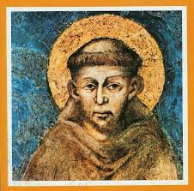

6.
The Path of the Bats

“You make known to me the path of life; you will fill me with joy in your presence, with eternal pleasures at your right hand.”
Psalm 16:11 (NIV)

Over Memorial Day weekend, we drove out to West Texas to see a colony of Mexican free-tail bats. My uncle said up to 10 million bats would swarm out of the cave at sunset.

We scrambled up the rocky hillside and waited. Dusk fell. The cave mouth remained quiet. Fearing we had come in the wrong season, we packed up to leave.

A few swallows began twisting over the cave mouth. Like dark smoke, bats trickled out. The sky filled with the beating of wings, and bats streamed out in an ever-widening spiral – millions of bats, furry creatures that can fly up to sixty miles per hour, climb to a thousand feet, and travel a hundred miles in one evening. We were awed, then stunned.

Red-tailed hawks ad peregrine falcons hovered just beyond the ridge. When bats left the spiral, the predators swooped in and picked them off. The bats had an ever-widening path and hundreds of square miles in which to fly freely, feasting on insects. When they stayed together in the prescribed pattern – in the center or near the edge – they were safe. But when they strayed off alone, raptors caught them.

God has provided a path for me too. Sometimes I fear this path limits my creativity or independence, but watching the bats that evening, I realized my path is wide and far reaching, leading to my heart’s desire. God is not a limit on how high or far I can go, but a refuge that provides the freedom to soar in ways that will sustain me and fill me with joy.

Dear Lord of the heavens and the earth, I can be so stubborn and proud, wanting to fly off and to do things my way. Help me to have patience to find lasting joy on Your path and trust that is provides all I need. Amen.

Author: Lucy H. Chambers
All God’s Creatures May/June 2021
Daily Devotions for Animal Lovers
A Guidepost Publication

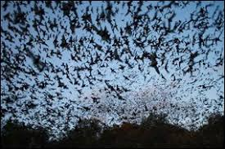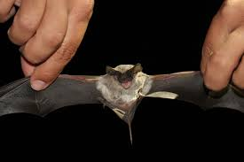

7.
Healing prayers for Michael Freeman & his diagnosis of prostate cancer

Pray for the repose of the soul of Joan Horr who headed to Heaven on 6-23-21. Pray for her husband and family as they transition into a new earthly life without her.

Continued prayers for Cindy Borgerding’s sister, Debbie Anderson who was involved in a terrible car accident, sustaining sever injuries. She has a long painful road to recovery.

Prayers for Martha & Holbein Restrepo as they recover from COVID. Martha was hospitalized but is now home. Both are recovering nicely. Continue prayers are requested!!

Claire Dwyer: pray for her daughter Shannon, suffering from anxiety & depression.

Pray for continued success for the ministry of YouFra & that a Local Animator will volunteer.

Praise God for beautiful baby Lucca Efaw! Congratulations to Ryan & Caitlyn Efaw!

Pray for all Priests and Seminarians throughout the world.

Continue to pray for Mary Pierson & family as they work through their grief.

Pray for Shelley Barger & GG who are both using scooters, unable to walk. Shelley will be undergoing scans at the hospital. Pray outcome will be a favorable one.

Pray for Carla Lewton’s mother Barbara who has been steadily declining. Pray family will find a wonderful healthcare facility that will be agreeable to Carla, her two brothers & Barbara.

Pray for our new Council, for the Holy Spirit to guide them & give them the wisdom they’ll need to fulfill their elected positions with a true Franciscan Spirit.

Thanksgiving for Ike’s new grandnephew Leo Anthony Battistini born 7-22-21!

Please email Ike at her new email address: eileenOFS@comcast.net for prayer requests & updates to be included in Newsletter

Make sure you make room in The Rule for THE RULER!

8.
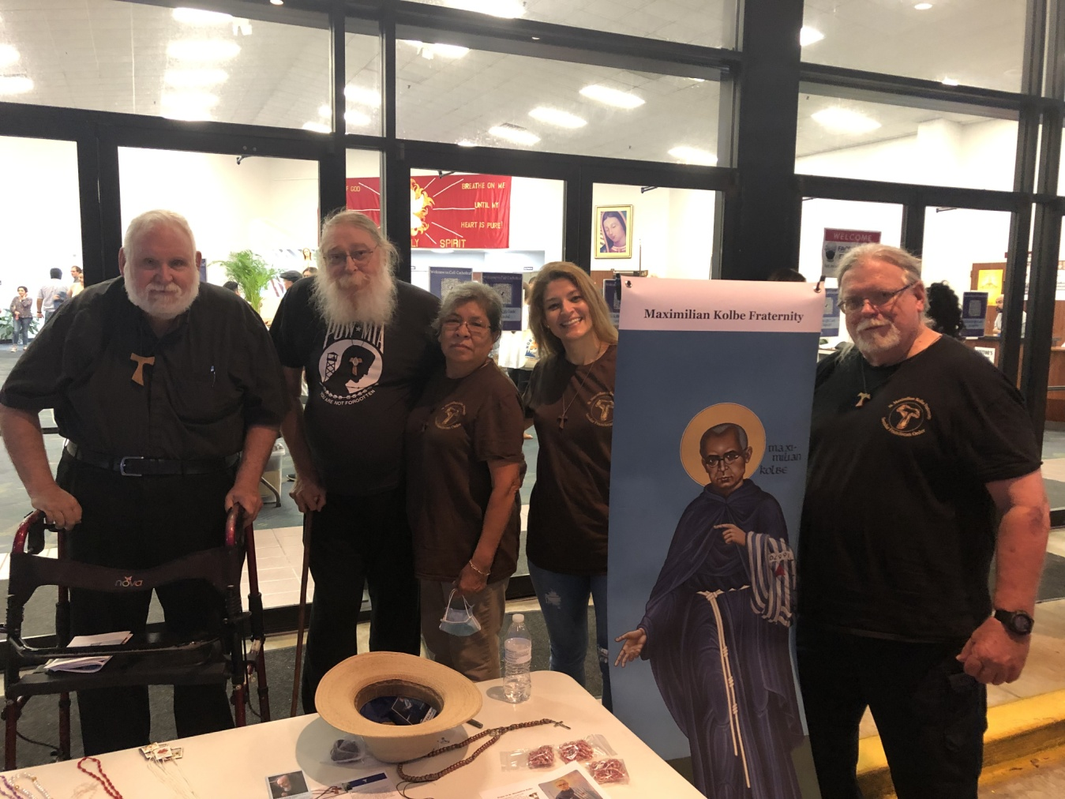
Fr. Mike Van Cleve, Danny & Maria Marquer, Fabiola Cespedes, Mike Freeman

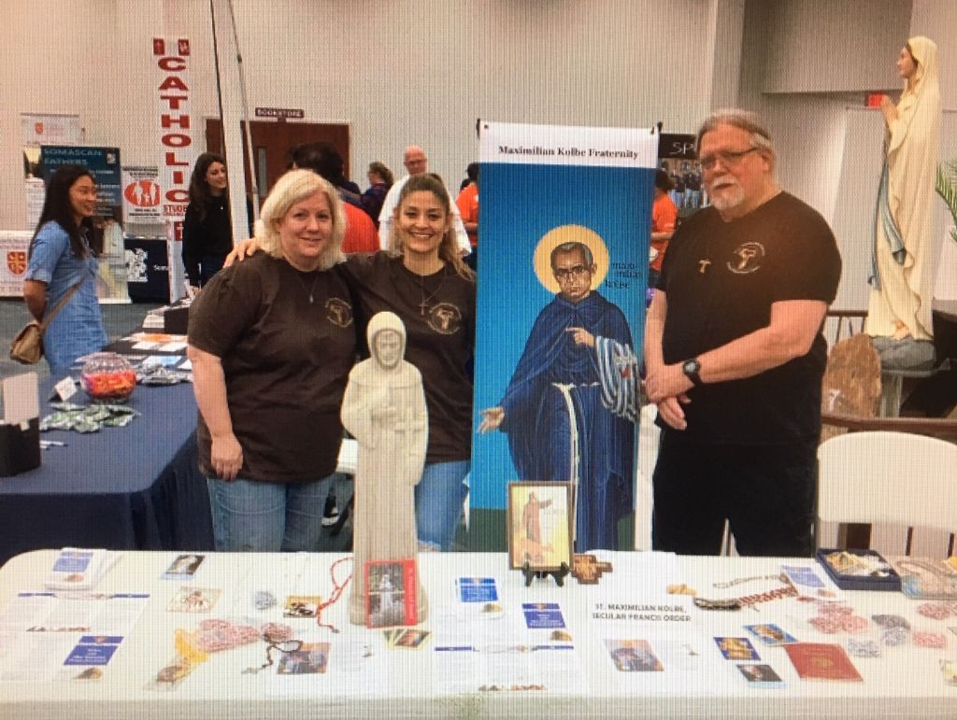
Carla Lewton, Fabiola Cespedes, Mike Freeman
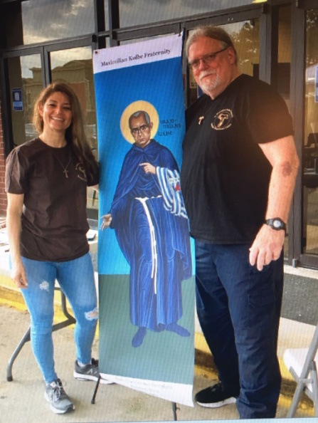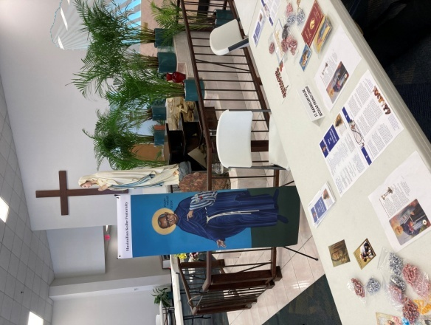

Café Catholica Sponsor Information

Thank you to our Café Catholica 2021 Sponsors
These sponsors help to make Café Catholica possible. Please click below to learn more about these organizations and how they can help young adults grow in their faith, pursue further education, become a leader in the church, and more.
Ablaze Ministries
Adore Ministries
Center for Faith and Culture at the University of St. Thomas
Christian Renewal Center
Concert for Life
Cristo Rey Jesuit Volunteer Service Corps Program
Hallow
Houston Chapter of Young Catholic Professionals
Houston Coalition for Life
Magnificat Houses
Maryknoll Fathers and Brothers
MAX Studios - University of St. Thomas-Houston
Notre Dame Young Adults Ministry
Office of Family Life Ministry
Office of Pro-Life Activities
Office of Vocations
Paradisius Dei
Somascan Fathers
Spiritus Ministries
St. Maximilian Kolbe, Secular Franciscan Order
Texas Catholic Conference
Get Involved with Young Adult Ministry in your area! Learn more here!
Young Adult Groups in Archdiocese of Galveston-Houston (English and Spanish)

