Secular Franciscan Order OCTOBER 2019 Newsletter

The Secular Franciscan Order was established by St. Francis of Assisi more than 800 years ago. Our purpose is to bring the Gospel to life where we live and where we work. We look for ways to embrace the Gospel in our lives and try to help others to do likewise.

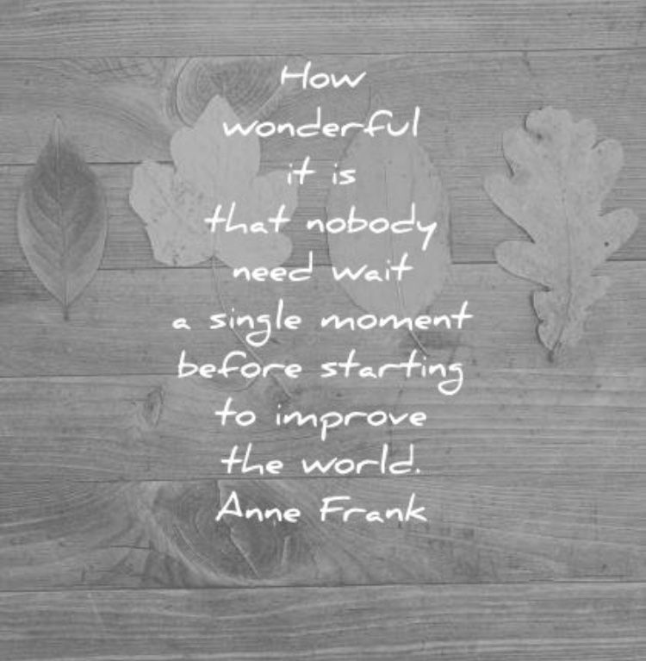
our Gathering
October 5th, 2019 Amy Le led us in our lighting of the candles prayer. It was an honor to participate in our Regional Visitation & we had the privilege of welcoming our St. Joan of Arc Regional Minister, Cherryle M. Fruge, OFS, our Assistant Regional Spiritual Director, Bro. Daniel Barrett, OFM. Paul Stranahan, OFS participated as an observer. Cherryle has a true gift of hospitality! She explained why they were there, the purpose of a Regional Visitation and welcomed any questions we might have. Her down-home personality and Franciscan Spirit kept things joyful. She & Brother Dan spoke on change and our personal limitations as we grow older. Some things we might have been good at no longer apply, so we change and grow and adapt to what we can do well now. We use our present gifts for the good of all. We must listen more attentively to the Spirit’s leading.
We were then lead in the Prayer for the Pastoral/Fraternal Visit (pg 50 Ritual) Dora read the Scripture, then discussion followed.
A much welcomed Right of Admission ceremony for Dori Ellis & Joan Horr was celebrated. Great joy for our Fraternity! Warm hugs all around….
We then took a break to enjoy all the delicious food everyone brought to share. Continuing the theme from last month, Dora facilitated our ongoing formation. We opened with a prayer and a video from the Catholic Climate Covenant’s Feast Day of St. Francis participant guide.* Dora then had us reflect on paragraph 18 of our Rule. A heartfelt discussion followed as to ways we, as individuals, can do our part to further the Franciscan concept of universal kinship. We are all connected – cry of the Earth – cry of the poor. Little did we know that at Fiesta Franciscana, Daniel Horan, OFM would speak directly to this as Franciscans do not follow the previously prevailing models of Care of Creation which were Dominion, and then Stewardship. He stated that we are to be ambassadors for the Kinship model - an eye-opening statement for many of us!
Our Council was dismissed to meet separately from the Fraternity. Cherryle, Bro. Dan & Paul met with the Fraternity and were given an opportunity to share any joys, sorrows or changes we might like to see happen in our Fraternity. Cherryle will bring our ideas back to our Council. What an enriching experience for our Fraternity. The Council was welcomed back and our concluding prayer from The Ritual (pg. 51/52) was led by Bro. Daniel.

REFERENCE: *(Catholic Health Association/Catholic Climate Covenant. www.catholicclimatecovenant.org/cct)
Greetings Good People!
Our sister Mary wrote the following article and I wanted to share with all:

Bishop helps kick off National Secular Franciscan gathering
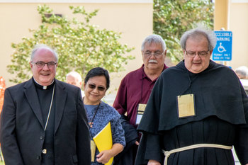
Bishop Michael Mulvey and our National Spiritual Assistant Fr. Christopher Panagoplos, TOR
October 17, 2019
by Mary Stronach, OFS Contributor
Under a domed ceiling depicting Christ feeding the multitude, Bishop Michael Mulvey shared spiritual food with Secular Franciscans as he helped them launch their National Chapter, held Oct. 15-20 at Pax Christi Liturgical Retreat Center. It was the first time the Secular Franciscan Order in the United States held its national gathering in Corpus Christi, with some 80 participants from across the country and Guam.
Like St. Francis, he noted, Secular Franciscans are “called to renew the church with the living spirit of Christ.”
Bishop Mulvey began his homily by sharing an affinity with the Franciscan charism, noting that his grandmother was a Secular Franciscan who brought him to Franciscan gatherings as a child, that his great aunt became a Poor Clare nun, and that he celebrated his second Mass as a priest at the tomb of St. Francis in Assisi.
So, “it’s good to be among family.”
Bishop Mulvey said that it can sometimes be hard for people “to accept reality as it is,” and, quoting Pope Francis, they can become “mummified.”
For example, when the Jews were wandering in the desert, they wished they could go back to Egypt. “We want to leave things the way they were, but the promised land is ahead of us…We need a different mentality today, one that is not “mummifying.”
“Unless we remain in the living spirit of Christ, we dry out and wither,” and “we become mummified.”
The bishop urged Secular Franciscans to work with other groups to help the Church. If we “come together – Franciscans as Franciscans, Carmelites as Carmelites, we could be a powerhouse! God has called you to be Franciscan today with the charism of Francis and Clare lived today.”
He said: “Let’s not point fingers at the Church. Let’s get in there and help them as Francis and Clare would have done. Never be a part of the difficulty; be a part of the solution.”
He added: “We are in the desert. It’s not an easy task. But with the body of Christ (Corpus Christi), many parts and one head…we can become a powerhouse of spiritual strength that will renew the Church.”
Quoting the saint of the day, St. Teresa of Avila, he closed with a reassuring message, “If Jesus dwells in a person, that person can endure all things.”
The joyful sound of guitar music was provided by Bob Conces, OFS, from St. Francis of Assisi Fraternity in San Antonio. (MY NOTE….Bob was formerly on our Regional Council and Minister of St. Padre Pio in Huntsville, Texas, and Dustin was professed at St. Francis Fraternity in San Antonio……family members may move but it’s so great when we come together!)
At the close of the opening Mass of the Chapter, National Minister Jan Parker, OFS, thanked Bishop Mulvey for his encouragement to rebuild and renew the Church. “The (Franciscan) Rule says we are united most intimately with the Church… We are one body, one Lord. We are with you. You are in our hearts and our prayers.”
*The above article was taken from the Diocese of Corpus Christi newspaper, South Texas Catholic

Let’s not become mummified! We are one Body, One Family. As Fr. Chris said Thursday morning we are in Corpus Christi, the Body of Christ. His Body is wounded; the homeless, the immigrant, racism, the division, etc. Let us greet all we meet as Francis had the Friars greet everyone they encountered; and that is with Peace!
Peace
michael
.

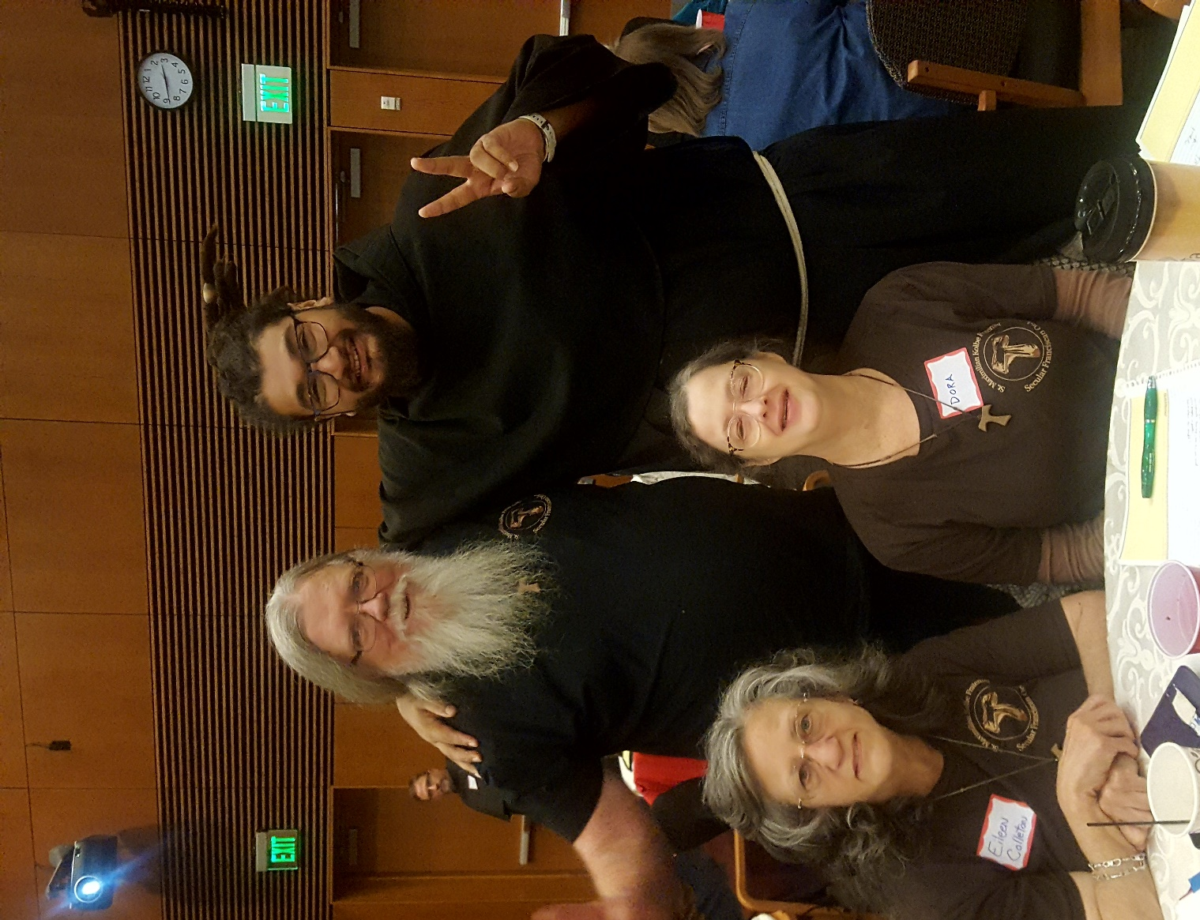
Brother Jaime with Michael, Dora & Ike

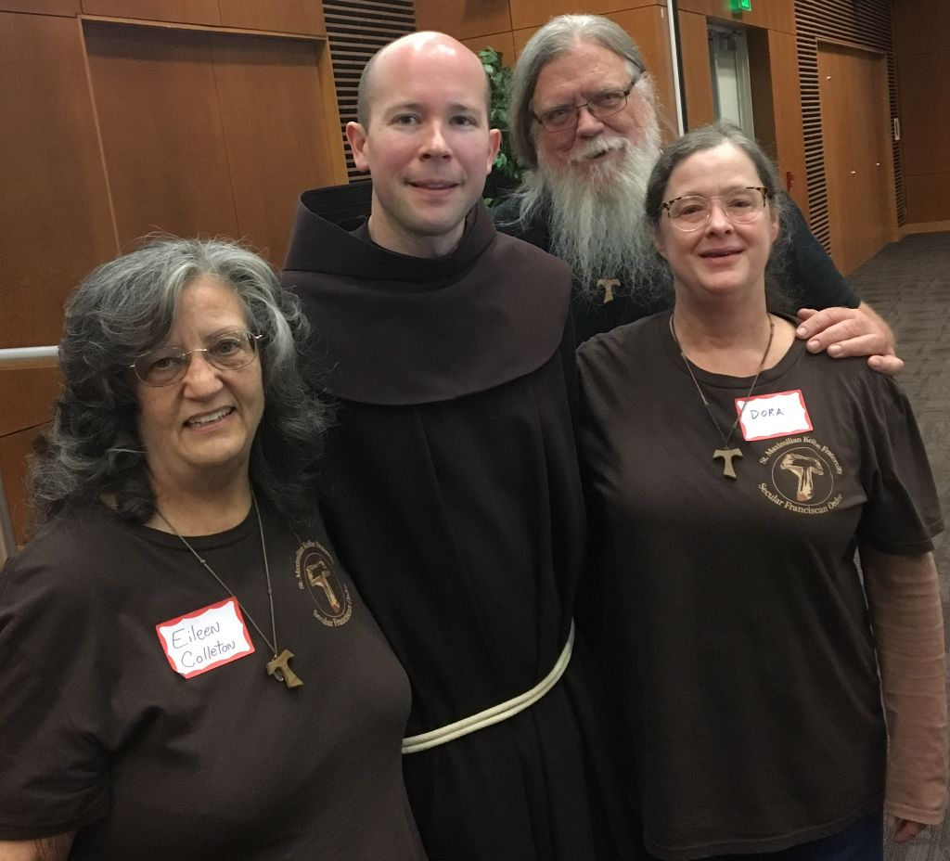
Daniel Horan, OFM raised the bar for Fiesta Franciscana! What a Blessing!

Next Meeting: November 2nd, 2019 beginning @ 10:00 a.m. in
St. Jerome Catholic Church: In the Outback Building
Bring your Liturgy of the Hours.
ALSO
We will be remembering All Souls who have transitioned and returned to Our Father. Please bring photos or mementos of your dearly departed Loved Ones!
Early Birds: An opportunity to join together in The Holy Mass in the day chapel @ St. Jerome @ 8:15 a.m. Candidates and Inquirers Formation begins @ 9:00 a.m. in the Outback!

All Souls Day is 11-2-19
May the Souls of the faithfully departed Rest In Peace!

are available in many different colors. If you’re interested in purchasing one, please contact Alba. They are $20/ea. Alba ordered some F.U.N. Manuals (For Up to Now – Foundational Topics for Initial Formation). They do not come with a binder. Purchase price is $13/ea.

Our contribution bag will be made available at all gatherings. Cash or checks.
Make checks payable to: St. Maximilian Kolbe Fraternity.

St. Joan of Arc Regional Retreat
April 25-27, 2020

FOR MORE INFORMATION ABOUT EVENTS & FORMS, PLEASE REFER TO E-MAILS FROM secretary.StMaxSFO@gmail.com

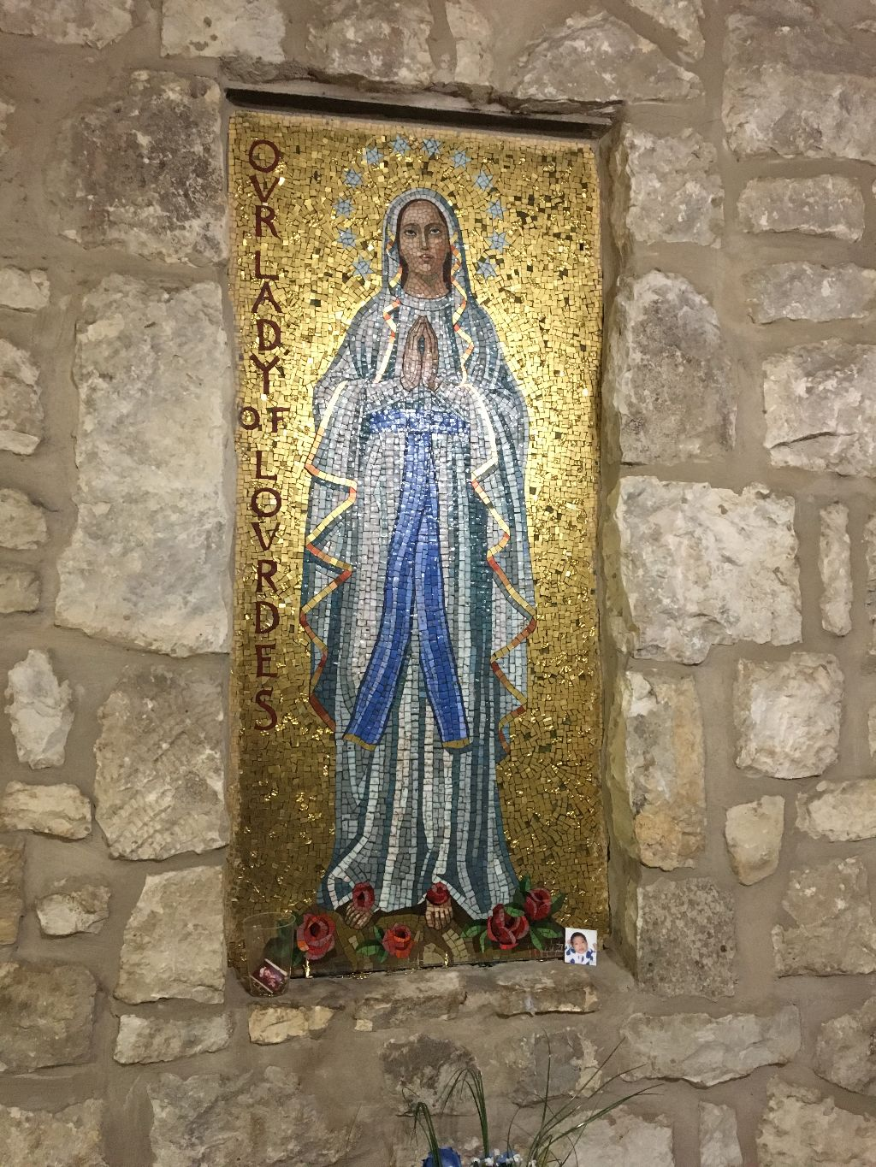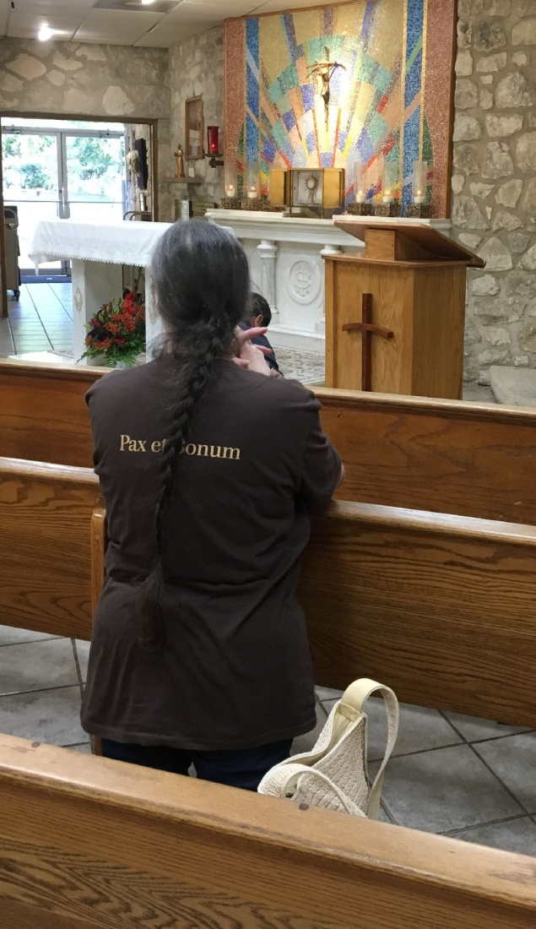
Mosaic inside Our Lady of Lourdes Chapel @ Oblate Renewal Center with Dora in adoration of our precious Lord.

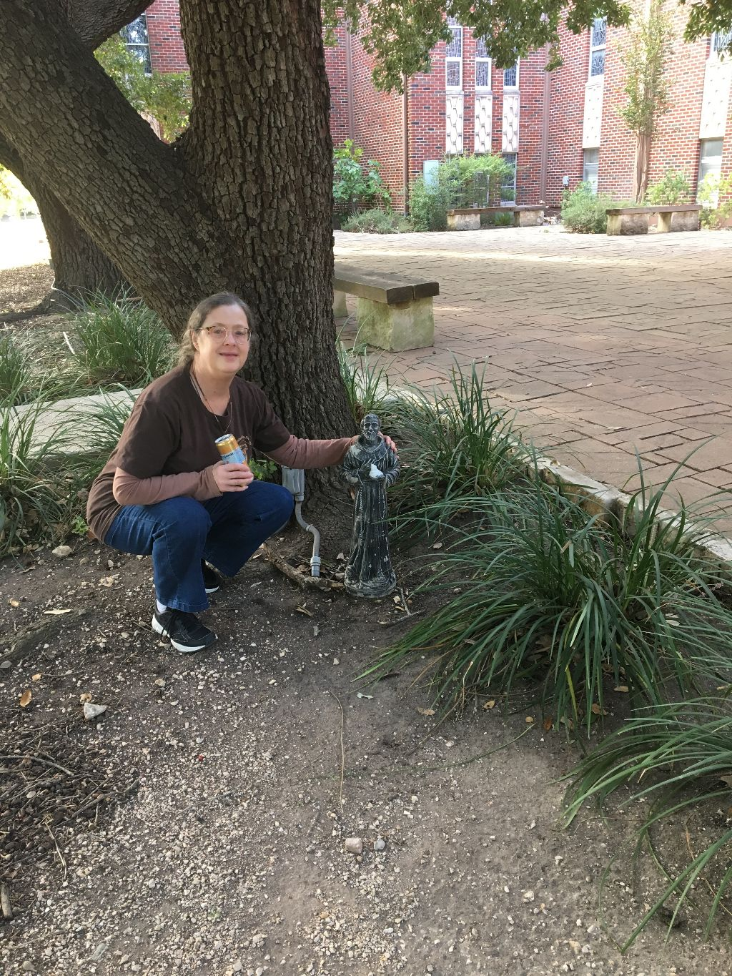
Dora found a small St. Francis statue while exploring the grounds.

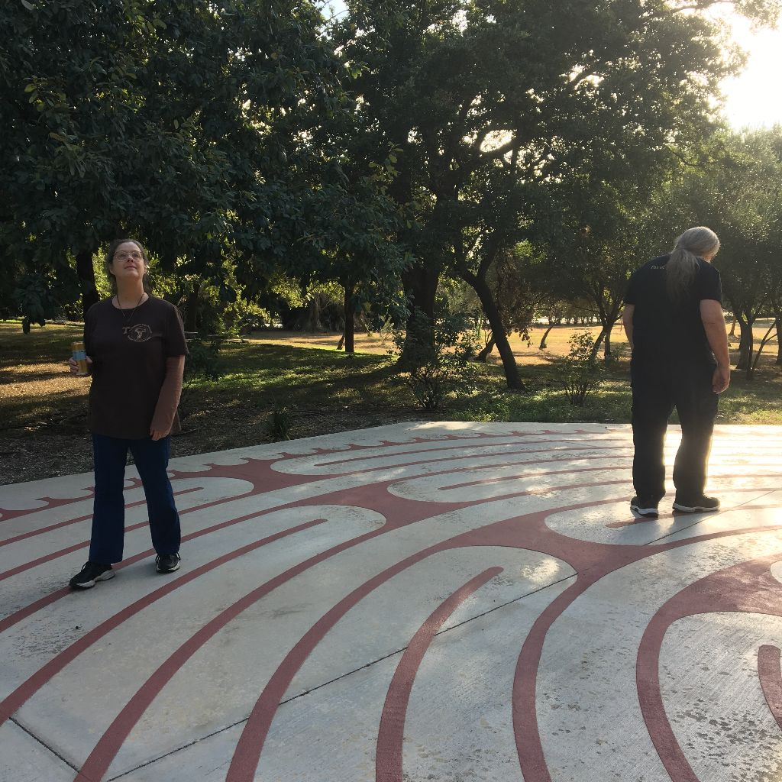
Enjoying the gorgeous outdoors while contemplating – walking the Labyrinth @ the Oblate Renewal Center

Lessons Under a Log

“But ask the animals, and they will teach you, or the birds in the sky, and they will tell you; or speak to the earth, and it will teach you, or let the fish in the sea inform you.” Job 12:7-8

It was a silly assignment for a college-level course nonscience majors took to fulfill a requirement. The professor instructed us to find something small in nature, magnify it, and make a hundred observations about that one small thing.

How were we supposed to learn anything from that? I sure didn’t know, but I wanted it done. I turned the first rotted log I found and scooped up a brown hard-shelled centipede that curled into a tight ball on sight. If I was stuck, maybe I could write about each leg.

No sooner had I magnified the creature, though, than my arrogance dropped to its knees. What had appeared to be a simple brown covering turned out to be a work of art. Up close, the intricate pattern lovingly painted on the insect’s back became awe-inspiringly clear. I gathered several more to confirm my finding.

Who does that? What kind of God invests art and design on the back of a bug most of us will never see? Why bother with detail, colors, shapes, and swirls on centipedes that live under logs? I was wonder-struck in that lab considering what else I was missing by not stopping to truly see. I must confess, the assignment led me to worship God in science class.

My parents often comment that a person’s handiwork reflects his or her character. In nature, we see God the Artist, God the Craftsman, God who doesn’t need an audience to display his finest effort.
Lori Stanley Roeleveld

Father, teach us to stop and observe creation. Help us see what you reveal about yourself through your artistry and craftsmanship, in every creature great and small.
May we reflect you, too, in the details of our own lives.

Taken from All God’s Creatures. Daily Devotions for Animal Lovers. Sept/Oct 2019 Guideposts

