Secular Franciscan Order August 2019 Newsletter

The Secular Franciscan Order was established by St. Francis of Assisi more than 800 years ago. Our purpose is to bring the Gospel to life where we live and where we work. We look for ways to embrace the Gospel in our lives and try to help others to do likewise.

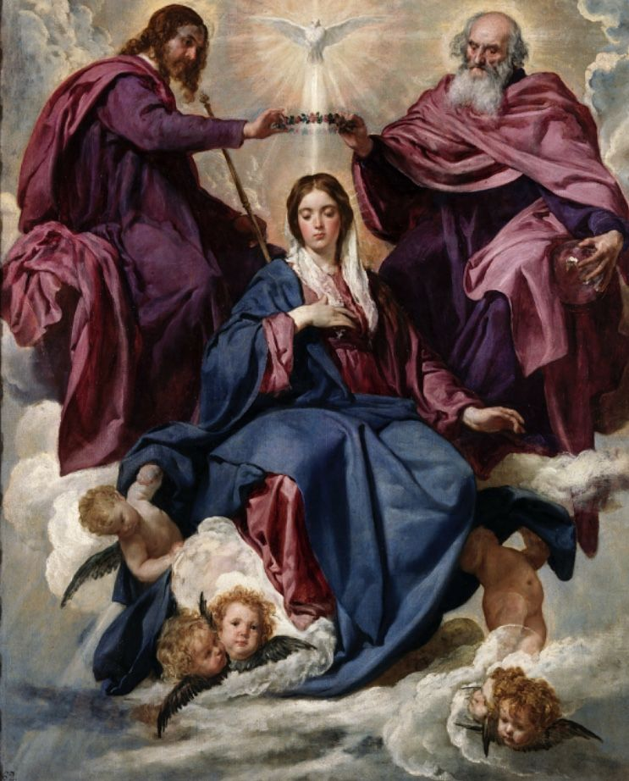
our Gathering
August 3rd, 2019 Joe Swonke, OFS led our gathering in praying The Liturgy of the Hours. In honor of St. Maximilian’s upcoming feast day, Joe had a special handout for the Second Reading from the letters of St. Maximilian Mary Kolbe. It was a lovely addition to our Liturgy of the Hours.

Cindy Borgerding, OFS read an excerpt from the book, “She Shall Crush Thy Head”, compilations of the writings of St. Maximilian Kolbe by Hilda Brown. The writings touched a lot of hearts and a beautiful discussion followed.

Rachael Persicano, OFS led our candle prayer for the three orders of our Franciscan Family; past, present and future.

Michael Freeman, OFS led us in our opening prayer from the Ritual of the Secular Franciscan Order, page 35. Mike then introduced several visitors; Ryan’s mother, Barbara’s God-Daughter, and a friend of Fabiola’s.

Our Fraternity joyfully participated in the Ceremony of Introduction & Welcoming for Clare Dwyer from our Ritual of the Secular Franciscan Order, pg 9.
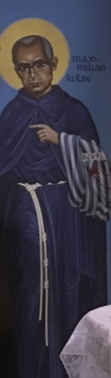 Dora Freeman, OFS shared some fascinating information on our Icon of St. Maximilian Kolbe. A great definition of an Icon: A work of theology to be prayed on. Dora explained the features of our Icon. She said everything written & depicted for all Icons have meaning. When Robert Lentz, OFM was asked about the Icon, he wrote that the reason St. Maximilian is pointing is that during the installation at All Saints Church he is pointing to Mary, who was at his side. If you have not been to this church in which we were canonically established, please go check out the other inspiring icons! He has saints from all continents represented!

We had a special presentation of a play written by Kazimierz Braun. Michael explained how he came across this play on the English language support site from the Diocese of Krakow, Poland. He contacted Dr. Braun; who was excited and expressed his happiness that we wanted to do this. Dr. Braun, while researching St. Maximilian met and lived with Friars who knew him. Dr. Braun has written 3 plays and Psalms that have been performed around the globe. The one chosen to share with our Fraternity was “Passion of Saint Maximilian Kolbe”.
Heartfelt thanks from Michael, our Sound Technician, to those brave souls who stepped up to present: Eileen for directing, Alan, Ryan, Joe, and Dora for their roles, and Dori who did as she does for the gatherings in the summer… a 2,400 mile round trip from her summer home in Michigan and still showing up at the Outback House before the 8:15 a.m. Mass to help Eileen set up the play!

Mike reminded us of upcoming opportunities for service and to “be in the world but not of the world”; including Family Fun Day at the University of St. Thomas, sponsored by Houston Catholic Radio Station KSHJ 1430 and the Office of Vocations.

Mike led us in the Closing Prayer from the Ritual of the Secular Franciscan Order, page 36.

We then enjoyed the goodies everyone brought to share. Yum!

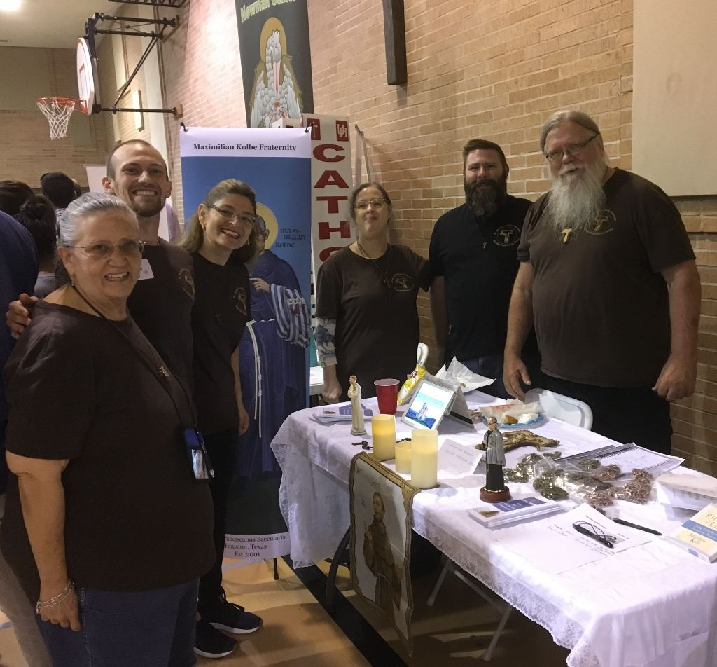
Café Catolica 7-29-19 @ St. Michael’s Catholic Church
Eileen Ike Colleton / Ryan Efaw / Fabiola Cespedes / Dora Freeman / Joe Swonke / Mike Freeman

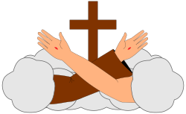
I need more H2O
Last Saturday I had the good fortune to participate in a day of reflection/formation for the men and women team members who serve on the retreat team for the Ignatian Spirituality Project here in Houston.
The topic was Poverty of Spirit; based on the classic book by Johannes Metz... We began with singing Glory and Praise to our God and continued with the Canticle of Creation by our seraphic father St. Francis…..for a minute I thought I was within a group of Franciscans!
Spiritual Poverty is the way of living Christ shared with us in the Sermon on the Mount. We are all familiar with the Beatitudes. Many commonly refer to these as the attitudes to “Be”……what we need to Be to be as a Christian.
Our facilitator shared this quote from Metz “Becoming a human being involves more than conception and birth. It is a mandate and a Mission, a command and a decision.”
It is by our Baptism we are called, and our journey or mission is to be open to what we have been called to do. We have been called through the Holy Spirit and through the many graces freely bestowed upon us as we are called to rebuild the Church.
It is easy to look around and see so many things that need to be changed in our world. Horrors abound and one can easily become cynical, blaming so and so or this party or that party.
We can get caught up in the work of trying to rebuild the Church stone by stone, one cause after another, while forgetting or conveniently choosing not to start with ourselves.
Within the course of our reflections one gentleman, a retired doctor, shared that his prayer was he needed more H2O. Humility, Hope, and Openness
Whoa!!
Me too!!!!!
I know so many of my own personal issues and sin are related to my deficit of humility….quick to anger, pride; I could go on and on, but I have hope that by my increased openness to what my Commander in Chief Jesus Christ is calling me to be, I can become what I have been called to be.
Through the Most Holy Eucharist, the Word of God, His Church, Reconciliation, daily conversion with ever increasing amounts of H2O, I continue on my journey.
The primary command on this mission or journey is that we love one another as Christ has loved us. It is to be the love that as Murray Bodo, OFM writes in Surronded by Love: Francis fell in love with the love who is Infinite Love, a love that made him cry out ‘May the fiery and honey-sweet power of your love, O Lord, wean me from all things under heaven, so that I may die for love of your love, who deigned to die for love of my love. pg. 101
I have a friend who retired from the military, and he frequently says “The mission is what the mission is”. We have our orders; our mission, it’s our decision……..we know what the mission is, & hopefully, we are strengthened by the motto of St. Junipero Serra: “ Siempre Adelante”.

Peace
michael

Next Meeting: September 7th, 2019 beginning @ 10:00 a.m. in
St. Jerome Catholic Church: In the Outback Building
Bring your Liturgy of the Hours.
Early Birds: An opportunity to join together in The Holy Mass in the day chapel @ St. Jerome @ 8:15 a.m.
Candidates and Inquirers Formation begins @ 9:00 a.m. in the Outback!

Remember to keep Brother Juniper in prayer for healing!

St. Maximilian Kolbe carried a pocket full of Miraculous Medals to hand out whenever possible. He called them his special bullets to fight against the heresies and evil he came across.

are available in many different colors. If you’re interested in purchasing one, please contact Alba. They are $20/ea. Alba ordered some F.U.N. Manuals (For Up to Now – Foundational Topics for Initial Formation). They do not come with a binder. Purchase price is $13/ea.

Our contribution bag will be made available at all gatherings. Cash or checks.
Make checks payable to: St. Maximilian Kolbe Fraternity.

9-13-19 thru 9-15-19 Houston Area Franciscan Camping & Celebration
LAKE HOUSTON WILDERNESS PARK
Come for the weekend OR just come for our
PotLuck ItalianThemed Picnic on
Saturday, the 14th @ 5:30 p.m. near the Pine Grove Dining Hall.

10-12-19 Fiesta Franciscana in San Antonio, TX – 9:00 a.m. – 3:30 p.m.
with Fr. Daniel Horan, OFM
“All God’s Creatures: Rethinking Franciscan Theology of Creation”
Registration $20 plus $15 for the optional lunch.
For more information, contact Stan Whitener, OSF @ (210) 827-5309

St. Joan of Arc Regional Retreat
April 25-27, 2020

FOR MORE INFORMATION ABOUT EVENTS & FORMS, PLEASE REFER TO E-MAILS FROM secretary.StMaxSFO@gmail.com

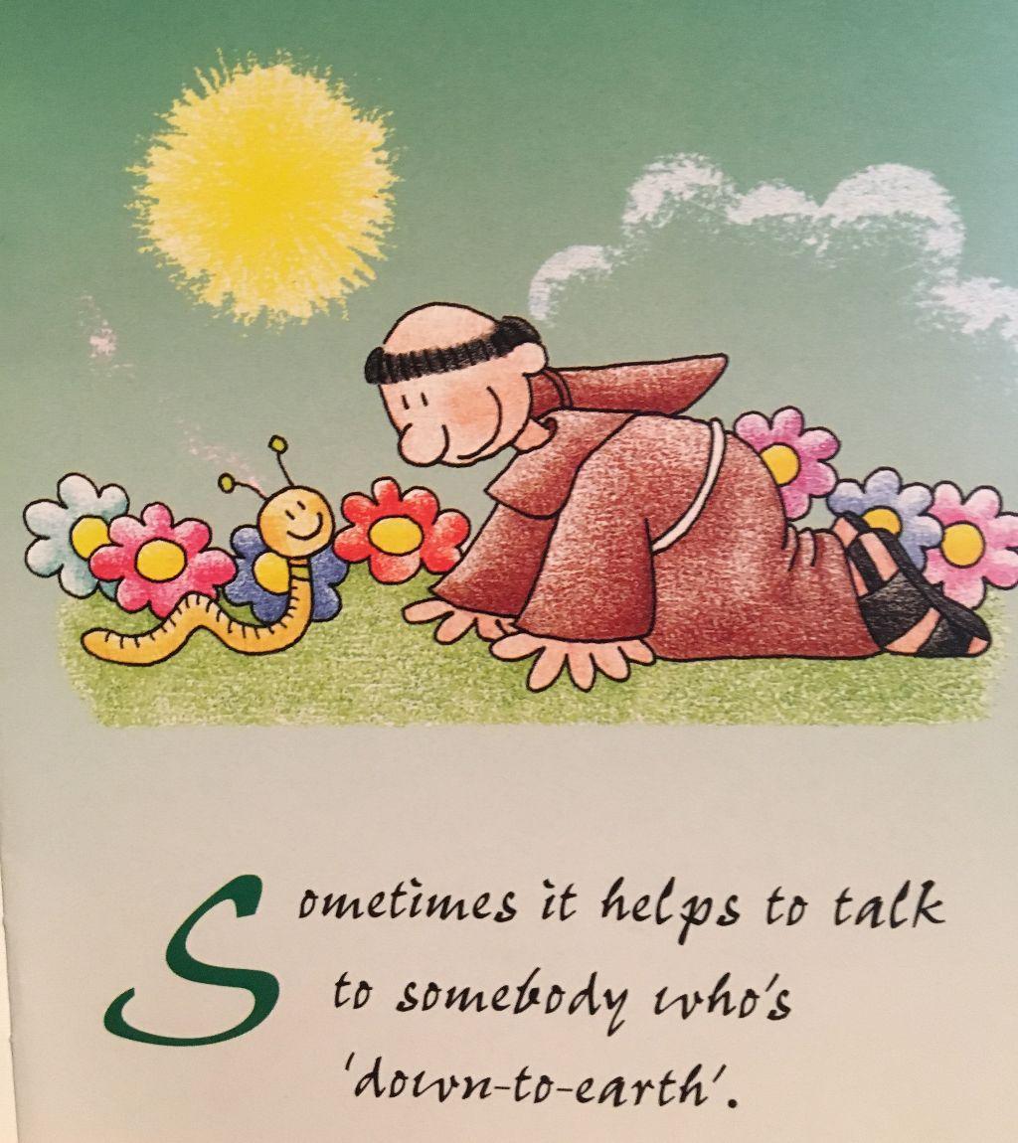
FROM: Little Francis Love Notes written by Julie Hanna
Illustrated by Sister Chiara Amata

