Secular Franciscan Order February 2018

It was an exciting Election Day filled with anticipation as we prepared our hearts and minds by praying the Rosary. We had an added blessing of having Brother Juniper present to make sure we crossed all our “t’s” and dotted all our “i’s”. Lore Payne, OFS officiated the election process and guided us through correct procedures. In our St. Joan of Arc Region, there are 4 Councilors. Lore covers the West side. She is a member of St. Thomas Moore Fraternity & made herself available to help with our elections.
There were 16 professed members counting Fr. Mike Van Cleve. He was excluded as a voting member due to his status of Spiritual Advisor. 15 members were present and accounted for to cast their votes. The New Council is as follows:

Officer Minister: Michael Freeman
Vice Minister: Amy Le
Secretary: Ryan Efaw
Treasurer: Alba Hernandez
Formation Director: Dora Freeman
Councilor #1: Dustin Greenwood
Councilor #2: Joe Swonke
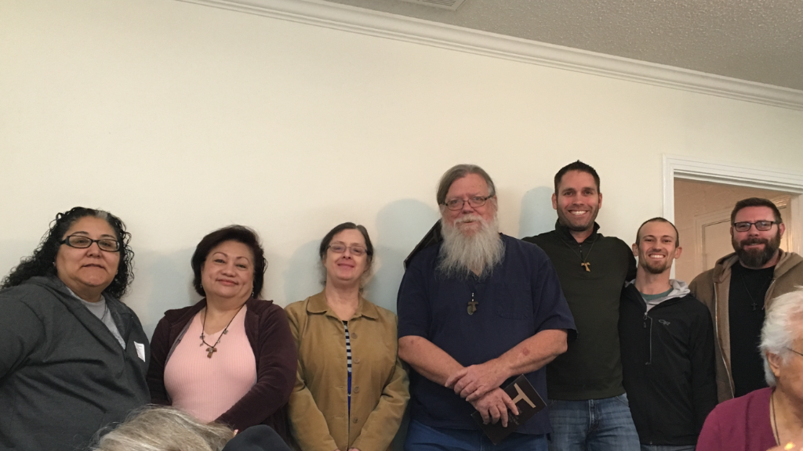
L to R: Alba, Amy, Dora, Michael, Dustin, Ryan, Joe

Our meeting ended with an invitation to enjoy all the delicious goodies everyone brought to share. Yum!


“I have been all things unholy.
If God can work through me,
He can work through anyone.”
St. Francis of Assisi

Reminder: Save The Date!!
The Annual Regional Retreat
Will be held on May 4th-6th at
The St. Charles Retreat Center
In Moss Bluff, LA.

Have a Happy & Blessed
St. Valentine’s Day

Can the Administer of Ashes
Make a heart shape? ☺

“Without diminishing our beliefs, we approach others with love rather than domination. We approach others with a desire to share what is important to us rather than make them feel insignificant or stupid. We approach others with a readiness to understand them rather than presuming that they should think like us. We approach others with respect, even reverence, creating an atmosphere of friendship rather than jumping into an argument we must win. We approach others, if need be, with a forgiving spirit rather than imposing feelings of guilt. We approach them with joy and hope rather than fear and suspicion.”
Lester Bach OFM Cap [Seeking a Gospel Life]
Where have you gone, Mister Rogers?

I have been going back and forth, aka stalling, to send something over to Eileen, who made Dora so happy when she agreed to take over this newsletter. Dora has been doing it, with a brief break when Valerie stepped up, for about a decade.

I have several drafts which I started right after the election. What an exciting time for our fraternity! I am so grateful for those that served our council as its servant leaders these past three years as I struggled, not always knowing what to do, as minister…yet the Holy Spirit animated us and we are so blessed to be growing. I am blown away by those new council members stepping up and their willingness to serve. As minister, I have truly been blessed having the opportunity to serve you and also traveling to the Regional meetings to represent Maximilian Kolbe Fraternity. It is often said that as Franciscans we are not trying to become another Francis. In our little brown ritual book, pg. 24, we see the words we each promise at our profession, “May the grace of the Holy Spirit, the intercession of the Blessed Virgin Mary and our holy father St. Francis, and the fraternal bonds of community always be my help, so that I may reach the goal of perfect Christian love.”

It is this, to the fraternal bonds of community, that the Holy Spirit has called us each to journey together.

Our journey into Lent this year begins on Valentines Day! Let us show this love to everyone, not just those who love us in return. Let us share our Fathers love with the unloved; those who have no one to show them love.

Our fraternity came out of the Kolbe Project, which was begun by Franciscan friars to serve those suffering from H.I.V./A.I.D.S. They were the modern day lepers at the time. Today’s lepers are more numerous as they are the prisoners, homeless and others many do not want to see or be around or have come into our communities.

Yesterday our Bishop traveled to the Ellis Unit outside of Huntsville and brought eight men, all convicted felons, into the church. Two of the 3 readings involved lepers! There are no coincidences! Afterwards Deacon Lopez thanked Daniel Cardinal DiNardo for taking the time out of his busy schedule and the Cardinal responded, and I’m sure I am paraphrasing, “A shepherd will always find time to take care of his flock.”

Now about Mr. Rogers…I stole this title from lyrics in the Simon and Garfunkel hit which asked where have you gone Joe DiMaggio? Everyone of that era knew of the Yankee Clipper…those of us with children and grandchildren know Mr. Rogers, who was an ordained Presbyterian minister. Fred Rogers wrote: “Love isn’t a perfect state of caring. It’s an active noun like ‘struggle’. To love someone is to strive to accept that person exactly the way he or she is, right here and now…I think everybody longs to be loved and know that he or she is loveable…and consequently, the greatest thing that we can do is to help somebody know that they’re loved and capable of loving.”

The call from Mr. Rogers asking everyone to be his neighbor, starting each show with, “Hi, neighbor” was considered counter-cultural then and even more so today as a renewed call for isolationism has become a driving factor. Many are not seen as neighbors, but as ‘those’ people, etc. The article addressed an early episode in which King Friday, who was the ruler of the Neighborhood-Make Believe, wanted to build a wall around his kingdom to protect it from change.

Hmmmmmm….

As penitents, everyday is Lent for us…let us make every day Valentines Day!

pax et bonum

michael
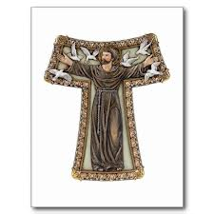

The Way To Peace
I call upon the Eternal Father through his Son, our Lord Jesus Christ, that through the intercession of the most holy Virgin Mary, the mother of the same God and Lord Jesus Christ, and through the intercession of blessed Francis, our leader and father, he may enlighten the eyes of our soul to guide our feet in the way of that peace which surpasses al understanding. This is the peace proclaimed and given to us by our Lord Jesus Christ and preached again and again by our father Francis. At the beginning and end of every sermon he announced peace, in every greeting he wished for peace, in every contemplation he sighed for ecstatic peace --- like a citizen of that Jerusalem of which that Man of Peace says, who was peaceable with those who hated peace, pray for the peace of Jerusalem. -Bonaventure “The Soul’s Journey into God”
Saint Margaret of Cortona, T.O.S.F., was an Italian penitent of the Third Order of St. Francis. Her mother died when she was 7 years of age. Her step-mother was not very loving towards her and Margaret ran away from home with her boyfriend. She became pregnant and never married. After 9 years, her boyfriend was murdered. Becoming destitute, Margaret went back home to her father, asking for forgiveness. He would have nothing to do with her. The Friars Minor took her in. She later became a Third Order Franciscan as well as her son. Her ministry was to the poor and sick and she eventually was given permission to found the Confraternity of Our Lady of Mercy. She was born in Laviano, near Perugia, and died in Cortona. Her DOB: 1247, DOD: 2-22-1297. She was canonized in 1728 by Pope Benedict XIII.





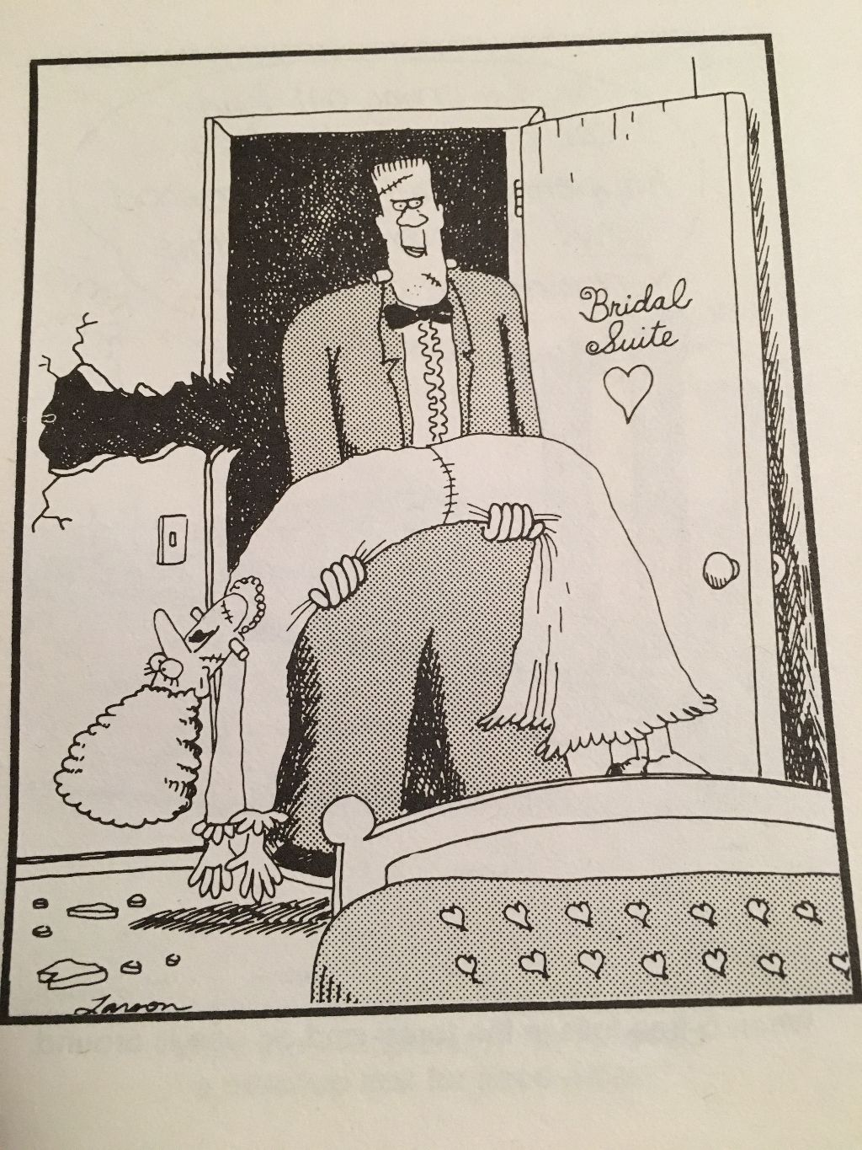
Holy Humor

