Secular Franciscan Order October 2020 Newsletter

The Secular Franciscan Order was established by St. Francis of Assisi more than 800 years ago. Our purpose is to bring the Gospel to life where we live and where we work. We look for ways to embrace the Gospel in our lives and try to help others to do likewise.

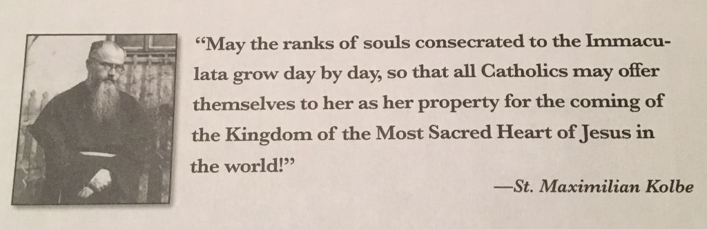

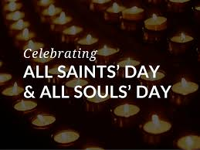

1
our Gathering
October 3rd, 2020

We began our Gathering by uniting our voices in praise and thanksgiving by singing, “Let There Be Peace on Earth”. We need to take it on the road, in my opinion! Excellent job!

Ryan Efaw shared a Franciscan Reading which led us into a mindful discussion.

Eileen Ike Colleton led the lighting of the 3 candles, calling all Franciscans, past, present and future to be present in Spirit.

Mike Freeman spoke about one of those names from our past, our first minister, James McLendon.

We all participated in the Opening Prayer from our Ritual book, then prayed together “Let Us Pray”, from “Spirituality and JPIC”, a presentation by Patricia Grace, OFS.

Dora Freeman read a brief passage written by Ilia Delio OSF from the book: “Compassion: Living in the Spirit of St. Francis”.
Some thoughts: how do we break open our hardened hearts and welcome God into our midst?
Embracing suffering helps break open and bring compassion to a deeper level. Compassion can lead to conversion.
We are “loved into being”.
A question to ask oneself: “What is the value of Community in my life?”
Deep, personal sharing followed. It was so beautiful to hear others share how precious our St. Maximilian Kolbe Fraternity is to them.

Mike Freeman reminded us that Fraternity Elections are coming up in February 2021. It is so important that we remember the 3 promises we made in the Church the day of our Profession…this was a perfect segue as to
What is Yours to Do in 2020: From FAN September 28, 2020 newsletter. We went around the room sharing the homework Mike gave us: to list the things of great joy. So, “what brings us deep joy”? So many amazing ideas; music, people healing/reconciliation, family, things, our senses, nature…. It was a beautiful sharing and gave me great food for thought for future prayer times. I was surprised & disappointed just how limited my list was.

A handout: An Ignatian Examen for Civic Life was given out to help us in the discernment process on the interrelationship between Gospel values and political engagement. It is a prayerful way to have a heart to heart with God.

Our Gathering ended with our Closing Prayer from the Ritual of the Secular Franciscan Order, page 36.

As a follow up to the earlier mention of our first minister, James McClendon: His sister had contacted us and informed us that his remains were being moved at Glenwood Cemetery and was hoping a Priest could be present and provide a service. We were blessed in that his remains were moved on the Tuesday following our gathering, October 6, 2020 & seeing that Tuesday is Fr. Mike’s one day off of the week, he said, “Yes!” Thank you Fr. Mike! It was a beautiful service. Jim’s sister had cleaned up the statue of St. Francis that they had originally placed on his gravesite and also informed us how important being a Franciscan was to him. He was buried in his shroud (the only time we are to wear them). It was so good to hear & learn about him.

2

If Christ deemed us worthy to live in these times, at this hour-the only hour we have-
we cannot let ourselves be overcome by fear, nor allow this time to pass without
living it fully with joyful fidelity.
Pope Francis,
September 24, 2018

Greetings Good People!
It was so good getting together again in the flesh! I used to jokingly say at work if I could only be two places at once…well the envelope (or is it Pandora’s box) has been pushed and we can be in person at St. Jerome’s and also in space thanks to Zoom.
It’s not the same though. On May 12, 2020 our National Fraternity put out guidelines for gathering during this pandemic. We can still gather and have initial and ongoing formation virtually, yet so much of what we do, such as Professions, Rites of Welcoming, visitations, and elections must take place in community. Our National Fraternity will be gathering later this month for their Chapter and perhaps this will be discussed/updated.
We are so fortunate that a large enough space is available for our use at St. Jerome’s. While I loved gathering in the Outback House; it did not allow for us to maintain an appropriate physical distance so at least for now (and a new Council should be elected in February 2021 and can certainly reconsider), I have requested the Fr. Raye Center for the rest of this year and 2021. Speaking of a new council….if you are professed, have you discerned serving? You are needed! It truly is a Blessing .
Prior to last month’s gathering I sent out “The Care and Feeding of Councils”. While it was somewhat long and you may have chosen not to read it thinking, well, I’m not on council, please review.
The local fraternity is the basic unit in our Franciscan Family. Article 22 of our Rule reads:
3
The local fraternity is to be established canonically. It becomes the basic unit of the whole Order and a visible sign of the Church, the community of love. This should be a privileged place for developing a sense of Church and the Franciscan vocation and for enlivening the apostolic life of its members.
As I write this there is so many things happening that are happening throughout the world that can easily lead one into the abyss, yet when we let it, the Hope, Light and Love of Christ shines through; and we must see it and share it.
When I lie in bed at night I do not always complete an Examen, yet I always do the first part, gratitude. I thank God for so much, and often it has come through those I encounter. The Houston area dodged the devastation of one storm after another this year. It’s nothing we did, it was only by the Grace of God.
Last weekend Dora, Phyllis, her daughter in law Kendall and I went to Crowley, Louisiana .Her sister Stephanie is coordinating relief efforts in Cameron as well as the Diocese. We met in Crowley as Cameron is not expected to get any electricity until at the earliest, January, and they also organized a statewide rodeo for junior and high school students. Regardless of their own suffering they were doing what they could to help these kids and their families resume some level of normalcy in their lives. What really blew me away was when her brother- in-law Nicky said in regards to the anticipated new storm Zeta, he wished it would spare other areas and that it would go ahead and hit Cameron as they are already having to completely rebuild. Whoa…..
The kindness and generosity of you all who have so kindly served, donated and are constantly praying will not be “Breaking News” yet in my humble opinion, when the day comes, we know some will be on the right and some on the left… sheep and goats, not elephants and donkeys.
There is nothing to fear……Jesus, I Trust in You !
Peace - Michael 4
Next Meeting: November 7th, 2020
10:00 a.m.
St. Jerome’s Fr. Raye Center
Candidates & Inquirers in Formation: 9:00 a.m. in the Fr. Raye Center
There is no 8:15 a.m. Mass on Saturday at St. Jerome’s.
Our Gathering will be available via Zoom for those cannot attend in person.
Reference 11-2-20 email from Mike Freeman for log-in information.

PLEASE continue to Wear A Mask & Wash Your Hands!
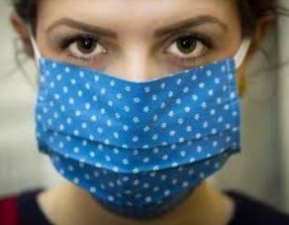
We are continuing the SUNDAY Meal Sign Up for Deacon Louis & Jean Horr.
See email on 9-24-20 from secretary.StMaxSFO@gmail.com

Alba ordered some F.U.N. Manuals (For Up to Now – Foundational Topics for Initial Formation). They do not come with a binder. Purchase price is $13/ea.

$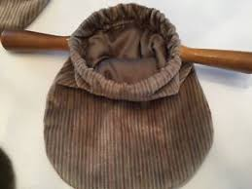$$ Bring all that money you’ve been saving for our contribution bag to our
10-3-20 live and in person meeting! Cash or checks made payable to: St. Maximilian Kolbe Fraternity.

4
A Spanish version of the TAU-USA is now available and being mailed to Spanish speaking members upon request. Email your name, address, fraternity name & region name to:
Cindy Wesley OFS, cw93444@gmail.cm
Or mail request to:
Cindy Wesley OFS
846 Calimex Place
Nipomo, CA 93444

5

Every Day for PRAYER!

There are LOTS of ways to become involved.
Reference emails from Ryan @ secretary.StMaxSFO@gmail.com and emails from Michael @ mbigfree@aol.com for specifics!

Next Meeting will be 12-5-2020

“What the eye cannot see
The heart cannot feel”
Latin American saying quoted by Sr. Helen Prejean

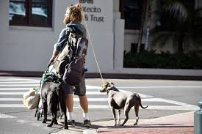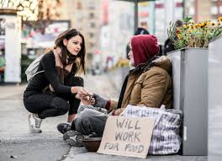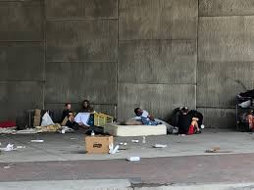

6
They Won’t Bother You

“Follow peace with all men, and holiness,
without which no man shall see the Lord…”
Hebrews 14:14 (NIV)

Blessed are those who have a mother who gardens. My mom and I spent many hours together digging holes, planting seeds the right distance apart, watering and nurturing seedlings to maturity. She even had ways of making weeding seem worth the effort to a preteen boy.

Mom grew a diverse garden running the perimeter of our large stone house, including snapdragons, four-o’clocks, petunias, geraniums, bleeding hearts, and many others. An endless cavalcade of color June through August, her flower beds lit up our neighborhood.

Integral to her plan, we always had plenty of bees buzzing nearby. She taught me from an early age to remain calm when a honeybee, or even a large yellow jacket, swooped into view.

“If you leave them alone, they won’t bother you,” she said frequently to embed it into my young mind.

While playing outside almost every summer day, I saw lots of bees, but they never stung me. Friends might get worried and become fearful, but repeating my mom’s sage advice brought calm into those situations. Friends who heeded her advice never seemed to get stung. Several who swatted at the yellow jackets eventually paid a price.

As I read the scripture above from Hebrews, my mind goes back to those peaceful days in my mother’s garden. Most people react to provocative words or actions from others. If we remain calm, most situations pass unremarkably. If we swat back at them with our words, the situation usually escalates, and we get stung. The best way to cultivate a lifestyle of peace is not to stir up strife.
God, please make me an instrument of your peace.
Help me hold my tongue and be patient with others. Amen.

Author: David L. Winters
Guideposts - All God’s Creatures
Daily Devotions for Animal Lovers

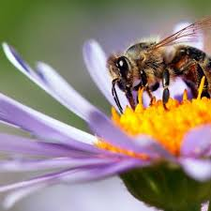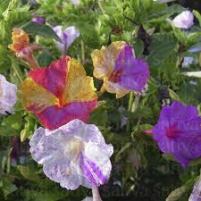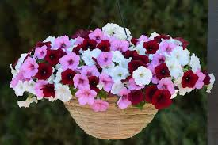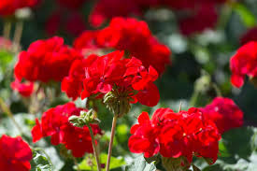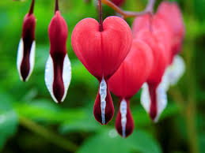
Honey Bee Snapdragons Four O’Clocks Petunias Geraniums Bleeding Hearts
7
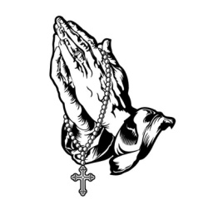
Remain in prayer for:
Healing prayers for Michael Freeman, OFS & his diagnosis of prostate cancer
Thanksgiving Prayers of healing for Alba Hernandez, OFS
Healing prayers for Consuelo Davis
Healing Prayers continue for Joan & Deacon Louis Horr
Safe travel for Dori Ellis & family as they return to Houston
Fr. Mike requests prayers for all who have died due to COVID-19 and all who have been infected
Claire Dwyer: pray for her daughter Shannon, suffering from anxiety & depression.
For all those who continue to be impacted by severe weather
Continued prayers for Alan Allen, OFS, his fellow coworkers & all seeking sustainable employment! Pray for peace, patience & renewed hope.
Safe travel and good health for Fabiola Cespedes, OFS who is visiting her parents in Bolivia.
For Fabiola’s brother, Miguel, his wife and a reconciliation between family members.
For continued prayers for our National Minister Jan Parker.
Continued success for Alan & Fabiola in their ministry of YouFra.
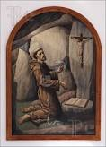
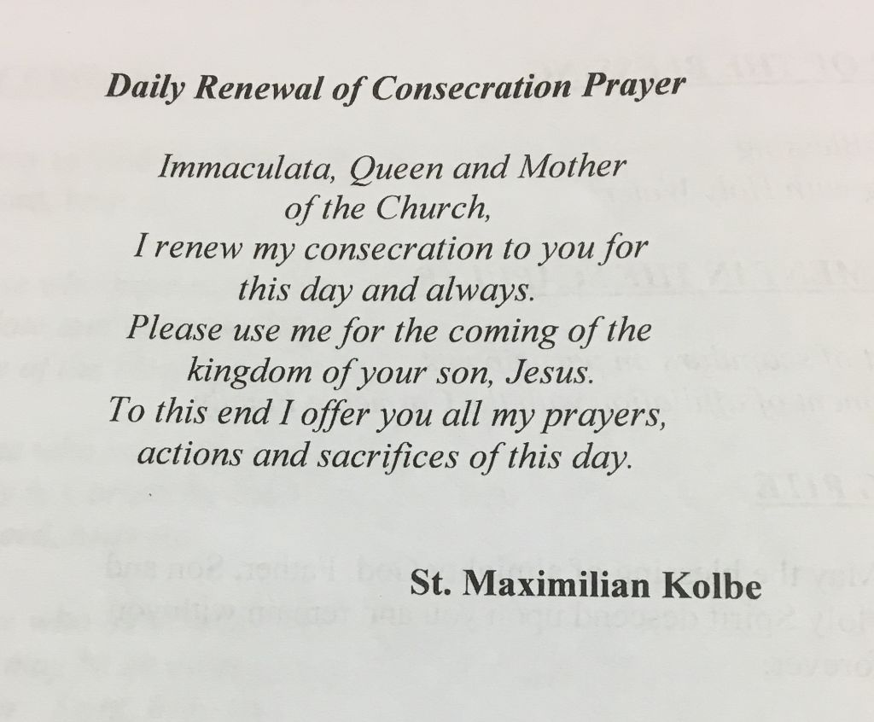

8

