Secular Franciscan Order August 2020 Newsletter

The Secular Franciscan Order was established by St. Francis of Assisi more than 800 years ago. Our purpose is to bring the Gospel to life where we live and where we work. We look for ways to embrace the Gospel in our lives and try to help others to do likewise.

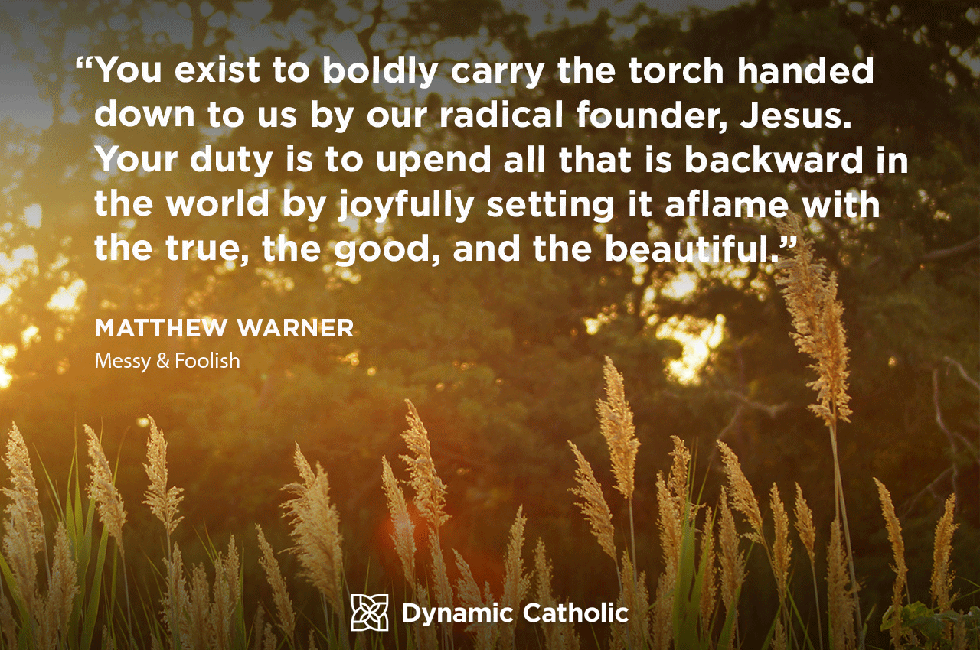
Permission to use quote per Dynamic Catholic
From the book: Messy & Foolish by Matthew Warner

1
our Gathering
August 1st, 2020

There used to be a kid’s show called Zoom. “Zoom zoom zooma zoom, we’er gonna zoom zoom zooma zoom”, come on, sing along…. Okay, so I’m dating myself. Ha ha

Once again we began by checking in with everyone to see how the world is treating us and how we are treating the world. It was enlightening to see how many are making a difference in their corner of the Universe, from the Gospel to the lives of others! A good portion of our Gathering was spent on catching up with each other.

Dora read a prayer St. Francis prayed before the crucifix where Christ commissioned him to Go Rebuild My Church.

Our Spiritual Assistant, Fr. Mike shared that we must look inward at our own defects in character before trying to correct the defects in others. He very much appreciated the handouts Mike Freeman emailed to us all. They were suburb reading and enlightening. Mike Freeman referenced an article from the National Catholic Reporter by Sarah Salvadore where Franciscans grapple with colonial legacy of Junipero Serra. He reiterated what Fr. Dan Horan said; that the Gospel is not necessarily perceived as “Good News” by everyone. The key is to listen to the other person’s perspective and be open to their point of view.

Dora kept with tradition and prayed the 3 Candles prayer for past, present and future Franciscans. As always, it was a beautiful reflection.

Mike Freeman referred to another handout from the updated version of The Franciscan Journey. This was also listed in the July 2020 edition of the St. Maximilian Kolbe Newsletter. The Appendix has information on Dialogue & Debate. There is a distinct difference in the two. Franciscans are called to dialogue, which purpose is to have each side understand, truly listen to one another with open hearts and minds, not trying to win the other person over, just to listen with love.

Ryan Efaw began reading a prayer from the TAU. The prayer was titled “Prayer in Preparation for the 2007 Quinquennial Congress” by Anne Mulqueen, SFO. We then took turns reading aloud. Discussion followed.

Benjamin Turk shared a prayer he finds very helpful when loving our enemies seems too difficult at the present time. Jesus, love my enemy for me, I can’t at this time. Great prayer! You know that prayer will be answered for sure!
Forgiveness crushes the head of Satan; forgiveness of self as well as others.

We again took turns reading another handout: Prayer for 100 days before the Election. This beautiful prayer was sent to Karen Parsons from her sister, who is also a Franciscan at heart. It was based on Psalm 86: 6-7
“Lord hear my prayer, listen to my cry for help. In this time of trouble I call, for You are my help.”

There was lots of heartfelt discussion that followed each topic. It was a thought provoking Gathering. Much to ponder in the days & weeks ahead!

Our Gathering ended with our Closing Prayer from the Ritual of the Secular Franciscan Order, page 36 with a final blessing from Fr. Mike.
2

Greetings Sisters and Brothers!
Once again I have continued to procrastinate and not return the rough draft to Eileen to send out. It is not for lack of wanting to, it has been difficult to respond as a Franciscan should in the midst of all the hate. So, instead I want to spend time talking about an election coming up in which there will be no special interests , name calling, outside interference, “debates”, secretly taped conversations, etc. The Holy Spirit, the True Animator, will be in charge.

In our Essential Documents there are at least 8 pages on elections at different levels of the fraternity. I have taken the following from these off of the OFS USA website:

GENERAL CONSTITUTIONS OF THE SECULAR FRANCISCAN ORDER
Article 31
1. Rule 21 “On various levels, each fraternity is animated and guided by a council and minister (or president).” These offices are conferred through elections, in accordance with the Rule, the Constitutions, and their own Statutes.
2.The office of minister or councilor is a fraternal service, a commitment to hold oneself available and responsible in relation to each brother and sister and to the fraternity so that each one will realize his or her own vocation and each fraternity will be a true community, ecclesial and Franciscan, actively present in the Church and in society.
3. The leaders of the SFO at every level should be perpetually professed, convinced of the validity of the Franciscan evangelical way of life, attentive to the life of the Church and of society with a broad and encompassing vision, open to dialogue, and ready to give and receive help and collaboration.
4. The leaders should see to the spiritual and technical preparation and animation of the meetings, both of the fraternities and of the councils. They should seek to inspire life and soul into the fraternities by their own witness, suggesting appropriate means for the development of the life of the fraternity and
3
of apostolic activities in the light of the fundamental Franciscan options. They should see to it that the decisions made are carried out and they should promote collaboration among the brothers and sisters.

When Francis returned from war, having been a P.O.W. and possibly suffering from PTSD he prayed in the chapel at San Damiano and Christ told him to go rebuild his Church. After his conversion he spent the rest of his life doing exactly that. In his testament he wrote:
“ And after the Lord gave me brothers, no one showed me what to do, but the Most High Himself revealed to me that I should live according to the form of the Holy Gospel….”
We too need our Sisters and Brothers as we do our part to rebuild the Church. We are responsible to one another on this journey. Let us never forget that when we professed we promised to be faithful to this vocation, to practice the spirit of service proper to Secular Franciscans, that we wished to bind ourselves more closely to the Church, work intently to rebuild the ecclesial community, and to pledge ourselves to make the fraternity a genuine ecclesial assembly and a living Franciscan community.
I do not remember any part of it saying yea, but x y and z. The Holy Spirit has called you to this vocation and let your yes be yes.
We are expecting to have elections during our February gathering if possible. To be eligible to vote and serve you do need to be an actively professed member yet we need all to participate and be present.
At our gathering this Saturday I hope to be able to show a You tube video that David Seitz OFS posted on his blog which I found to be so good I asked if he would mind if I showed it………see you in space !
Peace
michael
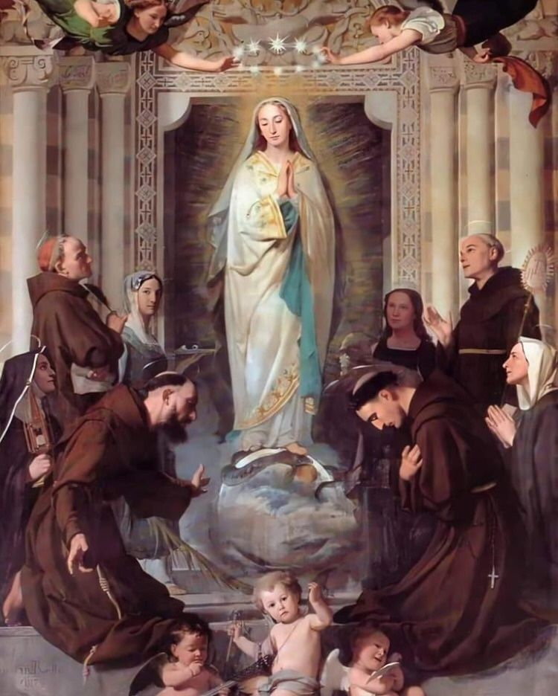
4
Next VIRTUAL Meeting: September 5th, 2020
ZOOM TIME: 10:00 a.m.
Candidates & Inquirers in Formation: Check your email from your group coordinator for details.

PLEASE continue to Wear A Mask & Wash Your Hands!
Alba ordered some F.U.N. Manuals (For Up to Now – Foundational Topics for Initial Formation). They do not come with a binder. Purchase price is $13/ea.

$$$ Continue to save money for our contribution bag!
Cash or checks made payable to: St. Maximilian Kolbe Fraternity.

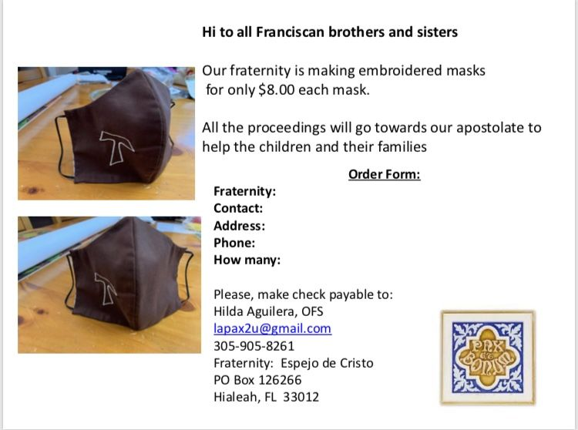

5

Every Day for PRAYER!

There are LOTS of ways to become involved. See the 8-28-20 email from secretary.StMaxSFO@gmail.com for more details.

September 1, 2020 through October 4th, 2020
Season of Caring for Creation
For a copy, reference an email from Michael Freeman, OFS on 8-31-2020

20th Quinquennial Congress
Phoenix, AZ
THIS HAS BEEN RESCHEDULED TO A FUTURE DATE
www.quinquennialcongress.org

Next Meeting will be 10-3-2020

For more specific info, see emails from secretary.StMaxSFO@gmail.com

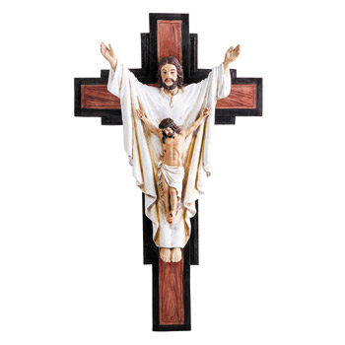
6
Gentle Spirits

“My dear brothers, take note of this: Everyone should be quick to listen, slow to speak and slow to become angry.”
James 1:19 (NIV)

Olivia is a cat with a gentle spirit. I have never seen her hiss at a dog, even one chasing her. She doesn’t demand our attention. She just quietly sits near, her very presence ushering in a feeling of calm. She was a feral foundling but showed up in our lives with this gentle spirit. She seemed to know that to have her needs met, she didn’t need to fight for everything. She just allows good to come to her.

Her manner was contagious. Dogs wreaking havoc would quickly lose interest and go to their beds and lie down. Other cats would not defend their territory because Olivia didn’t challenge them for space. She lives in the mindset that there is always enough. Peace follows Olivia wherever she goes.

I want to have more of that peace-bearing gentle spirit. Often, I have felt challenged in the workplace. People vie for a place at the top. We get jealous. We get angry. We harbor resentment. Even if we say nothing about those emotions, they show in our countenance.

When faced with confrontation of late, I have begun the practice of remaining quiet. When allowed to speak, I take my time and consider compassion before responding. Instead of reacting quickly, I take a few moments to allow God to form my sentences. I have learned that when I allow gentleness to enter the room, the confrontation usually diffuses and peace falls on heated moments. Quiet and compassionate truth always leaves the most powerful impact.

Walk of Faith: Wait on God to whisper words to our hearts when we are in conflict, so that peace can enter the room.
Author: Devon O’Day
Guideposts - All God’s Creatures
Daily Devotions for Animal Lovers

7
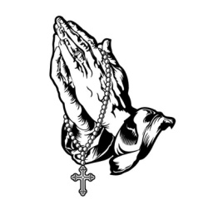
Remain in prayer for:
Healing prayers for Michael Freeman, OFS & his diagnosis of prostate cancer
Thanksgiving Prayers of healing for Alba Hernandez, OFS
Healing Prayers continue for Joan & Deacon Louis Horr
Fr. Mike requests prayers for all who have died due to COVID-19 and all who have been infected
Alan Allen, OFS: pray for all the people at my company as we wait to see who will be impacted by the upcoming layoffs.
Claire Dwyer: pray for her daughter Shannon, suffering from anxiety & depression.
For all those impacted by Hurricane Marco & Hurricane Laura
In thanksgiving for Cherryle Fruge, OFS Minister – St. Joan of Arc Region still has a house to come home to.
Dustin Greenwood, OFS had a terrible fall while hiking, sustaining several injuries.

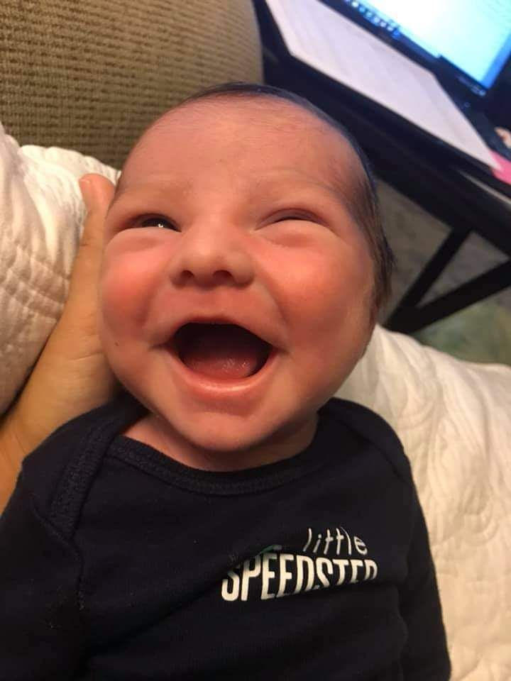
Prayer of Thanksgiving from Consuelo Davis on a safe delivery of her 2nd great-grandson on July 24th, 2020.
Jax Matthew Taxiarchou...this baby has been so alert from day one. We are thrilled!

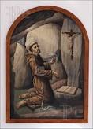 8

