Secular Franciscan Order APRIL 2020 Newsletter

The Secular Franciscan Order was established by St. Francis of Assisi more than 800 years ago. Our purpose is to bring the Gospel to life where we live and where we work. We look for ways to embrace the Gospel in our lives and try to help others to do likewise.

Remain in prayer for:
The repose of the soul of Vincent Wayne Persicano, Rachel’s grandson & prayers for the family.
Continued healing for Dexter, Phyllis Prince’s nephew & Godson
In thanksgiving for healing of Dustin & Loretta Greenwood from COVID-19. They are cleared from quarantine!
Prayers of healing for Alba Hernandez, OFS
Prayers of healing for Sandra Flake(stomach cancer), Joan Horr’s sister
Prayers of healing for Fr. Joseph, OFM (recovering from COVID-19 in Louisiana)

our Gathering
April 4, 2020
History in the Making!!! Our first ZOOM Gathering. We began with an opportunity to share about our own personal experiences with quarantine and updates on family. Many good things happening and many sad things. Thanks to Alan and Ryan for being our tour guides for those among us who are not natives but tourists in the digital world .

Mike invited us all to pray together the Opening prayer from our Ritual (pg. 35). Dora read a letter from Fr. Christopher, T.O.R. who would have been our Retreat Master at the cancelled Reginal Retreat. Discussion followed.

We then prayed in unison, St. Clare’s prayer to the Five Wounds of Our Lord. It was interesting listening to everyone reciting the prayer in their own syncopation. Dora responded that it reminded her of what Pentecost must have been like with everyone speaking in tongues, hearing with our hearts while our ears heard a cacophony of love.

This Lenten Season has allowed us to reflect on what is truly important in our lives. On the first Saturday in Lent many of us participated in Caritas Day at the Co-Cathedral .What an incredible opportunity to come together as we joined with those from throughout the Archdiocese packaging delicious and healthy meals for those in our community who benefited from the 850 pounds of beans we provided. Thank you!

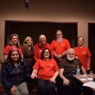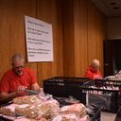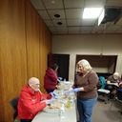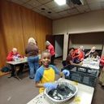

Those who were blessed to attend our day of prayer with Br. Tim Lamb on 3-7-20, gave their take on their experience and what they gleaned from the day. It never ceases to amaze me how we can all hear the same verbiage but receive just the perfect personalized message for ourselves. God is so good to speak to us individually, giving us exactly what we need.

Mike continues to email many resources for us to refer to & keep us informed, prayerful and blessed in cyber connection with one another. Thank you, Mike, for keeping us prayerfully grounded in Christ and the Franciscan walk.

Our Zoom gathering was interrupted for several of us participating via phone….an Amber alert came through and bumped them. We concluded with a prayer from our Ritual, pg.77 “The Salutation of the Blessed Virgin Mary”.

Greetings Sisters and Brothers and may the Resurrection of Christ bring you Peace!
I felt so much joy seeing and hearing from you during and after our cyberspace gathering. (despite the two headed monster that was Dora and I on the screen capture..LOL).
One thing that really struck me was something Dora said after we collectively prayed. Our microphones were unmuted, some folks praying faster, some slower. She imagined that it must have been like that on Pentecost, all different voices, united and raised up by The Holy Spirit. Beautiful.
Let us continue sharing the Gospel in our families and community as we celebrate and give thanks to everything Our Lord Jesus Christ has done for us.
Hopefully we will soon enter a time of resuming our lives with what is being called a new normal; along with a renewed appreciation of gathering in community . In this morning’s paper I saw a picture of Fr. Sean Horrigan, the pastor of Christ the Redeemer with empty pews that had pictures of parishioners!
It drives home the message…… We are The Church!
In our hemisphere Spring time brings new growth. My garden is showing promise of new creation…….pretty purplish flowers that will become eggplants, those fuzzy things that will become cucumbers , the excitement of yellow buds that are turning into small green tomatoes( that are already being consumed by bugs) .Our Liturgical Calendar within our Church also bring us opportunities for new growth.
Lent led us into the Triduum as we celebrated the mysteries of redemption. Easter season we rejoice, Light has overcome darkness, and life has triumphed over death. We move forward toward Pentecost .Let us share this new life and share it with everyone, being attentive and discerning what is ours to do.
It is my prayer that I become what I have been created for; and for all of us to gain what we were created for, Paradise……..I do not want to become that little green tomato that is so infested with bugs that I get discarded along with the weeds. Like the little tomato I need the Light, Living water, nourishment, and an environment free of creatures that attack me and weeds that choke the life out of me.
I wish I could remember so I could attribute it to them, but I read some time ago that anyone who plays music is a musician, you do not need to meet any set criteria or to be paid as a professional . We are all called to be saints, to become a Saint we need to keep practicing with the gifts our Almighty Father has given us.
Like St. Francis let us become a troubadour of the Great King. Let us give Glory and Praise to our God!
I will close by changing the beginning words to the popular prayer wrongfully attributed to St. Francis:
Lord, thank you for making me an instrument of your peace.
Peace
Michael

Next VIRTUAL Meeting: May 2nd, 2020 via ZOOM!
To be held in the COMFORT OF YOUR OWN HOME!
TIME: 10:00 a.m.
The Rite of Profession of Phyllis Prince & Eileen Ike Colleton into the Secular Franciscan Order has been rescheduled due to COVID-19. It is now set for
June 6th, 2020 to be held at the 8:15 a.m. Mass
St. Jerome Catholic Church Day Chapel
When we come together we will also be celebrating the Rite of Admission into the Secular Franciscan Order for Carla and Clare!
T-Shirts are available in many different colors. If you’re interested in purchasing one, please contact Alba. They are $20/ea. Alba ordered some F.U.N. Manuals (For Up to Now – Foundational Topics for Initial Formation). They do not come with a binder. Purchase price is $13/ea.

$$$ Since we are not meeting in person as a Fraternity, perhaps, if the Holy Spirit moves you, set aside your contribution & doubly bless our Fraternity when we eventually come together again! Cash or checks made payable to: St. Maximilian Kolbe Fraternity.

Every Day for PRAYER!
John Michael Talbot online Concert for Healing and Hope
Begins 3-31-2020 and can be viewed through April 31, 2020 Cost: $10.00

For more info, see emails from secretary.StMaxSFO@gmail.com
Dearly Beloveds,

I hope all is well with each and everyone of you! I believe I can speak for all of us when I say this is a Lent and soon to be Easter season like none other we’ve ever experienced!! However in the midst of these great challenges worldwide, I still feel optimistic about how all this will play out. After all, we know who always wins the Battle!

I am comforted often by the Lord’s encouraging messages in Scripture, “Be Not Afraid”. That has been such a stronghold of my Faith these days. I feel certain many of us have had some profound spiritual intimacies during our prayer life. Those moments also help to enlighten and sustain us Day by Day. I look forward to the day to hear such beautiful sharing of the many God moments we have been facing.

I share with you a message from the National Executive Council and they ask that we share this with every member of Fraternity especially within our Local Fraternities! Thank you!

I wish you a very Holy Triduum and a Joyful Easter Sunday!! I love you with all my heart. God Bless you Abundantly and give you Peace.

Humbly in His Presence,

Cherryle

Cherryle M. Fruge, OFS
Minister – St. Joan of Arc Region
337-438-2720
cherrylefruge@msn.com

April 9, 2020

Greetings of peace, Franciscan Brothers and Sisters,

The NEC has been keeping all of you in much prayer. We understand the need, even more so now, to stay in touch and encourage each one of you to remain strong and continue to be in touch with your Fraternities. There are ways in which to do this without being face to face. Due to what is going on in our country with the coronavirus, many meetings have been cancelled. We ask that you follow your local, regional and national officials regarding the practice of distancing.
Our Fraternities are the wellspring of our calling. Many of you are conducting Zoom meetings and phone calls, which are suggested options. Some fraternities have members who do not use a computer, so they will need frequent phone calls. Our relationships are very important, and we need to continue to develop this by frequent ‘check ups’ of our members. Some may feel isolated and need help. Let us respond with a personal call.
Our Regional Visitations and Elections have been postponed from April – May, for now. We all know this can change due to the crisis we are experiencing. We have to take one day at a time.

During this time of uncertainty, we remember what Pope Francis shared in his homily on March 27th, 2020:

“The storm exposes our vulnerability and uncovers those false and superfluous certainties around which we have constructed our daily schedules, our projects, our habits and priorities. It shows us how we have allowed to become dull and feeble the very things that nourish, sustain and strengthen our lives and our communities.

“This Lent your call reverberates urgently: ‘Be converted!’ ‘Return to me with all your heart’ (Joel 2:12). You are calling on us to seize this time of trial as a time of choosing. A time to choose what matters and what passes away, a time to separate what is necessary from what is not. It is a time to get our lives back on track with regard to you, Lord and to others.”

During this time we are experiencing, we need to come together and stay unified; stay connected with one another. We are to “reawaken and put into practice that solidarity and hope capable of giving strength, support and meaning to these hours when everything seems to be floundering. The Lord awakens so as to reawaken and revive our Easter faith.

“Embracing His Cross means finding the courage to embrace all the hardships of the present time, abandoning for a moment our eagerness for power and possessions in order to make room for the creativity that only the Spirit is capable of inspiring. It means finding the courage to create spaces where everyone can recognize that they are called, and to allow new forms of hospitality, fraternity and solidarity.”

Let us all embrace Hope and strengthen and sustain one another in the spirit of compassion, exercising patience, taking care of one another. God brings serenity into our storms because with God, life never dies.

Dear Sisters and Brothers, be encouraged as to what you are now doing in your Regions. Know that your National Council is praying for you and are here when you need to be in touch with us.

“May God’s blessings come down upon you as a consoling embrace. Lord, may you bless the world, give health to our bodies and comfort our hearts. You ask us not to be afraid…you Lord will not leave us at the mercy of the storm. Tell us again: ‘Do not be afraid’ (Matt, 28:5) and we, together with Peter, ‘cast all our anxieties onto you, for you care about us.’” (I Peter 5:7)
Pope Francis prayer of blessing to us all

We are all in this together so let us continue to stay united by our prayers and staying in touch with our Fraternities …we will weather this storm together.

God’s Blessings of trust and faith will bring His Mercy and Grace to our hearts along with His Peace.

We are your humble servants,
Lord make us instruments of your Peace…where there is doubt, faith…
Where there is darkness, light.

Fraternal love, your National Executive Council and Commission Chairs,

Jan, Mary, Jane, Claudia, Donna, Josh, Dennis, Willie, Fr. Christopher,
Diane, Carolyn and Kathleen
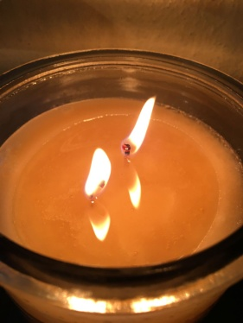 The following was sent by our Regional Formation Director Cynthia.
Pray - Learn - Reflect

San Damiano Cross

Reflections on The Cross of San Damiano
By Patrick McNamara, OFM,Cap.

I look to the Cross, I gaze upon its figure,
I wait, I listen, I hope.

Will you speak, will you move, will I be moved.

Will you once again touch the heart of one who seeks.
Of one who questions, of one who seems so lost.

Will you embrace the soul, as you did that of Francis.
Will you take it to Yourself.

Will you give it peace, give it comfort, give it love

This soul waits, listens, prays for such grace.
This soul seeks the Love from the Lover.

It wavers. It stumbles. It falls.

Your gaze looks down, embraces all.
Takes all, Loves All. Your Grace heals, accepts.

Again you respond, Again you Love.
Again you speak to a searching and troubled heart. I turn.
I continue the journey. I continue in Hope.
I too have heard you Speak.

Read about the San Damiano Cross
https://secularfranciscansusa.org/wp-content/uploads/The-San-Damiano-Crucifix-8-page-explanation.pdf

Diane F. Menditto, OFS
Chair, National Formation Commission
Minister, Our Lady of the Angels Region

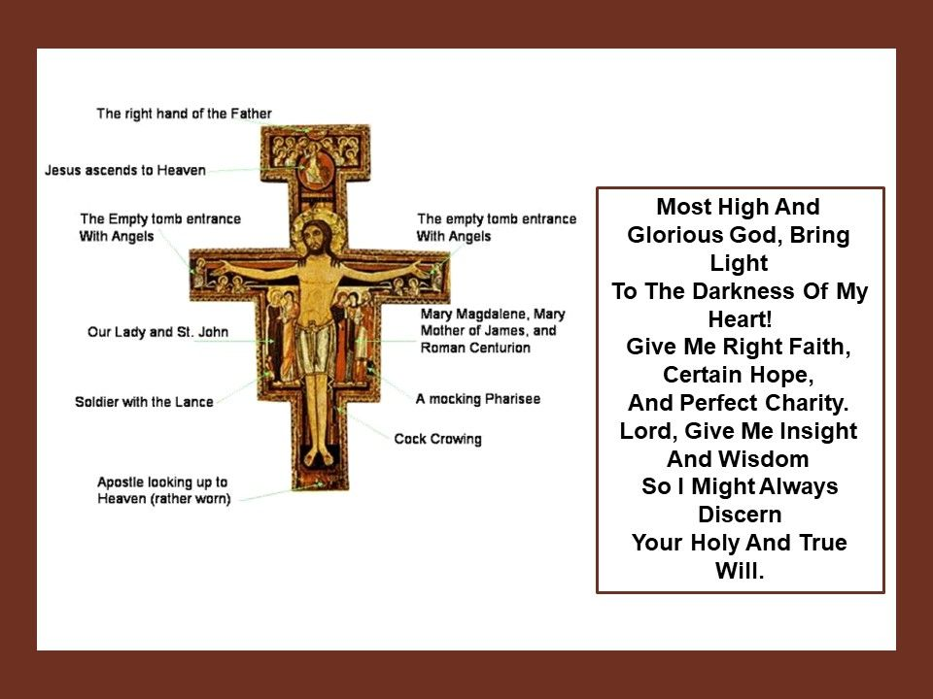

About as Big as a Basketball

Always be prepared to give an answer to everyone who asks you to give the reason
for the hope that you have. 1 Peter 3:15 (NIV)

My daughter and I visited the local pet store, searching for just the right pet for her tenth birthday. We considered a guinea pig or a hamster. The lop-eared rabbits caught her eye, but they required more living space than we had available. Then, as she rounded the corner into the bird room, she spotted a creature she’d never seen before. Tucked between a cockatiel and an African grey was a baby hedgehog. Big eyes, black nose, and quills sprouting from everywhere made her laugh in delight.
Certain she’d found the pet of her dreams, she asked the salesman, “How big will he get?” Before he could respond, the African grey beside her squawked, “About as big as a basketball.” Apparently, the fast-talking parrot had heard the question (and the answer) often. So often, in fact, it had memorized the response, recalling and sharing it appropriately.
As Christians, we should be just as quick to answer when someone asks us questions about life and faith. The apostle Peter exhorts us always to be ready to share the hope we have in Christ. To do so, we must become so familiar with common questions and their biblical answers that they pop out naturally. Spending time daily in God’s Word and learning as much as we can will make it easier to share what we know with others.
My daughter didn’t leave the pet shop that day with a hedgehog, but our time wasn’t wasted. I came away with a powerful reminder of how to be a better witness for Christ.
- Lori Hatcher

Father, help me become a student of your Word. Then give me the courage
and boldness I need to share with others the hope I have in Christ. In Jesus’s name I pray. Amen

Guideposts - All God’s Creatures
Daily Devotions for Animal Lovers

