Secular Franciscan Order July 2018 Newsletter

“In our individualistic society, structural sin is accepted as good and necessary on the corporate or national level. Large companies, churches, and governments get away with and are even applauded for killing (war), greed, vanity, pride, and ambition. The capital sins are rewarded at the corporate level but shamed at the individual level. This is our conflicted Christian morality! Instead of legitimating the status quo, liberation theology tries to read history and the Bible not from the side of the powerful, but from the side of the pain. Its beginning point is not sin management, but “Where is the suffering?” The world tends to define poverty and riches simply in terms of economics. But poverty has many faces – weakness, dependence, and many forms of humiliation. Essentially, poverty is a lack of means to accomplish what one desires or needs, be it lack of money, relationships, influence, power, intellectual ability, physical strength, freedom, or dignity. God hears the cry of the poor. And we, created in God’s image and likeness, must do the same to be like God.”
Excerpt from Fr. Richard Rohr’s Daily Meditation 6-24-18

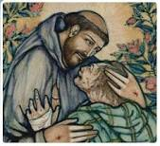

July Meeting Minutes!
July 7, 2018 Fraternity Meeting was held in The Outback at St. Jerome Catholic Church. We began the meeting with Dora Freeman, OSF leading us in Office of Readings. It is such a beautiful community prayer & due to the participation, it sounded like more of us are getting the hang of it! Sophia Lee, OFS prayerfully read the Candle lighting remembering past, present & future Fraternity members. Alba Hernandez, OSF read a short meditational prayer & floor was open for comments. Our Spiritual Advisor, Fr. Mike Van Cleve just returned from a private retreat in Colorado. He shared that the emphasis of the retreat was Centering Prayer only to return to Houston just in time to attend the LifeTeen Retreat. “It was an interesting transition from silence to boisterous teens, he said with a chuckle. Dora Freeman, OFS then gave an informative talk on our Franciscan Rule. Last month we discussed Chapter One, paragraphs 1 & 2. This month she shared on paragraphs 3, 4 & 5. There was a lot of heartfelt sharing & thoughts to ponder further given to us for our personal enlightenment. Our Fraternity has been blessed with so much wisdom. To hear sharing from the heart is a joy as it proves we are devoting our lives to “going from gospel to life & life to the gospel”. Alba Hernandez, OFS read an excerpt about the 40th Celebration of the 1978 Rule. We took a short break, enjoying all the delicious goodies people brought to share, then back to the meeting. Mike Freeman, OSF & Dora Freeman, OSF shared about their experiences of attending World Refugee Day Houston on 2-20-18. Our Mayor Sylvester Turner gave a moving speech along with several other speakers. There was a variety of panel members who opened the floor for questions. Considering it was a torrential downpour of rain, the event was well attended. Alba Hernandez, OFS explained the Fraternity would no longer be handing out envelopes for people to contribute money to the Fraternity but instead, a box would be placed on the head table for members to insert donations. A copy of the budget & monetary needs of the Fraternity will be sent to all. It is requested that we each prayerfully look over our budget & determine with the Holy Spirit’s discernment, how much we can afford to share. Individual contributions will not be tracked & no set amount is required. Donations should come from the heart with the Holy Spirit’s guidance. The closing prayer was offered & meeting was adjourned. Many stayed after to fill the plastic bags with the items we brought to share with the people temporarily housed at Casa Juan Diego.

June 2, 2018 Fraternity Meeting was held in The Outback at St. Jerome Catholic Church. It was beautifully done and most thought provoking. We began with our Opening Prayer. Joseph Swonke, OFS led us in the Office. Martha Restrepo, OFS prayerfully read the Candle lighting remembering past, present & future Fraternity. Dustin Greenwood shared an excerpt from “The Simple Way” by Fr. Murray Bodo, OFM followed by a short meditation which opened up an insightful discussion. We then had a mini-teaching by Dora Freeman, OFS on The Rule of the Secular Franciscan Order, enhancing the discussion with thoughts from “Pick More Daisies” – Ongoing Formation for Secular Franciscans by Lester Bach, OFM, Cap
Two things are necessary to be a true Franciscan:
1) The Gospels
2) Community
Personal sharing’s along with lots of discussion followed. In this Jubilee Year of celebrating 40 years of our Rule we will be covering our Rule in its entirety. It was all so interesting that we only had time to talk about Our first and second Rule.
The floor was opened up for personal sharing on our recent retreat in Louisiana. It was interesting to hear what others gleaned from their time with other Fraternities.
World Refugee Day is coming on June 20, 2018. There are multiple opportunities for us to be witnesses to the Gospel.
Michael spoke with Louise Zwick @ Casa Juan Diego and found out they have many ongoing needs. Our Fraternity agreed to donate by creating bags of goods consisting of toiletries, socks underwear and flip flops for the numerous refugees who cross their doorstep. More information to come on creation and distribution of the bags as we plan to do this quarterly. Michael will share at Regional and perhaps others will participate.
Our closing meditation was a beautiful Prayer and Intentions taken from CRS and USCCB for World Refugee Day 2018 that fit perfectly with our Franciscan charism to help the poor. Our closing prayer was from our Ritual of the Secular Franciscan Order. We adjourned to enjoy delicious goodies provided by generous members. Bon appétit – YUM!
PAX ET BONUM

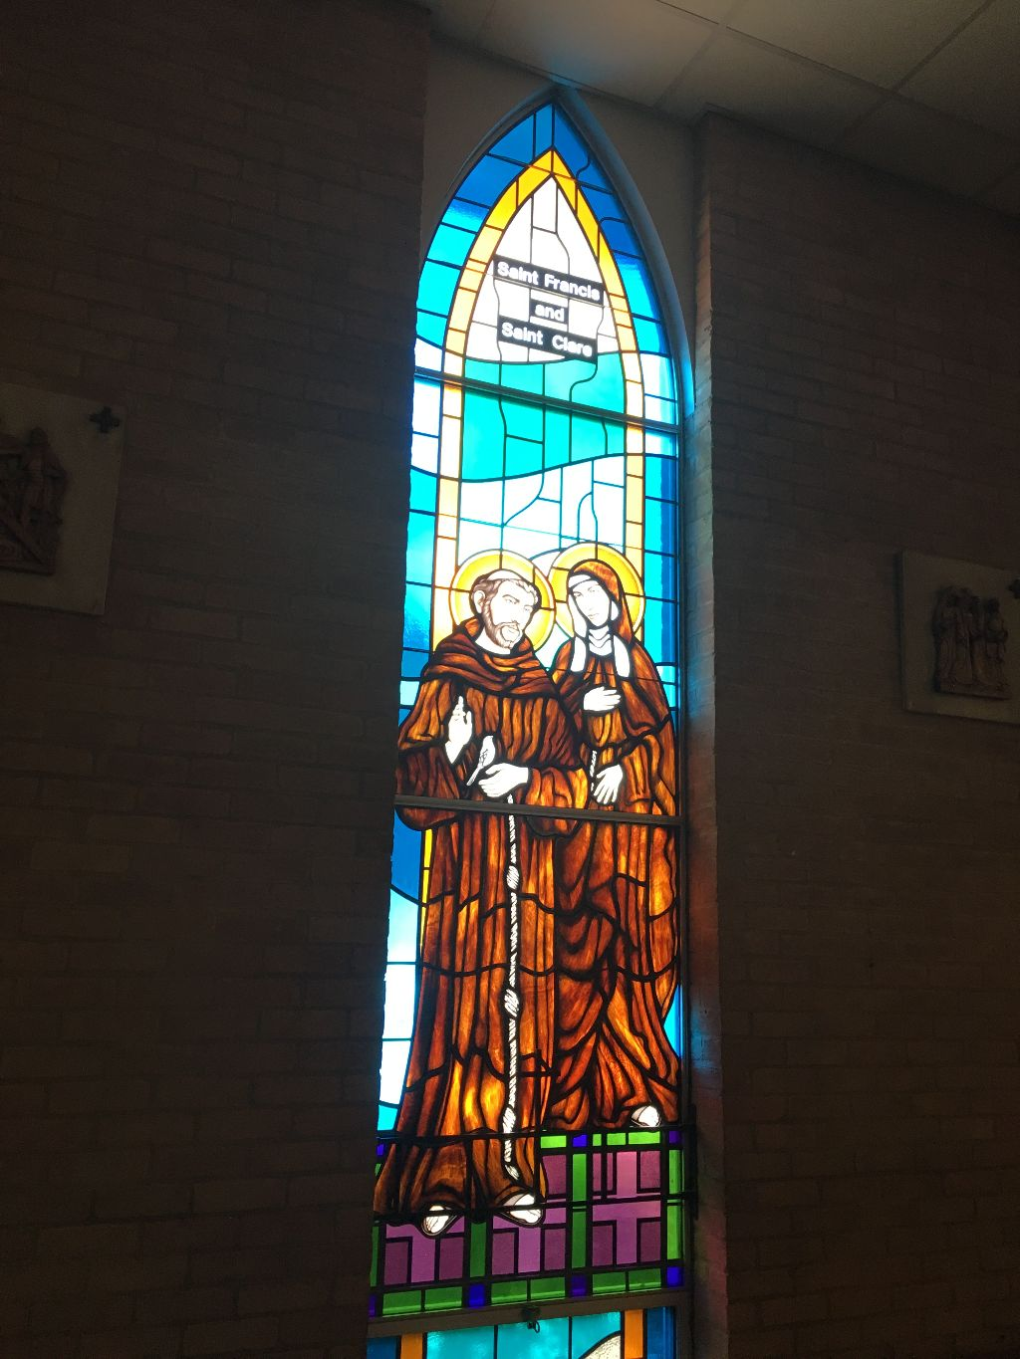
Our heartfelt condolences to Ryan Efaw, OFS on the death of his Grandmother, Joyce Alene Telschow Cipolla 1927-2018. A beautiful Funeral Mass was celebrated on June 26th. It was a true celebration of a life well lived! The picture on the right was taken that day. It was fitting that St. Francis and St. Claire were so vividly represented with the light of the sun illuminating their presence.
Receive her soul and present her to God most high. Eternal rest grant unto her, O Lord, and let perpetual light shine upon her. May her soul and the souls of all the faithful departed, through the mercy of God, rest in peace.

Stained Glass Window from St. Patrick’s Catholic Church, Houston.

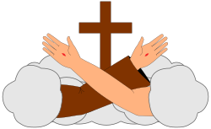

We are so blessed to live in a city as beautiful and diverse as Houston. My family were immigrants who fled the horror of the potato famine which had been orchestrated by a foreign government. Our great nation was built by the blood sweat and tears of immigrants who were forced to deal with discrimination and inhumane conditions; yet our family units were not destroyed as they were with the genocide of our indigenous people, the slave trade and the recent “zero tolerance” policies. Immigrants have proudly served our nation in both World Wars, Korea, Viet Nam, and all of the other arenas of the late 20th and 21st century. One of the speakers at the World Refugee Day event was a former refugee from Viet Nam who came to Houston as a youth. He graduated high school, joined the United States Marine Corps, and is now a principal at one of our high schools in southwest Houston that has students from 78 different countries! In recent years Houston has had the leadership that has been welcoming. After Katrina our mayor did not have a plan in place to shelter the evacuees from New Orleans; yet we welcomed the evacuees with open arms! God calls us to serve and if we let the Holy Spirit animate us we will know what to do. Jesus, I Trust in You !
The Third Pillar of our Catholic Church found with the Catechism is Christian Morality: The Faith Lived .We read “The most basic principle of the Christian moral life is the awareness that every person bears the dignity of being made in the image of God”
As Franciscans this is interwoven throughout all of our Essential Documents and is also what J.P.I.C. is all about. As we go about our secular lives do we have the courage to freely speak Gospel values, or worse yet, do we distort them? Our Church is not a Church that ignores human suffering, nor is it a Church that one can choose from an a la carte menu of which teachings we find comfortable.

Like Francis we are to rebuild the Church . We must do it one person, one stone at a time. Murray Bodo, OFM wrote in his book The Way of Francis:
“If our following of Saint Francis is basically medieval at heart, then we have failed to do in our lives what Francis did in his. Saint Francis was a postconciliar man putting into practice and implementing the decrees of Lateran Council IV, one of the great reform councils of the Church. He made the gospel ring true for his own times, which is basically what any renewal in the Church is all about.
The gospel of Jesus Christ is eternal, and when it is no longer applicable, then the fault is in us who have not made the painful journey into ourselves and into our times to rediscover God’s present Incarnation. To try to imitate Francis rather than listen to the Lord in our own time as he did in his only stops time and absolves us from restoring God's house, which is once again falling into ruin. What are the stones that will restore it, and who is the one who will listen and not be ashamed to beg, and what is the house of God?
When we try to answer these questions by looking around us rather than looking only to the past, we begin in our own time and place, and we begin to hear God’s voice here and now. It is clear and unmistakable; it is the word enfleshed in our world.”
We are blessed to be living in a period following another great reform council, Vatican 2. We are no longer in the Middle Ages. Vatican 2 made it clear that all of us are the Church, we are one body, We are to care for one another as the Shepherd cares for the Flock .Like Francis who was afraid of the lepers until he embraced them; we are called to see Christ in all, even if they scare us. If we listen we will begin to here Gods voice.
We hear His voice; crying at the border; crying from the abortion factories; crying from death row.
“Passion of Christ, Strengthen Me”

Peace
michael

Next Meeting: August 4th, 2018 in the Outback @ St. Jerome Catholic Church beginning 10:00 a.m.
Early Birds: An opportunity to join together in The Holy Mass in the day chapel @ St. Jerome beginning 8:15 a.m.
Candidates and Inquirers Formation begins @ 9:00 a.m. in the Outback

Fiesta Franciscana is again happening and it will be October 13, 2018 at the San Jose Mission (different spot than last year). Registration forms, etc. are not available yet....but mark your calendars for October
13th. It would be fun to all stay in the same hotel. Several of us have reserved a room at Embassy Suites by Hilton. 7610 South New Braunfels, San Antonio, TX 78235. (210) 534-1000. Present pricing: $173 with 2 queen beds. Cancellations can be made if something else more affordable or closer to the retreat site is found.
Booking now with a refundable deposit will guarantee we can all stay in the same place!

********

For those unable to make the road trip to San Antonio, David Schubert, OFS is involved in an organization RESULTS Educational Fund that is hosting a fundraiser

“The Seeds of Hope Benefit Dinner”.

WHEN: Friday, October 12th, 2018
TIME: 7:00 p.m.
PLACE: Junior League, 1811 Briar Oaks Ln., Houston, TX 77027
COST: $150.00
Stay tuned as there will be a future online website to sign up to attend or just make a donation of your abilities. RESULTS is a movement of passionate, committed everyday people using their voices to influence political decisions that will bring an end to poverty.

Mercy & Mary Retreat
WHEN: Friday, October 19, 2018 7:15 pm – 8:15 pm
Saturday, October 20, 2018 7:45 am – 4:30 pm
WHERE: St. Theresa Catholic Church – Austin, TX
SPEAKER: Fr. Michael Gaitley, MIC, author of 33 Days to Morning Glory
CONTACT: Marian Missionaries of Divine Mercy (413) 944-8500, ext# 10
EMAIL: events@marianmissionaries.org

St. Thomas More Fraternity is hosting a “Franciscan Retreat Day” Saturday, November 17th, 2018 from 9:00 a.m. to 4:00 p.m. in Houston. FREE OF CHARGE
Topic: From Gospel to Life within the Franciscan Charism
Retreat Master: Fr. Bernie Tickerhoof, TOR from Pennsylvania.
For more info on Fr. Tickerhoof, go to: http://www.franciscanstor.org/btickerhoofBIO/

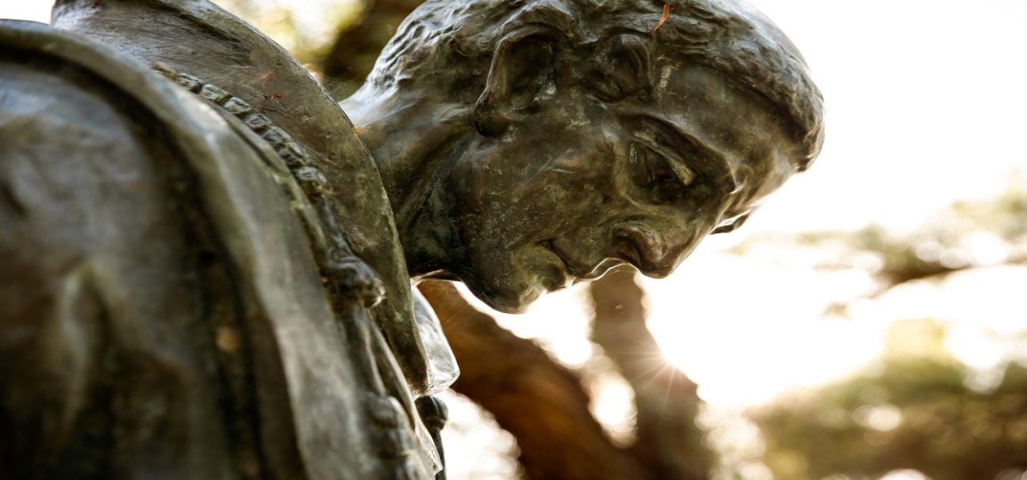

Saint Junipero Serra

Saint of the Day for July 1

(November 24, 1713 – August 28, 1784)
https://www.franciscanmedia.org/wp-content/uploads/2016/08/SODJul01.mp3

Saint Junipero Serra’s Story
In 1776, when the American Revolution was beginning in the east, another part of the future United States was being born in California. That year a gray-robed Franciscan founded Mission San Juan Capistrano, now famous for its annually returning swallows. San Juan was the seventh of nine missions established under the direction of this indomitable Spaniard.
Born on Spain’s island of Mallorca, Serra entered the Franciscan Order taking the name of Saint Francis’ childlike companion, Brother Juniper. Until he was 35, he spent most of his time in the classroom—first as a student of theology and then as a professor. He also became famous for his preaching. Suddenly he gave it all up and followed the yearning that had begun years before when he heard about the missionary work of Saint Francis Solano in South America. Junipero’s desire was to convert native peoples in the New World.
Arriving by ship at Vera Cruz, Mexico, he and a companion walked the 250 miles to Mexico City. On the way Junipero’s left leg became infected by an insect bite and would remain a cross—sometimes life-threatening—for the rest of his life. For 18 years, he worked in central Mexico and in the Baja Peninsula. He became president of the missions there.
Enter politics: the threat of a Russian invasion south from Alaska. Charles III of Spain ordered an expedition to beat Russia to the territory. So the last two conquistadors—one military, one spiritual—began their quest. José de Galvez persuaded Junipero to set out with him for present-day Monterey, California. The first mission founded after the 900-mile journey north was San Diego in 1769. That year a shortage of food almost canceled the expedition. Vowing to stay with the local people, Junipero and another friar began a novena in preparation for St. Joseph’s day, March 19, the scheduled day of departure. On that day, the relief ship arrived.
Other missions followed: Monterey/Carmel (1770); San Antonio and San Gabriel (1771); San Luís Obispo (1772); San Francisco and San Juan Capistrano (1776); Santa Clara (1777); San Buenaventura (1782). Twelve more were founded after Serra’s death.
Junipero made the long trip to Mexico City to settle great differences with the military commander. He arrived at the point of death. The outcome was substantially what Junipero sought: the famous “Regulation” protecting the Indians and the missions. It was the basis for the first significant legislation in California, a “Bill of Rights” for Native Americans.
Because the Native Americans were living a nonhuman life from the Spanish point of view, the friars were made their legal guardians. The Native Americans were kept at the mission after baptism lest they be corrupted in their former haunts—a move that has brought cries of “injustice” from some moderns.
Junipero’s missionary life was a long battle with cold and hunger, with unsympathetic military commanders and even with danger of death from non-Christian native peoples. Through it all his unquenchable zeal was fed by prayer each night, often from midnight till dawn. He baptized over 6,000 people and confirmed 5,000. His travels would have circled the globe. He brought the Native Americans not only the gift of faith but also a decent standard of living. He won their love, as witnessed especially by their grief at his death. He is buried at Mission San Carlo Borromeo, Carmel, and was beatified in 1988. Pope Francis canonized him in Washington, D.C., on September 23, 2015.

Reflection
The word that best describes Junipero is zeal. It was a spirit that came from his deep prayer and dauntless will. “Always forward, never back” was his motto. His work bore fruit for 50 years after his death as the rest of the missions were founded in a kind of Christian communal living by the Indians. When both Mexican and American greed caused the secularization of the missions, the Chumash people went back to what they had been—God again writing straight with crooked lines.

