Secular Franciscan Order May 2021 Newsletter

The Secular Franciscan Order was established by St. Francis of Assisi more than 800 years ago. Our purpose is to bring the Gospel to life where we live and where we work. We look for ways to embrace the Gospel in our lives and try to help others to do likewise.

Come Holy Spirit, fill the hearts of your faithful and enkindle in them the fire of Your love. Send forth Your Spirit and they shall be created. And You shall renew the face of the earth. O, God, Who by the light of the Holy Spirit, did instruct the hearts of the faithful, grant that by the same Holy Spirit we may be truly wise and ever enjoy His consolations, through Christ Our Lord. Amen!

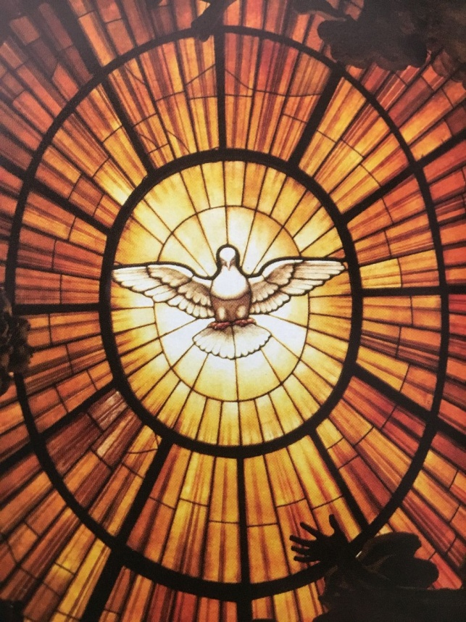

1.
Our Gathering

On May 1st. we met in person! What a Holy group of people, a sight for sore eyes for sure! It was good to see so many of you! Of the 23 possible electors we had 19! Thanks to everyone who came as elections are necessary for our continued growth. We even had a former member who drove over from Austin to be with us on this joyful day. Great to see you, Valerie!

Brother Dan Barrett, OFM who is our Regional Spiritual Assistant drove in from New Orleans, LA to be our Friar Witness for this election. Tom Ha, OFS who is on our Regional Council was the delegate for the St. Joan of Arc Region and served as our Presider. He is a member of the St. Elizabeth of Hungary Fraternity based here in Houston; which is made up of our Korean Sisters and Brothers. Both graciously came to preside over our Celebration of the Fraternity’s Chapter of Elections.

Rachel Persicano led us in the Candle Prayer as we remembered all past, present (including those who can no longer participate due to health) and future members of our Franciscan family.

Tom invited us to participate by turning to page 41 in our Ritual book.

Andy Arnett stood in as an official witness to the proceedings. Karen Parsons, Claire Dwyer & Martha Restrepo all participated in the voting process to insure all eligible members of the St. Maximilian Kolbe Franciscan Fraternity received ballots & that their ballots were all accounted for & tallied accurately.

Congratulations to our Newly Elected Council for 2021-2024

MINISTER: Alan Allen, OFS
VICE MINISTER: Ryan Efaw, OFS
SECRETARY: Eileen Ike Colleton, OFS
TREASURER: Phyllis Prince
FORMATION DIRECTOR: Cindy Borgerding
COUNCILOR 1: Michael Freeman
COUNCILOR 2: Fabiola Cespedes

Brother Dan gave a very moving message on St. Joseph the Worker; how important & integral we are to one another. We all need to remain active in service to our Fraternity, to our Catholic Church & to God’s beautiful world. Decisions must be made prayerfully & prudently as we keep all creation in mind.

We then sang a stanza from “All Creatures of our God and King”, and continued with the Rule Book page 42 to end the Gathering. It was time then for photo ops. Smile!

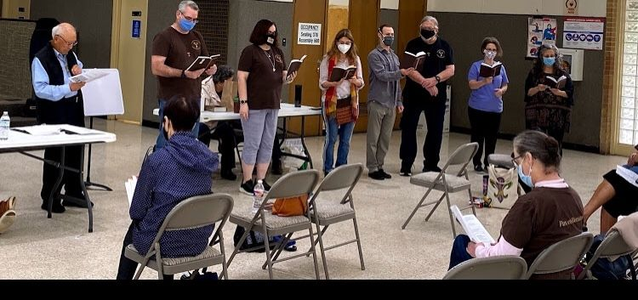
2.

Greetings Sisters and Brothers
May the Peace of Christ be with you all! Thank you again to everyone who was able to attend the May meeting in person. It was wonderful to see so many faces in person. While technology is great and has helped us to stay connected through these very unusual times, I am thankful to start seeing people in person again. This was especially important for our May meeting as we held our fraternity elections. I want to say, “Thank you!” to all of the new council members who said “Yes!” to being leaders in our fraternity: Phyllis Prince, Eileen Colleton, Cindy Borgerding, and Fabiola Cespedes Pena. Thank you also to our returning council members Mike Freeman and Ryan Efaw for their continued willingness to serve the fraternity.

I also want to say, “Thank you!” to all of the outgoing council members who have served the fraternity so well over the past 3 plus years: Amy Le, Alba Hernandez, Dora Freeman, and Joe Swonke. Also, thank you to David Schubert for his leadership as the JPIC Animator. We appreciate all of your contributions! Finally, though by no means last, thank you also to Fr. Mike Van Cleve for continuing on as our Spiritual Assistant and Danny Marquer taking on the role as our JPIC Animator.

For the opening reading at our first council meeting we read the following from the Unconfirmed Rule of 1221.

Therefore, all my brothers, let us be very much on our guard so that we do not lose or turn away our mind and heart from the Lord under the guise of (achieving) some reward or (doing) some work or (providing) some help. But in the holy love which is God (cf.1 Jn 4:16), I beg all (my) brothers, both the ministers and the others, as they overcome every obstacle and put aside every care and anxiety, to strive as best they can to serve, love, honor, and adore the Lord God with a clean heart and a pure mind, for this is what He desires above all things.
The Unconfirmed Rule of 1221 (22:25-26)

The message of this passage helped to frame up for us, the council, how our minds and hearts should be dispositioned as we take on our new roles. However, as I’ve reread and prayed on this passage I think it also speaks to how we, as Christians and Franciscans, ought to approach all activities in our lives.
All Blessings and Peace,
Alan

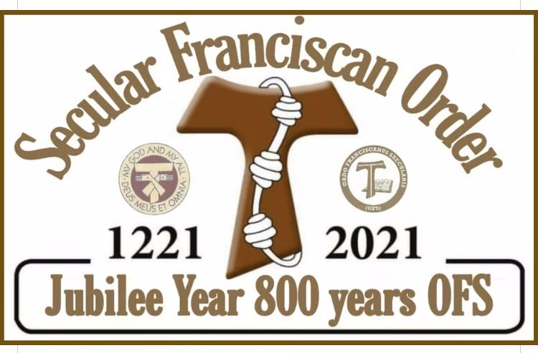

3.

Next Meeting: June 5th, 2021
10:00 a.m.IN PERSON & ZOOM.
Candidates & Inquirers in Formation: check your emails for more information
Our Gathering will be IN PERSON & ZOOM

Joan Horr is home under Hospice Care to allow Deacon Louis extra help in caring for Joan as her condition has deteriorated. Continue to lift both Deacon Louis & Joan Horr up in prayer.

$$$ Continue to save money for our contribution bag! Bring cash or checks.
Checks made payable to: St. Maximilian Kolbe Fraternity.

A Spanish version of the TAU-USA is now available and being mailed to Spanish speaking members upon request. Email your name, address, fraternity name & region name to:
Cindy Wesley OFS, cw93444@gmail.com Or mail request to:
Cindy Wesley OFS
846 Calimex Place
Nipomo, CA 93444

4.

Every Day for PRAYER!
Living Franciscan Virtues in our Contemporary World
Secular Franciscan VIRTUAL Conference
June 28 – July 1, 2021
$50.00
Stbonavenue.com
jmsmith@sbu.edu.

Greater than a Mother’s Love Retreat
August 20-22, 2021
Cedarbrake Retreat Center
Temple, Texas
Diocese of Austin
cedarbrake@austindiocese.org

There are LOTS of ways to become involved.
Reference emails from secretary.StMaxSFO@gmail.com and emails from
Alan @ caallen70@gmail.com for specifics!

July 2021 Meeting will be 7-3-2021

Read the Bible! It’s full of Light for your Soul
5.
The Beauty of a ….. Skunk?

“He has made everything beautiful in its time.”
Ecclesiastes 3:11 (NIV)

The park was almost eerily empty as my family and I rounded a corner alongside the river. That’s when we spotted a glistening ball of black and white – a skunk making its way toward a stone wall.

Surprisingly, my first thought wasn’t to run in the opposite direction (though that was my very close second!). The first impression I had of this creature was not one of fear but one of awe. I hadn’t had many close encounters with living skunks, and I was struck by the beauty of this animal – the clean white stripes running between shining black along its back. The fur that looked soft . . . and definitely not smelly.

Because we knew better than to chase after skunks – even beautiful, clean-smelling ones – we made a wide circle, hoping to catch a glimpse of this skunk on the other side of the stone wall. But it was nowhere in sight, probably just as wary of us as we were of the little creature.

As we walked toward our car, I thought of the many nuances and often surprising beauty of God’s creation, of how if I could but look with eyes not previously disposed to judgment, I might find so much more beauty. I thought of a bee that doesn’t just sting but makes honey and is gorgeous in its own right, a spider with the ability to weave delicate webs, or a skunk with a brilliant black-and-white coat that glorifies our Lord.

I wonder—if I were better able to see God’s creation in this light, would I see humanity better as well? Could I learn to appreciate the gifts of my fellow human beings instead of being so quick to jump to judgment? I think of that skunk often—a gift in the most unexpected of creatures.

Father, give us eyes to look for beauty and grace instead of judgment and cynicism.
May You be glorified. Amen.
Author: Heidi Chiavaroli
All God’s Creatures January/February 2021
Daily Devotions for Animal Lovers
A Guidepost Publication
6.
Healing prayers for Michael Freeman & his diagnosis of prostate cancer

Healing prayers for Alan Allen’s 90 yr old Mother-In-Law who had cholecystectomy 3-30-21 & for strength for his Father-In-Law, his wife & her sister. May Alan be given the wisdom words & peace to comfort all his family.

Continued healing prayers for Dori Ellis. She’s home, waiting for all the doctor follow-up visits

Healing Prayers continue for Joan & Deacon Louis Horr. Joan goes into Hospice Care June 1st @ home.

Kathy Kellen requests healing prayer for her daughter-in-law’s brother Mark Mosmen who has been diagnosed with pancreatic cancer that’s spread to his liver & lungs.

Claire Dwyer: pray for her daughter Shannon, suffering from anxiety & depression.

In thanksgiving for Alan Allen’s new job & steady employment!

Pray for continued success for the ministry of YouFra.

Ryan Efaw, Caitlyn & child: Expected due date has come & gone! Pray for good health for mother, child and of course, daddy!

Pray for all Priests and Seminarians throughout the world.

Fabiola requests prayer for her Confirmation sponsor Ian & his elderly parents. Both mum & dad are doing better. Mum is home from hospital, dad’s been diagnosed with vascular dementia & treatment begins but is happy his wife is home.

Continue to pray for Mary Pierson & family as they work through their grief.

Pray for Benjamin Joseph Turk: Thyroid is all clear! PTL! Turns out there was only 1 cyst & 1 nodule, both nothing to worry about. He has resigned from his job, last day is 5-28-21. Pray for clarity in future decisions.

Pray for Shelley Barger & GG who are both using scooters, unable to walk. Shelley will be undergoing scans at the hospital. Pray outcome will be a favorable one.

Pray for Carla Lewton’s mother Barbara who has been steadily declining. Pray family will find a wonderful healthcare facility that will be agreeable to Carla, her two brothers & Barbara.

Pray for our new Council, for the Holy Spirit to guide them & give them the wisdom they’ll need to fulfill their elected positions with a true Franciscan Spirit.

Remember to email Ike ecolleton@comcast.net for prayer requests & updates to be included in Newsletter

Make sure you make room in The Rule for THE RULER!

7.

Once Upon A Time…..
The Lie said to the Truth, “Let’s take a bath together; the well water is very nice.” The Truth, still suspicious, tested the water and found out it really was nice. So they got naked and bathed. But suddenly, the Lie leapt out of the water and fled, wearing the clothes of the Truth. The Truth, furious, climbed out of the well to get her clothes back. But the World, upon seeing the naked Truth, looked away, with anger and contempt. Poor Truth returned to the well and disappeared forever, hiding her shame. Since then, the Lie runs around the world, dressed as the Truth, and society is very happy…. Because the world has no desire to know the naked Truth.

Funeral Mass for
Gabriel Harkay, OFS
Saturday April 17th, 2021 @ 1:30 p.m.
Prince of Peace Catholic Church (Mary Chapel)
19222 Tomball Parkway – Houston, TX 77070
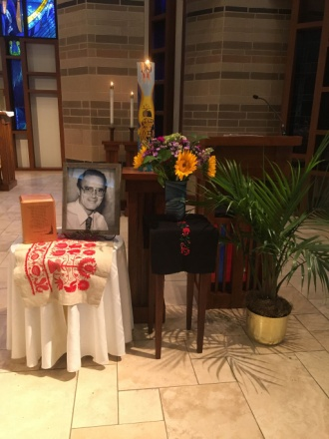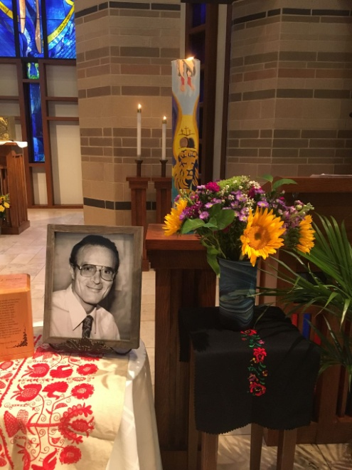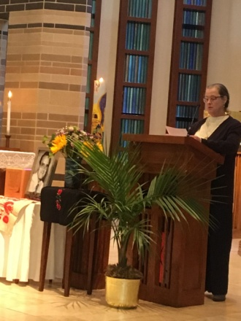
Dora Freeman, OFS lead us in the beautiful Franciscan Creed of the Resurrection
from Immaculate Conception Fraternity

8.
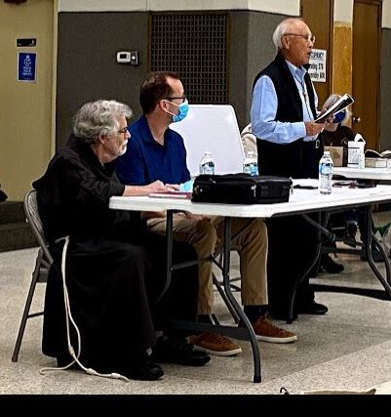
Brother Dan Barrett, OFM , Andy Arnett, Tom Ha, OFS

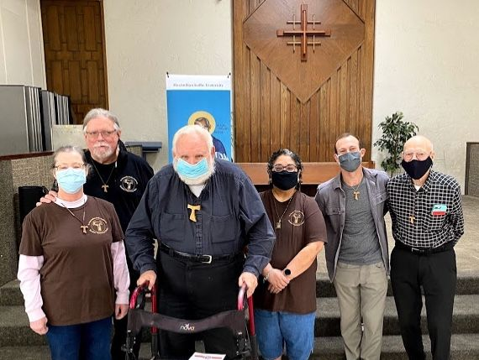
Dora & Mike Freeman, Fr. Mike Van Cleve, Alba Hernandez, Ryan Efaw, David Schubert

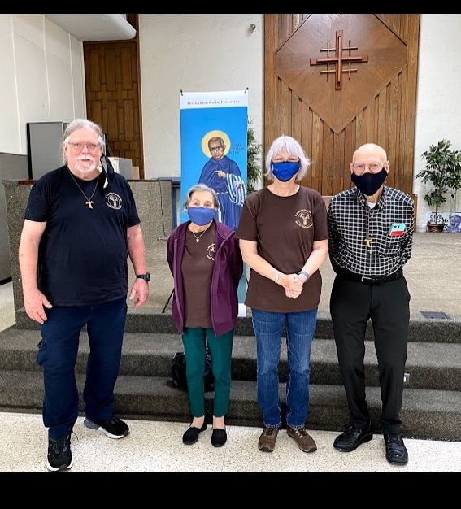
Mike Freeman, Rachel Persicano, Karen Parsons, David Schubert

9.
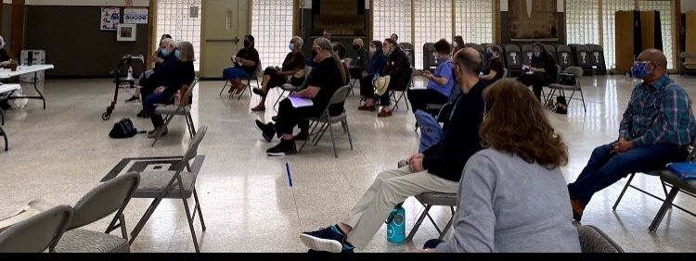

As you can see, nice turnout for our 2021 Celebration of the Fraternity’s Chapter of Elections!

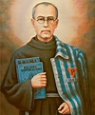

10.

