Secular Franciscan Order JUly 2019 Newsletter

The Secular Franciscan Order was established by St. Francis of Assisi more than 800 years ago. Our purpose is to bring the Gospel to life where we live and where we work. We look for ways to embrace the Gospel in our lives and try to help others to do likewise.

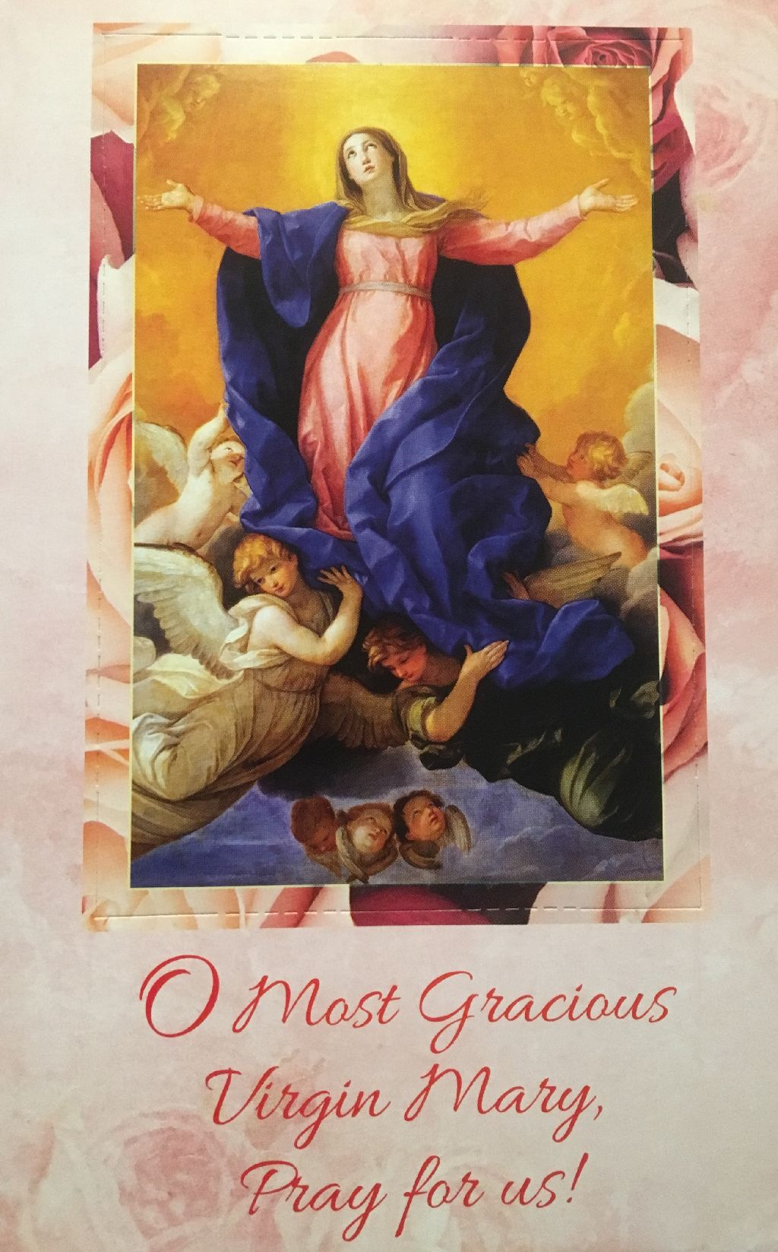
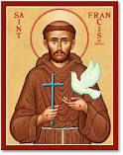
our Gathering
July 6th, 2019 Karen Parsons, OFS shared with us about a Seaman’s distressing situation in which she had to intervene on behalf of the Church. It brought home how many of those in positions of power as well as those charged with enforcing laws that govern immigration no longer show compassion, and not just on the Mexican border. We are cautioned to stay alert to those who refuse to recognize the inherent dignity of all. We must do what we can to love all our neighbors and pray for the wisdom and courage to address injustice when it rears its ugly head.

Joe Swonke, OFS led our gathering in praying The Liturgy of the Hours. Barbara Landry, OFS led our candle prayer for the three orders of our Franciscan Family; past, present and future. Michael Freeman, OFS lead us in our opening prayer from the Ritual of the Secular Franciscan Order, page 35.

Mike shared an audio presentation on Blessed Fr. Solanus Casey, OFM, Capuchin.
Born 11-25-1870 & died 7-31-1957. He was Beatified 11-18-2017. It was rich in thought provoking ideas. Our discussion was heartfelt. A few thoughts that surfaced: (external trappings are not the substance of holiness) (fool’s gold is beautiful and can attract & trick many into believing it is real. When the surface is scratched, its false identity is revealed. What happens when my surface is scratched? What is revealed?)

Dora Freeman, OFS led us in praying the Franciscan Family Chaplet prayer.

Michael Freeman, OFS led us in the Closing Prayer from the Ritual of the Secular Franciscan Order, page 36.

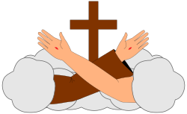
24/7
I have become more aware of all the things I have to be grateful for thanks to our Loving and Merciful Father. I am blown away by the workings of the Holy Spirit when we slow down and listen to what we are being called to be and do .I read somewhere that Franciscans are not made, they are born .We have been given this beautiful gift of our Franciscan Charism. We know that the primary agent of formation is the Holy Spirit, followed by ourselves and then the entire fraternity and formation director. We do not only belong to our fraternity here in Houston, Texas, but also to our Regional Fraternity, the National Fraternity, and the International Fraternity. This gift does not manifest only once a month, we are called to be Franciscan 24 hours a day, seven days a week. What we do with it becomes our own individual responsibility. We are Secular Franciscans and when we become candidates we are given the distinctive sign of our Order, the TAU. I remember the first time I saw Brother Juniper when he came to our fraternity. I do not remember if it was during a visitation or an election, but he addressed the significance of the TAU .He stressed that when we put it on we are “in uniform” and we are accepting all that comes with it; just as when the Friars put on their habits. I often find myself reaching for it; and if for some reason I am not wearing it I just don’t feel right.. By now everyone has received the attachments from our Region that Ryan sent out in regards to the 40th Anniversary of our Rule. Please take the time to read and absorb, they are an incredible resource. What a Treasure and gift we have been given!
There is a section in the address from Fr. Cantalamessa, OFM Cap. who has been the Preacher to the Papal Household since 1980 . I copied the following off his address in regards to the Tau and what it meant to Francis:
The Tau on the forehead
To Francesco the meaning of penance was entering God's heart, sharing His suffering, seeing things from that center, where everything, especially unfaithfulness and sin, takes on its true appearance. One thing, best of all, reveals to us what it means to do penance for Francesco: his incredible devotion to the Tau. There is a story behind this devotion that is worth remembering. In the prophet Ezekiel we read: Now the glory of the God of Israel went up from above the cherubim, where it had been, and moved to the threshold of the temple. Then the Lord called to the man clothed in linen who had the writing kit at his side and said to him, “Go throughout the city of Jerusalem and put a mark on the foreheads of those who grieve and lament over all the detestable things that are done in it”. (Ez 9,1-4) In the speech with which the elderly Pope Innocent III opened the IV Lateran council in 1215, he took up this symbol. He would have liked, he said, to be himself the man "dressed in linen, with a writing kit at his side" and to go personally through the whole Church to mark a Tau on the foreheads of people who agreed to enter a state of true conversion. He could not do it in person because of his old age (he died three months later), but that day, hidden in the crowd, probably there was also Francesco of Assisi hidden in the crowd. It is certain that the echo of the Pope's speech came to Francesco’s ears and he embraced this appeal and made it his own. From that day on he began to preach penance and conversion even more intensely than before and he started making the sign of the Tau on the foreheads of the people who met him. The Tau became his seal. He used to sign his letters with it; he drew it on the cells of the friars. After Francesco’s death, Saint Bonaventura said: "He had from heaven the mission to call men to cry, to moan ... and to sign the Tau on the foreheads of those who groan and cry". This is why Francesco was defined as "the angel of the sixth seal": the angel who bears himself the seal of the living God and marks it on the forehead of those who are elected. (cf. Ap 7,2 f.) I know that the symbol of the Tau is particularly dear to the brothers and sisters of the Secular Franciscan Order and therefore I ask the Seraphic Father to continue from heaven to put this sign on their hearts and on our hearts, as he put it on the forehead of people. P. Raniero Cantalamessa, OFM Cap
Yes, the Tau is particularly dear to us, especially when we reflect upon all that it represents. While we do not have it on our foreheads, we wear it above our hearts... In closing, I will share a prayer that I found on the St. Katherine Drexel Regions website, which is a Prayer for Daily Renewal:
Daily Prayer for Renewal
Heavenly Father, I thank You for the gift of my Secular Franciscan vocation and pray You will help me to value it as much as You do. Bring my heart back to the day of my Profession when the fervor for my Secular Franciscan vocation burned brightly.
Through the intercession of St. Francis and my Holy Mother Mary, I pray for the strength and courage to embrace the promises I made on the day of my Profession. Remind me each day to live the Gospel, knowing that doing this involves my total commitment by: observing the Rule; faithfully attending my Fraternity's monthly gathering as an act of worship and a building of Community; developing a greater awareness, understanding and responsiveness to the needs of my sisters and brothers in my local Fraternity as well as the Regional, National and International Fraternities; and wearing the Tau as a symbol of my commitment to the Secular Franciscan Order and it's Rule of life.
Dear Father of Mercies, I pray for your grace. Keep always before me my holy purpose as a “witness and instrument of the Church’s mission.” Enable me to renew afresh the precious gift of this vocation. I make this prayer through Your Son and my Brother and Savior, Jesus Christ. Amen
Peace
michael

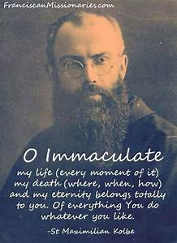

Next Meeting: August 3rd, 2019 beginning @ 10:00 a.m. in
St. Jerome Catholic Church: In the Outback Building
Bring your Liturgy of the Hours.
Early Birds: An opportunity to join together in The Holy Mass in the day chapel @ St. Jerome @ 8:15 a.m.
Candidates and Inquirers Formation begins @ 9:00 a.m. in the Outback!

Remember to keep Brother Juniper in prayer for healing!

The Secular Franciscan Order differs from other Third Orders in significant ways, and it is important that we be aware of the characteristics specific to the OFS.

--The OFS shares a common founder with the First and Second Order— St Francis of Assisi.

--The OFS is not associated or affiliated with the First Order or TOR—it is autonomous and self-governing.

--The OFS shares in vital reciprocity with the other branches of the Franciscan family and has equal dignity.

--The OFS was given the same charism and mission as the other branches of the Franciscan family. In our secular state, we, too, continue the mission of St. Francis to rebuild God’s Church.

--Our Rule and Constitutions are approved by the Holy See and not by the Ministers General of the First Order and Third Order Regular.

See FUN Manual "Our Identity as a Secular Franciscan." Chapter by Anne Mulqueen, OFS

Diane F. Menditto, OFS
Chair, National Formation Commission
Minister, Our Lady of the Angels Region
are available in many different colors. If you’re interested in purchasing one, please contact Alba. They are $20/ea. Alba ordered some F.U.N. Manuals (For Up to Now – Foundational Topics for Initial Formation). They do not come with a binder. Purchase price is $13/ea.

Our contribution bag will be made available at all gatherings. Cash or checks.
Make checks payable to: St. Maximilian Kolbe Fraternity.

10-12-19 Fiesta Franciscana in San Antonio, TX – 9:00 a.m. – 3:30 p.m.
with Fr. Daniel Horan, OFM
“All God’s Creatures: Rethinking Franciscan Theology of Creation”
Registration $20 plus $15 for the optional lunch.
For more information, contact Stan Whitener, OSF @ (210) 827-5309

Family Fun Party
Sponsored by the Office of Vocations
Sunday, August 4th from 2-5 p.m.
University of St. Thomas – Jerabeck Center
WEAR YOUR FRATERNITY T-SHIRT

Laudato Si’ & the US Catholic Church WEBINAR
July 31st @ 2:00 p.m. (eastern time)
Contact: Paz Artaza-Regan paz@CatholicClimateCovenant.org

St. Joan of Arc Regional Retreat
April 25-27, 2020

FOR MORE INFORMATION ABOUT EVENTS & FORMS, PLEASE REFER TO E-MAILS FROM secretary.StMaxSFO@gmail.com

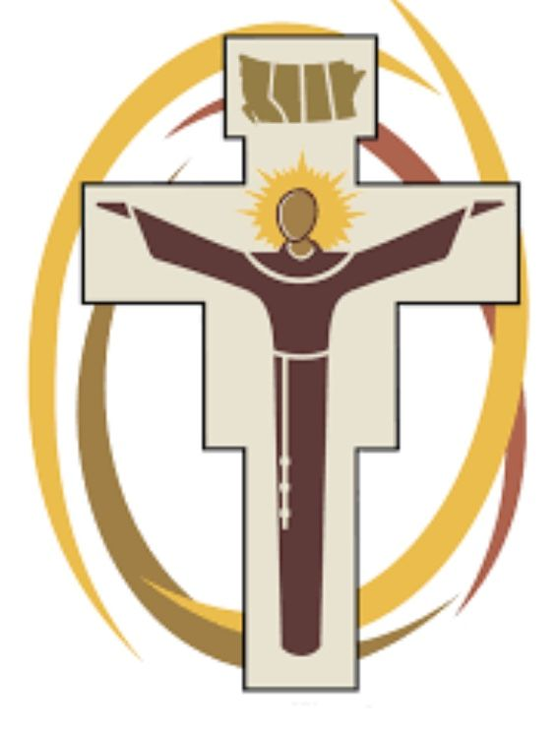

JUST FOR GRINS

