Secular Franciscan Order APRIL 2019 Newsletter

The Secular Franciscan Order was established by St. Francis of Assisi more than 800 years ago. Our purpose is to bring the Gospel to life where we live and where we work. We look for ways to embrace the Gospel in our lives and try to help others to do likewise.

2019 is the 41st year of our current Rule approved in 1978!

“What type of union is this (between the Holy Spirit and Mary)? It is above all an interior union, a union of her essence with the “essence” of the Holy Spirit. The Holy Spirit dwells in her, lives in her. This was true from the first instant of her existence. It was always true; it will always be true.
In what does this life of the Spirit in Mary consist? He himself is uncreated Love in her; the Love of the Father and of the Son, the Love by which God loves himself, the very love of the Most Holy Trinity. He is fruitful Love, a “Conception.” Among creatures made in God’s image the union brought about by married love is the most intimate of all (see Mt 19:6). In a much more precise, more interior, more essential manner, the Holy Spirit lives in the soul of the Immaculata, in the depths of her very being. He makes her fruitful, from the very first instant of her existence, all during her life, and for all eternity.
This eternal “Immaculate Conception” (which is the Holy Spirit) produces in an immaculate manner divine life itself in the womb (or depths) of Mary’s soul, making her the Immaculate Conception, the human Immaculate Conception. And the virginal womb of Mary’s body is kept sacred for him; there he conceives in time – because everything that is material occurs in time – the human life of the Man-God.
… If among human beings the wife takes the name of her husband because she belongs to him, is one with him, becomes equal to him and is, with him, the source of new life, with how much greater reason should the name of the Holy Spirit, who is the divine Immaculate Conception, be used as the name of her in whom he lives as undreated Love, the principle of life in the whole supernatural order of grace?”
St. Maximilian Kolbe

Our Gathering
April 6th, 2019 Joe Swonke, OFS began our gathering by leading us in The Liturgy of the Hours. Alan Allen OFS prayed our candle prayer for the three orders of our Franciscan Family; past, present and future. Michael Freeman, OFS lead us in our opening prayer from the Ritual of the Secular Franciscan Order, page 35. He then introduced our guest, Oliva Garcia, OFS who is an itinerant Franciscan visiting Houston who was also in town when we premiered A Sign of Contradiction.

Mike Freeman, OFS led us in a Ceremony of Introduction & Welcoming for Joan Horr & Veronica Delgado. Fr. Mike shared a few thoughts of welcome.

Cindy Borgerding, OFS gave us an inspiring teaching from Gospel to Life, Rule #11, page 16 centering on “What are we doing to help those less fortunate? and Why did St. Francis give everything away instead of using his goods to help others?” An interesting discussion ensued.

Dora Freeman, OFS challenged us to look at our Time Line or chronology of our life and question how, why, where was God involved in my life? We were to begin with our earliest memories of our childhood up to the present. It was a great exercise in self discovery, aiding us to evaluate our walk with God.

We took a short break to enjoy the goodies everyone brought to share. Mike Freeman, OFS called us back together to read and discuss “Apostolic Exhortation – Gaudete Et Exsultate of The Holy Father Francis on the call to holiness in today’s world”.

Dora Freeman, OFS then led us in a moving rendition of The Stations of the Cross with Mary, our Blessed Mother.

Michael Freeman, OFS led us in the Closing Prayer from the Ritual of the Secular Franciscan Order, page 36.

Fair Share
As many know I have been helping my nieces and nephew with the entering into hospice and the transitus of their mother, my sister Maureen (Mickey). I still do not know which is easier, the sudden death that my brother Jeffrey experienced; or the slow and inevitable decline and shutting down of the body. Mickey had asked me to do the service; which I said I would if I could not get a priest or deacon to come to the graveside for the service .Mickey, , her daughter( who is also my God daughter), and I reviewed the Rites and choose the readings .I met with the deacon at the parish she would have gone to yesterday and I breathed a sigh of relief that he will do the graveside service and that our planning for the Rite was appropriate and agreeable. I appreciate ya’lls prayers. The pre-Pauline Rule of our Order insured that each of us had a will; and even afterwards it has been encouraged that our wishes for our passing were known to our loved ones. Please make sure!
I knew I was behind my usual behind-it-ness in sending this to Eileen for inclusion in the newsletter .Being chronologically challenged I chose to borrow a message that was originally in the TAU in 2014.
That being said , the old adage of the only certainties in this life are death and taxes I thought of a recent discussion at a Council meeting which has been resonating in my head for some time……….Fair Share. We have been tasked with submitting a balanced budget to Regional, who also submits to National. In prior years it was determined that each member would have to contribute an average of $10.00 per month and we squeaked by. It was never intended to be viewed as dues, yet with little white envelopes with people’s names on them it was very easy to confused with such .People got into the habit of asking the treasurer how much have I paid, or how much do I still owe, and then a check would be written. We wanted to get away from this system as we are to contribute what we can, when we can, not monthly dues. Judith, David’s wife made us this little bag that is now passed around at the gatherings and folks can contribute into that. If you itemize your tax deductions it is not possible to remain anonymous ; but you can let Alba know and a receipt can be provided annually. Alba will be addressing this topic at a future gathering as our Fair share to Region has jumped more than 35%, from $40.00 to $55.00
As we continue to celebrate the anniversary of our Rule let us recall that the Rule is broken down into 3 chapters: the Secular Franciscan Order, The Way of Life, and Life in Fraternity. It is in this third chapter that the topic of Fair Share is addressed.
Secular Franciscan Rule #25: “Regarding expenses necessary for the life of the fraternity and the needs of worship, of the apostolate, and of charity, all the brothers and sisters should offer a contribution according to their means. Local fraternities should contribute toward the expenses of the higher fraternity councils.”
I had read a message from our former National Minister, Deacon Tom Bello OFS in which he fully addressed the concept of Fair Share and I will use what he has written for the remainder of this message.
Many of Tom Bellos messages are included in his book: For all the Saints: St. Francis’s Five Point Plan for Salvation and Other Spiritual, Fraternal and Personal Reﬂections for Information, Formation and Transformation in the Secular Franciscan Order.

Tom writes on our Rule#25:
First, this is where the notion of “Fair Share” originates, and as you can read, there is no mention of individual responsibility. Rather, the responsibility is a collective one: “all the brothers and sisters should offer a contribution according to their means.”
Second, the Secular Franciscan Rule has only 26 Paragraphs or Rules, so we only get to “expenses” at the next to the last one, thus offering some sense of their overall importance.
Third, the word “necessary” is paramount, but note the four “necessities”: the life of the fraternity, the needs of worship, the needs of the apostolate and the needs of charity.
Tom Bello continues with:
In addition, the Official Commentary to the Rule “prepared by the national spiritual assistants’ commission, Benet A. Fonck O.F.M., coordinator” might be helpful here as well:
Secular Franciscan Rule 25 "points out that the voluntary contributions of the members finance the fraternity’s spiritual and temporal needs and activities. The fraternity, according to its means and agreed upon arrangements, also contributes to the support of the regional, provincial, national and international fraternities. This paragraph is a contemporary application of the traditional Secular Franciscan values outlined in the very first rule that the members are responsible for taking care of their own in whatever way is necessary.”
This sense of co-responsibility is stressed in the General Constitutions Article 30, which, to this reader, puts the question of “Fair Share” into a wider context of co
“1. The brothers and sisters are co-responsible for the life of the fraternity to which they belong and for the Secular Franciscan Order as the organic union of all fraternities throughout the world.
2. The sense of co-responsibility of the members requires personal presence, witness, prayer, and active collaboration, in accordance with each one's situation and possible obligations for the animation of the fraternity.
3. Rule 25 In a family spirit, each brother and sister should make a contribution to the fraternity fund, according to each one's means, to provide the financial means needed for the life of the fraternity and for its religious, apostolic, and charitable works. The brothers and sisters ought to provide the means necessary for supporting the activities and the operations of the fraternities at higher levels, both by their financial assistance and by their contributions in other areas as well.”
Bello, 2014.
Peace
michael

Next Meeting: June 1st, 2019 beginning @ 10:00 a.m. in
St. Jerome Catholic Church: In the Outback Building
Bring your Liturgy of the Hours.
Early Birds: An opportunity to join together in The Holy Mass in the day chapel @ St. Jerome beginning 8:15 a.m.
Candidates and Inquirers Formation begins @ 9:00 a.m. in the Outback!
Ryan Efaw, BSN, RN, OFS led one of 7 breakout sessions on 4-27-19 @ Bites for Better Health, a Wellness & Weight Loss Event. 9:00 a.m. – 3:30 p.m. Your Fraternity is proud of you, Ryan!! Thanks for making our world a healthier place to live!

10-12-19 Fiesta Franciscana in San Antonio, TX – 9:00 a.m. – 3:30 p.m.
with Fr. Daniel Horan, OFM
“All God’s Creatures: Rethinking Franciscan Theology of Creation”
Registration $20 plus $15 for the optional lunch.
For more information, contact Stan Whitener, OSF @ (210) 827-5309
See last page of Newsletter for more info.

FOR MORE INFORMATION ABOUT EVENTS & FORMS, PLEASE REFER TO E-MAILS FROM secretary.StMaxSFO@gmail.com

Do not be dismayed by the brokenness of the world. All things break. And all things can be mended. Not with time, as they say, but with intention. So go. Love intentionally, extravagantly, unconditionally. The broken world waits in darkness for the light that is you.
L.R. Knost

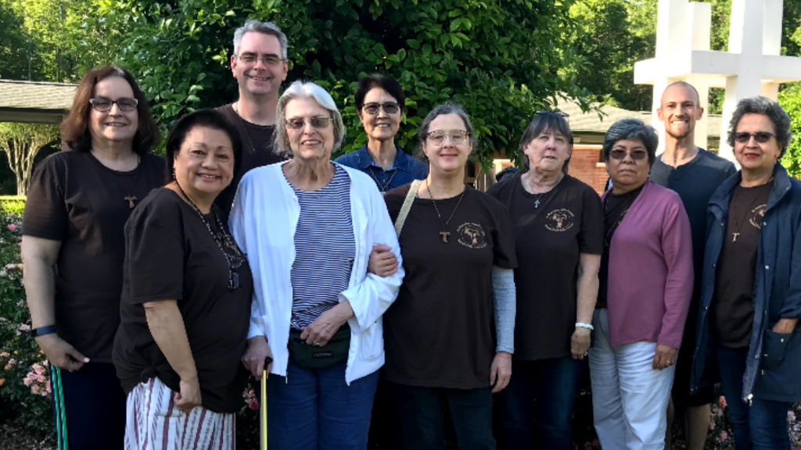
May 2019 Franciscan Retreat in Louisiana

