Secular Franciscan Order September 2019 Newsletter

The Secular Franciscan Order was established by St. Francis of Assisi more than 800 years ago. Our purpose is to bring the Gospel to life where we live and where we work. We look for ways to embrace the Gospel in our lives and try to help others to do likewise.

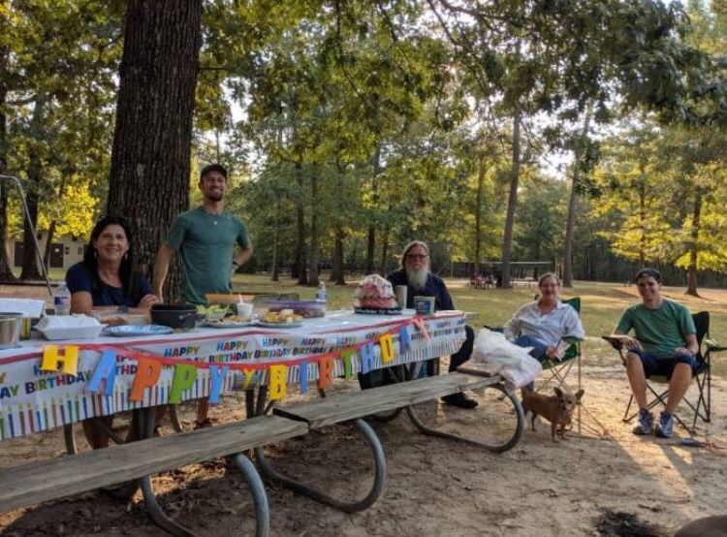
Lake Houston Wilderness Park
Franciscan Picnic – September 14, 2019

our Gathering
August 7th, 2019 What a wonderful September gathering we had! We celebrated the Care of Creation in many different ways. Rather than our usual Liturgy of the Hours, we began our morning with a Guided Rosary on Care for Creation from Catholic Climate Covenant, led by Dustin.
Afterwards, Phyllis led us in the opening prayer and lighting of the candles. We prayed from our Ritual Book.
In continuing our study of The Rule, Joe gave an excellent presentation on Article 13. Discussion ensued on the topic of inclusion of all peoples on the earth, regardless of race, religion, nationality, etc. We are called to love, without judgment, all of God’s creation. As peacemakers, we strive to dialogue openly, celebrating our likenesses, rather than our differences. Acceptance of all persons as God’s beloved children is our call. When we experience “the other”, we all benefit. We are Secular Franciscan’s, we are in the world. Alan reported his company has a prayer room which was opened for those in their company who are devout Muslims. He has since discovered that the prayer room is open to all.
Then Fr. Mike led us in a moving liturgy celebrating our spiritual connection with “country”. Country representing Creation, as revered by the Aboriginal cultures of Australia. The respect towards creation as shown by the indigenous peoples of the world should be our lesson on our behavior upon this Earth: the gift from God. We are called to be good stewards.
Discussion followed on what we can do to make a positive impact and reduce our footprint. Small things, such as not repurchasing Styrofoam cups for our gatherings, not buying individual small bottles of water, taking our old electronics to a recycling facility, not waiting for supermarkets to halt use of plastic bags but bring our own bags, etc. Carla told us about “Imperfect Produce”, a company which will deliver good produce that the stores will not sell due to imperfect appearance.
In a recent post by Daniel Horan, OFM, entitled “Climate change is the most important life issue today”, he wrote about Greta Thunberg, a young Swedish girl speaking out with a prophetic voice on our need to act NOW. Greta shows us adults how powerful one person can be. She has organized strikes all over Europe and recently sailed across the Atlantic for the UN climate talks. Watch her TED talk – amazing! Horan, who is a Franciscan friar and assistant professor of systematic theology and spirituality at Catholic Theological Union in Chicago, also writes: “Let us not squander this year’s Season of Creation, but instead allow it to be a time for us to reorder our priorities and form our consciences to be truly pro-life, because the future of all life is counting on us.”
We then had a very informative presentation by Ryan, who discussed how we can better care for ourselves, our choice of food and how it affects not only our own health, but the health of the planet. Where once smoking was the #1 killer of Americans, it has now become our diet. Highly processed foods and the eating of animals is not healthy! Let us take care of these temples of God which He has so generously gifted us.
Dora led us in a chant, words by St. Hildegard of Bingen, “We are greening, greening with life. We bear our fruit for all creation. We are greening, greening with life, we bear our fruit for all Creation. Limitless love, from the depth to the height, loving us, flooding us. It is the royal kiss of Peace.”

(Meanwhile, in another part of town) 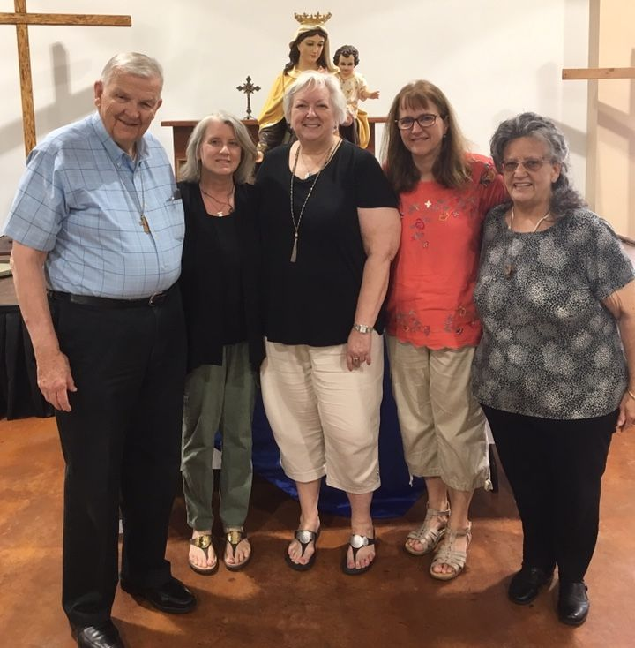
Celebration of our Marian Consecration on 9-7-19
Hell hath no fury like a woman scorned.
Mother Nature has been telling us this for years, and yet we let greed, indifference, or flat out denial frame our responses. Partisan politics, personal agendas, phobias, isms , on and on, one thing after another.
Our gospel values as Christians and Catholics require our active participation in serving Christ. In Luke’s Gospel we are told, “He who does not gather with me scatters” (Luke 11:23). In his letter to the parishioners at St. Jerome’s on the 25th Sunday in Ordinary time Fr. Dan wrote:
We cannot be morally neutral in life. We can’t sit on the fence. Either we live selfishly (life of mammon) or we live for Christ…..Jesus reminds us that we don’t make this choice just once but every day, in ‘small matters’ and ‘great ones’.
God constantly gives us opportunities and chances to encounter Him in all of His creation, if we allow the Holy Spirit to move us. Come Holy Spirit. Animate us.
This is the ongoing conversion that we as Franciscans seek every day. As Catholics we are Blessed to have the Word of God as well as the traditions and teachings of our Church. Additionally we have also been Blessed with the Grace of our Franciscan Charism. Last year we began focusing on Our Rule and the Essential Documents of the Secular Franciscan Order. In Article 18: 4 of our General Constitutions we read:
“Following the example of Francis, patron of ecologists, they should actively put forward initiatives that care for creation and should work with others in efforts that both put a stop to polluting and degrading nature and also establish circumstances of living and environment which would not be a threat to the human person”.
Let us actively put forward and carry through! It is a daily conversion. Small matters and great ones.
This past Thursday we experienced the second 500 year flooding event in two years. You know what they say about the definition of insanity……doing the same thing yet expecting different outcomes. Hopefully if we are fence sitters the fence is high enough as the water is rising! While I am mildly excited about the UN climate talks I am most excited about the upcoming Synod our Holy Father has called including the Bishops of all nine countries in the Amazon Region and 3 from the United States including Cardinal Sean Patrick O’Malley OFM CAP.
Our North American Church and Bishops will certainly strengthen the Call to Care for Creation in our communities. It is often said Catholic Social Teaching is the best kept secret of the Church…..let’ not keep it secret anymore
Our October gathering will be a special one as we will have our visitation, it’s the day after the Feast Day of St. Francis and we will conclude the Season of Creation with additional reflections begun in September.
Peace
Michael

Next Meeting: October 5th, 2019 beginning @ 10:00 a.m. in
St. Jerome Catholic Church: In the Outback Building
Bring your Liturgy of the Hours.
Early Birds: An opportunity to join together in The Holy Mass in the day chapel @ St. Jerome @ 8:15 a.m.
Candidates and Inquirers Formation begins @ 9:00 a.m. in the Outback!

The Season of Creation runs every year from September 1, the World Day of Prayer for Creation, through October 4, the feast of St. Francis of Assisi. During the Season of Creation, Christians around the world pray and act for creation. Learn more at SeasonofCreation.org.

are available in many different colors. If you’re interested in purchasing one, please contact Alba. They are $20/ea. Alba ordered some F.U.N. Manuals (For Up to Now – Foundational Topics for Initial Formation). They do not come with a binder. Purchase price is $13/ea.

Our contribution bag will be made available at all gatherings. Cash or checks.
Make checks payable to: St. Maximilian Kolbe Fraternity.

10-12-19 Fiesta Franciscana in San Antonio, TX – 9:00 a.m. – 3:30 p.m.
with Fr. Daniel Horan, OFM
“All God’s Creatures: Rethinking Franciscan Theology of Creation”
Registration $20 plus $15 for the optional lunch.
For more information, contact Stan Whitener, OSF @ (210) 827-5309

St. Joan of Arc Regional Retreat
April 25-27, 2020

FOR MORE INFORMATION ABOUT EVENTS & FORMS, PLEASE REFER TO E-MAILS FROM secretary.StMaxSFO@gmail.com

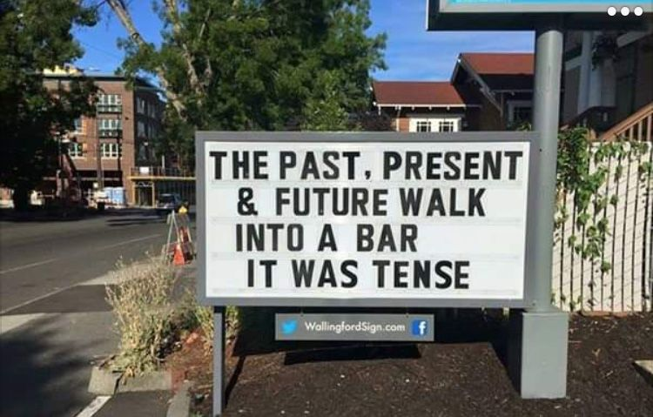
Just for Grins :}

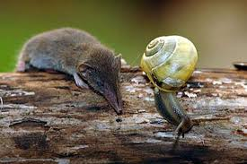 ~ 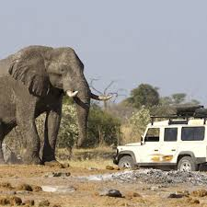

Look Around You!
“In his hand is the life of every creature and the breath of all mankind.” Job 12:10

The Animal Kingdom is wondrous. The tiny Etruscan shrew weighs two grams, less than the weight of a dime, but the largest African elephant ever recorded weighed more than twelve tons, six times heavier than the average car. One can imagine the shrew shivering in its burrow as an elephant’s passage shook the earth, but the elephant wouldn’t notice the shrew if it were perched on the end of its long nose!
Yet, both the shrew and elephant share the same organs – heart, lungs, kidneys, liver, and brain. In fact, both being vegetarians, they have more similarities than differences. Isn’t that amazing?
What about fish and birds? The bald eagle’s wings span seven feet, and it soars majestically on rising thermals, perhaps not even noticing the two-inch-long bee hummingbird flitting among flowers below. The whale shark, the biggest fish in the sea, is forty feet long and weighs twenty tons. But it feeds on the tiniest of sea creatures, krill and plankton, so small they are barely visible. The eagle and whale shark glide majestically through their own environs, but they would quickly die if forced to change places. Again, isn’t that amazing?
And don’t get me started on the insect world. Scientists believe that there are more than thirty million species of insects, the sum total approaching ten quintillion (that’s the number ten with eighteen seros behind it). I wonder, How much time would it take to count to that number?
For those who deny the existence of God’s kingdom, look at the incredible diversity of the animal kingdom. Is there any better evidence of God’s hand at work?
Author: J. Mason Williams
Let us go outside and open up our senses,
and soak in the wonders all around us.
I know that God will be there, waiting for us.

Taken from All God’s Creatures, Daily Devotions for Animal Lovers Sep/OCT 2019
Guideposts
  