Secular Franciscan Order DECEMBER 2019 Newsletter

The Secular Franciscan Order was established by St. Francis of Assisi more than 800 years ago. Our purpose is to bring the Gospel to life where we live and where we work. We look for ways to embrace the Gospel in our lives and try to help others to do likewise.

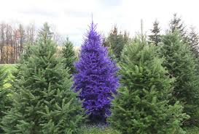
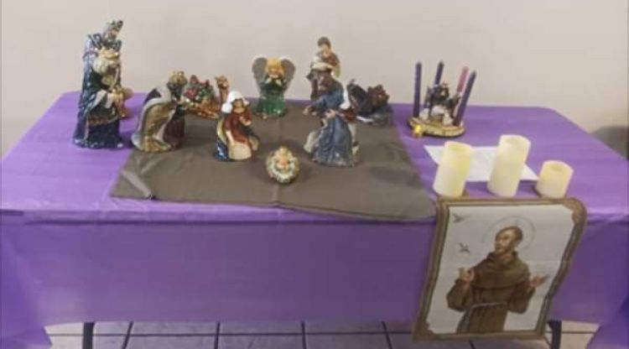
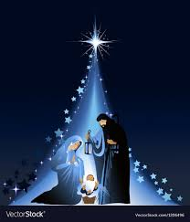
our Gathering
December 7th, 2019 Joe led us in the prayer of the Liturgy of the Hours. Candidates {Joan Horr, Dori Ellis, Phyllis Prince, Eileen Ike Colleton} were given the honored tradition of setting up the beautiful crèche. Alan led us in our lighting of the candles prayer. Mike led us in the opening prayer found on pg 35 of the Ritual. Dora shared with us the exciting news about Pope Francis issuing a new Apostolic Letter “Admirabile Signum”. He visited Greccio and spoke on the crèche as being a Living Gospel rising up from the pages of Sacred Scripture. It is the humble and poor who greet the Divine Christ Child. She then read an excerpt from Hidden Beauty, Reflections of St. Bonaventure’s Tree of Life, by Fr. Rick Martignetti, OFM. St. Bonaventure died at the age of 57 & was given the title of a Seraphic Doctor. His “prescription” for everyone was “Pray, Pray, Pray!” He believed the gift of intelligence was important, but so was having an imagination. All things, such as rocks, trees, etc… are words written by the Creator God. Dora shared many different insights into St. Bonaventure’s life & beliefs. We were invited to close our eyes and put ourselves in the presence of God while she read an excerpt from Bonaventure’s Tree of Life: Jesus Born of Mary: Kissing His Feet. It was a lovely meditation.
Mike told us to save the date for March 7th, 2020 which will be a Day of Reflection. More information to come at a later date.
Dora shared with us the results of our glowing Regional Report from Cherryle Fruge & Bro. Dan. It was so positive and uplifting. It is great to know our Fraternity is on the right track & our leadership is spot on! What a great Council we have!!! We received helpful advice to assist us as we continue to grow in our Franciscan Charism.
Mike & Dora began the Ceremony of Introduction & Welcoming to our two newest Sisters in Christ. Barbara Landry introduced LaDonna Hartman & Fr. Mike Van Cleve introduced Mary Pierson. WELCOME!
Danny Marquer thanked Mike for introducing Gabriel to our Fraternity. Danny had the privilege of visiting Gabriel in his Nursing Home along with Maria, Dora & Mike. Gabriel has been a Franciscan since 1965 & was so happy to see other Franciscans come to visit. A joy both ways!
Karen Parsons shared a heart wrenching story about a ship that was stranded outside of Galveston with no food for the crew on board. It was a sad tale but had a happy ending as Karen, her Assistant, the Coast Guard and many volunteers came to their rescue. For the full story, refer to the December 5th, 2019 email from secretary.StMaxSFO@gmail.com. When we hear these horror stories of those who must leave their families behind as they go out to sea for months it makes one so grateful for what we have. It is such a blessing that we were given this opportunity to spread a little joy with the shoeboxes we filled today. Thank you, Karen and all of you for this!
Mike led us in our Closing Prayer from our Ritual of the SFO, pg 36.
The rest of our gathering consisted of praying for those who will receive the boxes, singing Christmas Carols, much fun & frivolity, stuffing the Seafarers Boxes, wrapping them with pretty Christmas paper, then stuffing our tummies with the delicious victuals everyone brought to share. Thanks Connie, for the beautifully decorated table, making everything so festive!

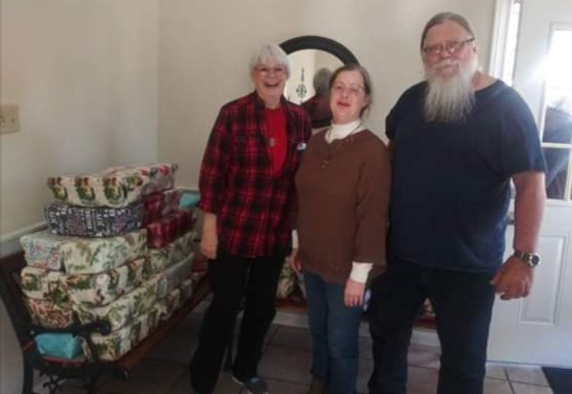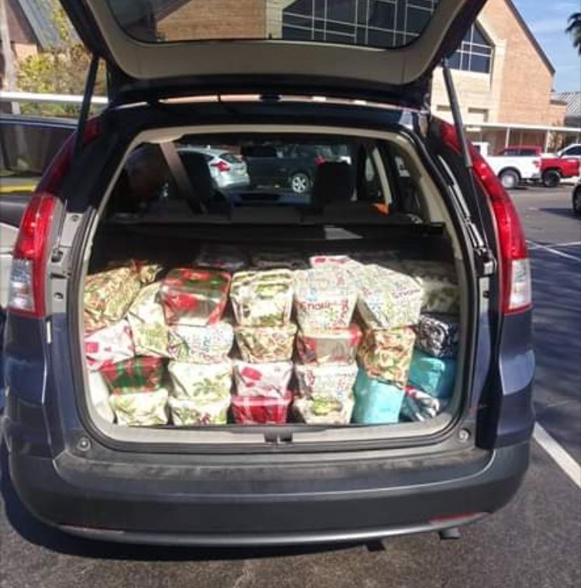

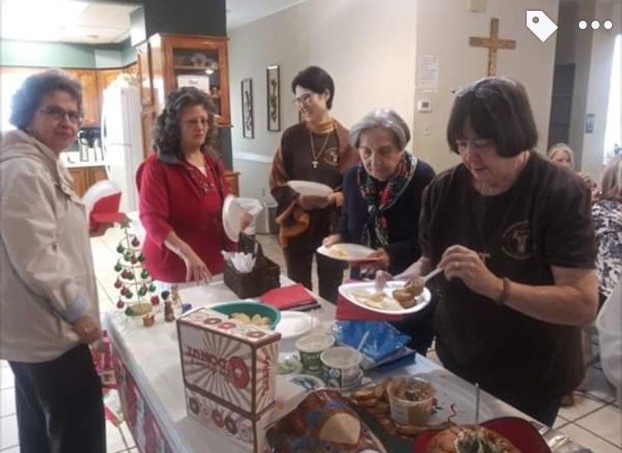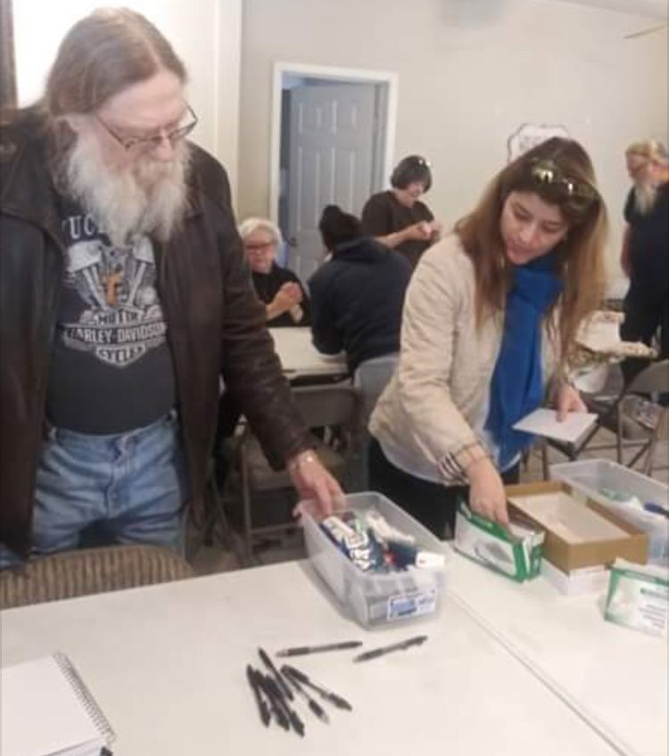

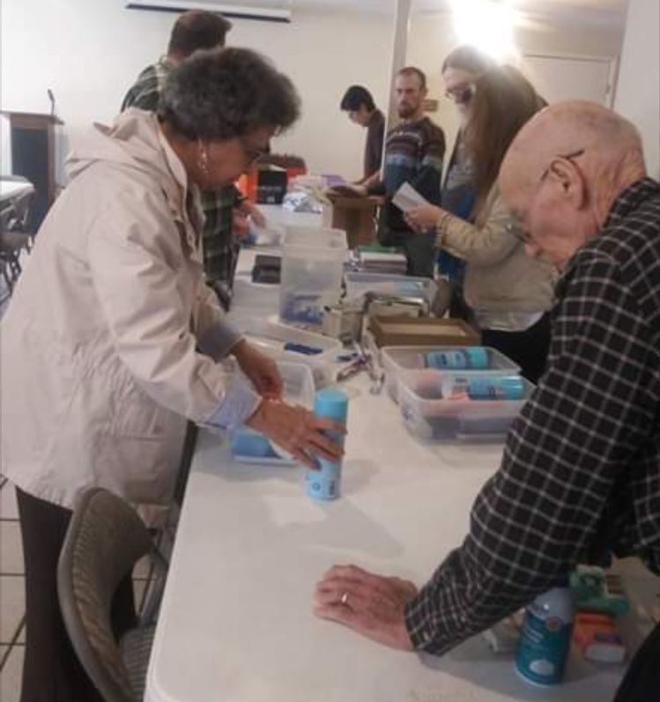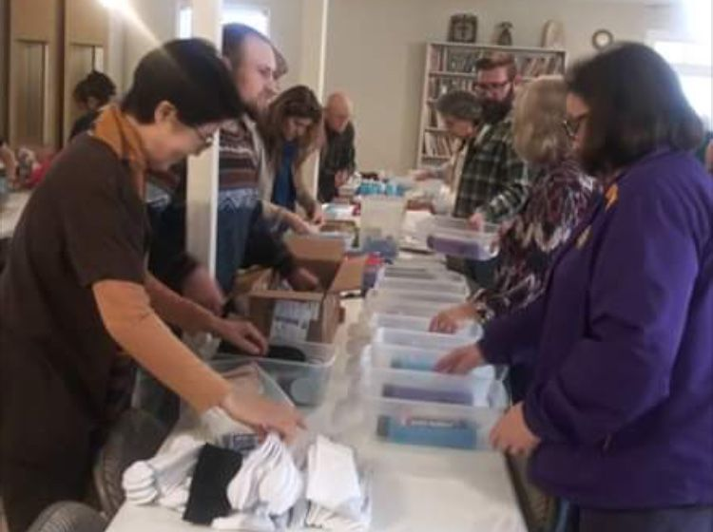

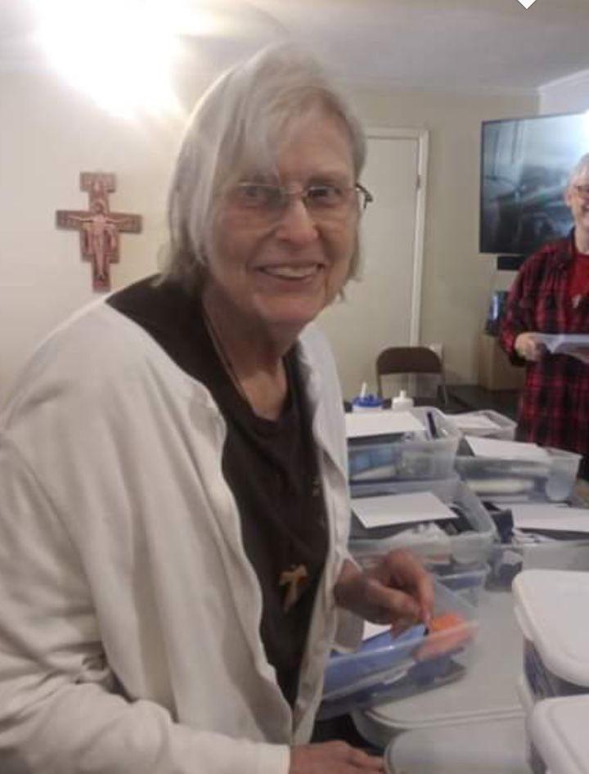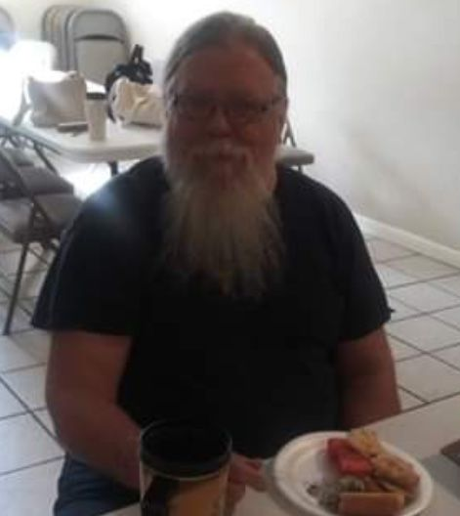

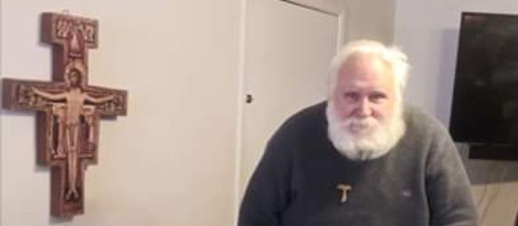

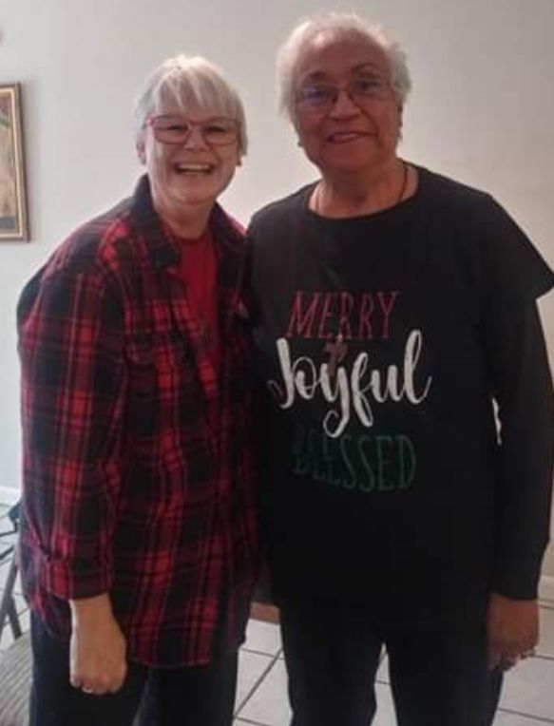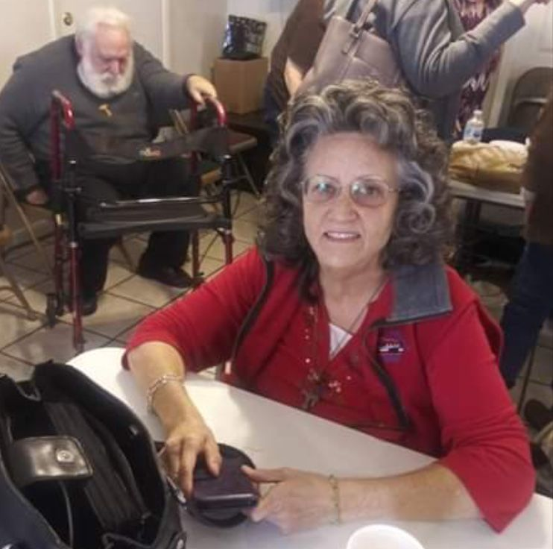

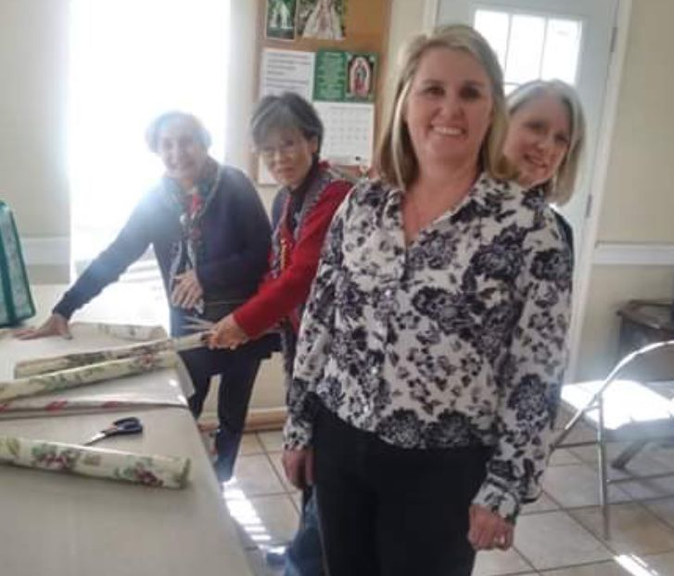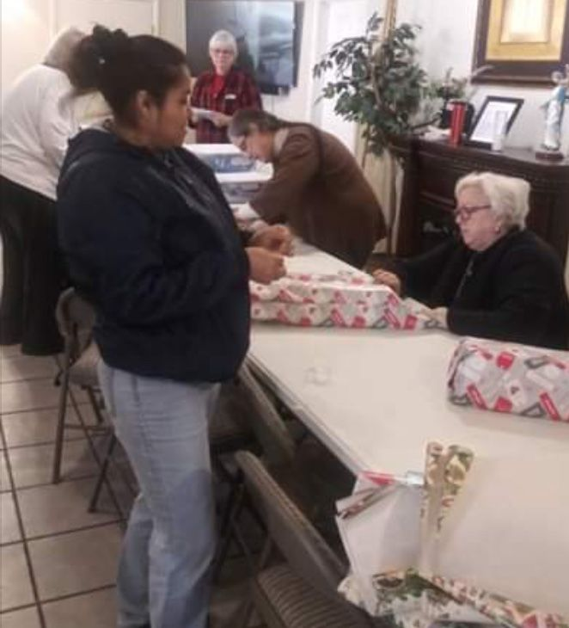

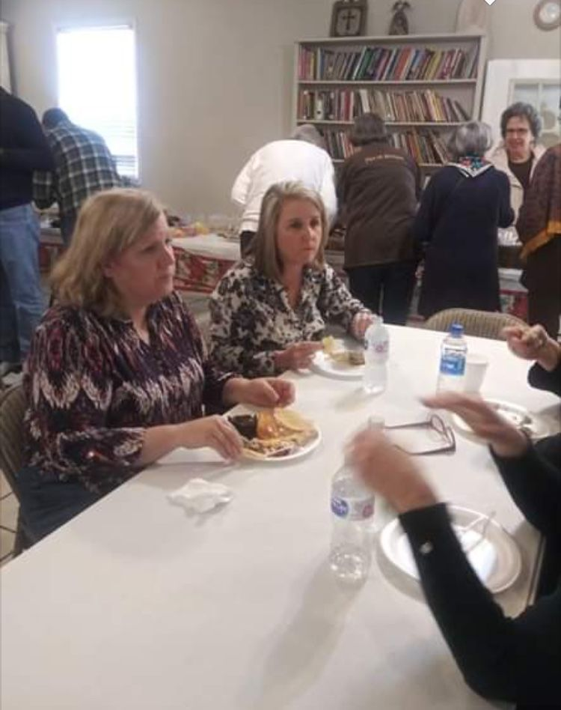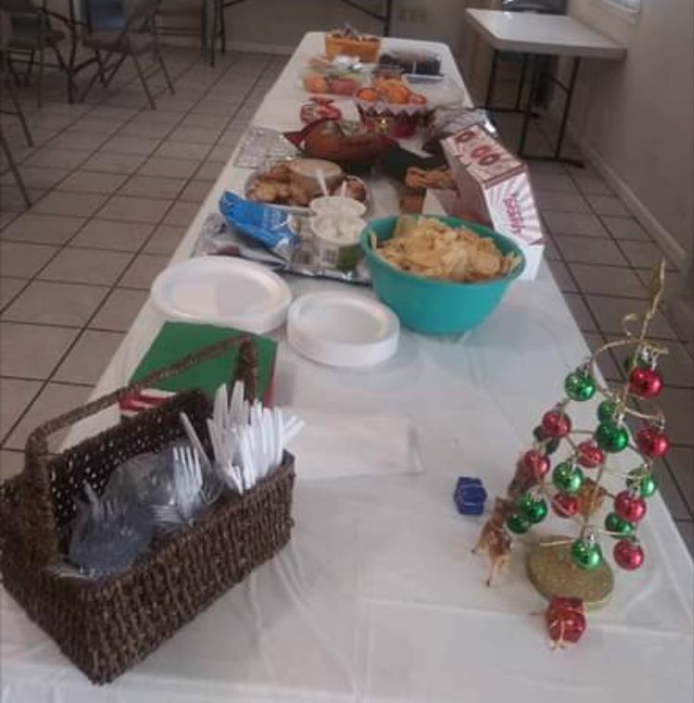
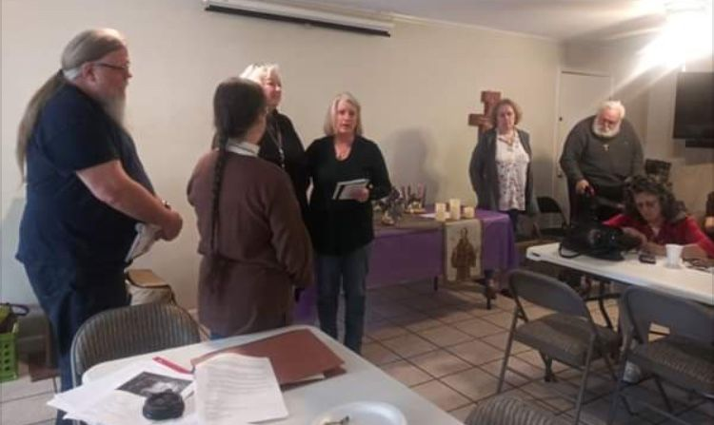
Ceremony of Introduction & Welcoming!
Barbara Landry introduced LaDonna Hartman & Fr. Mike Van Cleve introduced Mary Pierson. WELCOME!

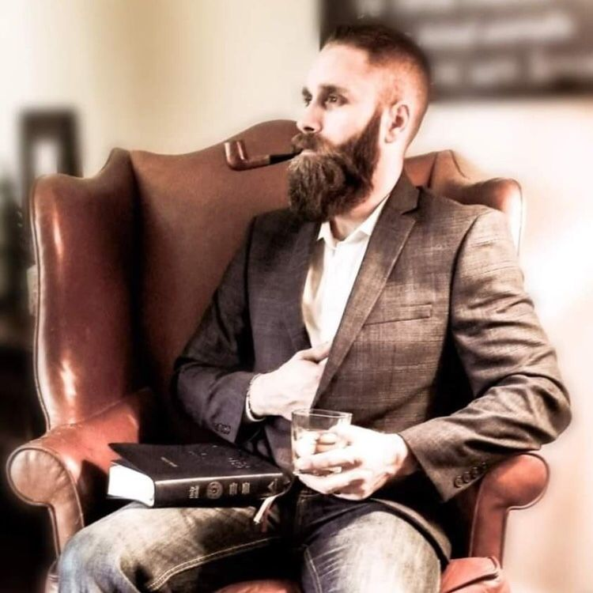
A distinguished Franciscan if ever there was one!

Greetings Sisters and Brothers
As we move closer and closer to the day when Christ our Savior was made incarnate by the Holy Spirit and the Virgin Mary, we are called to prepare the way. The journey for some of us has been one in which we choose the darkness, yet the flicker of light that was started with our Baptism was constant, much like the distant lighthouse seen by mariners.
By the grace of God I did not crash into the rock on my journeys as I was following the sirens song; nor drown at sea. I continue my journey, remembering St. Junipero Serras’ words Siempre Adelante, always forward.
We follow the Gospel in the footsteps of Francis and Claire (whose name means “bright and clear”).
When we are obedient and say Yes as Mary did to the Holy Spirit, the Light of Christ can enlighten even the darkest places.
I hope at our next gathering to spend some time demonstrating what a wonderful resource we have on the OFS USA site. I am not sure about WIFI though but will have a backup plan.
In the interim though I wanted to share the following with you from Pope St. John Paul 2 on the importance and treasure we have in our Rule and the General Constitutions which help us to live the Rule.(excerpts and emphasis added) :

ADDRESS OF JOHN PAUL II
TO THE SECULAR FRANCISCAN ORDER
Friday, 22 November 2002
Dear Brothers and Sisters,
I am happy to welcome you and offer my cordial greeting to each of you: to the members of the new and previous Presidency of the International Council of the Secular Franciscan Order, to the participants of the 10th General Chapter, and through you, to all Secular Franciscans and members of the youth movement "Franciscan Youth" present in the world.
At this General Chapter you finished updating your basic legislation. In your hands you now have the Rule which my predecessor of happy memory, Paul VI approved on 24 June 1978; the Ritual, approved on 9 March 1984, the General Constitutions, definitively approved on 8 December 2000, and the International Statute approved at this Chapter.
You must now look to the future and put out into the deep: Duc in altum!
The Church expects from the unique Franciscan Secular Order a great service to the cause of the Kingdom of God in the world today. She wants your Order to be a model of organic, structural and charismatic union at all levels, so as to present yourself to the world as a "community of love" (SFO, Rule, art. 26). From you, Secular Franciscans, the Church awaits a courageous and consistent witness of Christian and Franciscan life that aims at building a more fraternal and evangelical world for the realization of the Kingdom of God.
In the meeting I had more than 20 years ago, on 27 September 1982, with the members of the General Assembly of your International Council, I urged you: "Study, love and live the Rule of the Franciscan Secular Order, approved for you by my predecessor Paul VI. You have in your hands a genuine treasure, that agrees with the spirit of the Second Vatican Council, and responds to what the Church expects of you" (Insegnamenti, V/3, 1982, p. 613). I am pleased to be able to direct similar words to you today: study, love and live your General Constitutions!!
You are called to make your own contribution, inspired by the person and message of St Francis of Assisi, to hasten the coming of a civilization in which the dignity of the human person, co-responsibility and love may be living realties (cf. Gaudium et spes, n. 31ff.). You must deepen the true foundations of universal fraternity, and everywhere create a spirit of hospitality and of brotherhood. Firmly oppose every kind of exploitation, discrimination and marginalization, and every attitude of indifference to others.
Secular Franciscans, you live by vocation your belonging to the Church and to society as inseparable realities. For this reason, you are asked first of all to bear a personal witness in the place where you live: "before all: in [your] family life; in [your] work; in [your] joys and sufferings; in [your] associations with all men and women, brothers and sisters of the same Father; in [your] presence and participation in the life of society; in [your] fraternal relationship with all creatures" (SFO, General Constitutions, art. 12.1). Perhaps, you will not be required to pour out your blood as a martyr, but you will certainly be asked to give a coherent and steadfast witness in fulfilling the promises made at your Baptism and Confirmation, which you renewed and confirmed with your profession in the Franciscan Secular Order. By virtue of this profession, the Rule and the General Constitutions must represent for each of you the point of reference for daily living, based on your explicit vocation and special identity (cf. Promulgation of the General Constitutions of the SFO). If you are truly driven by the Spirit to reach the perfection of charity in your secular state, "it would be a contradiction to settle for a life of mediocrity, marked by a minimalist ethic and a shallow religiosity" (Novo Millennio ineunte, n. 31). You must be sincerely dedicated to that "high standard of ordinary Christian living" (ibid.), to which I invited all the faithful at the end of the Great Jubilee of the Year 2000
At this time, I urge you to take again into your hands the Rosary, which, by ancient tradition, "has shown itself particularly effective as a prayer which brings the family together. Individual family members, in turning their eyes towards Jesus, also regain the ability to look one another in the eye, to communicate, to show solidarity, to forgive one another and to see their covenant of love renewed in the Spirit of God" (Rosarium Virginis Mariae, n. 41). Do so keeping your gaze on the Virgin Mary, the humble handmaid of the Lord, ready for his Word and for all his calls, whom Francis enveloped in inexpressible love and who was made Protectress and Advocate of the Franciscan family. Witness to her your burning love, by imitating her unconditional readiness and pouring out a stream of confident and conscious prayer (cf. SFO, Rule, art. 9).
With these wishes, I cordially impart to you, Secular Franciscans and to the members of "Franciscan Youth", a special Apostolic Blessing.
© Copyright - Libreria Editrice Vaticana

Peace
Michael

Next Meeting: January 4th, 2020 beginning @ 10:00 a.m. in
St. Jerome Catholic Church: In the Outback Building
Bring your Liturgy of the Hours.

Early Birds: An opportunity to join together in The Holy Mass in the day chapel @ St. Jerome @ 8:15 a.m. Candidates and Inquirers Formation begins @ 9:00 a.m. in the Outback!
See secretary.StMaxSFO@gmail.com for list of items!

are available in many different colors. If you’re interested in purchasing one, please contact Alba. They are $20/ea. Alba ordered some F.U.N. Manuals (For Up to Now – Foundational Topics for Initial Formation). They do not come with a binder. Purchase price is $13/ea.

$$$ Our contribution bag will be made available at all gatherings. Cash or checks.
Make checks payable to: St. Maximilian Kolbe Fraternity.

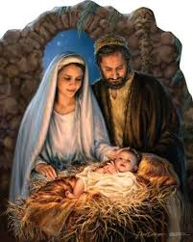

Caritas Day
Parish Day of Service
February 29th, 2020

Day of Reflection
March 7th, 2020
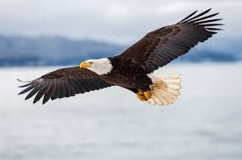
St. Joan of Arc Regional Retreat
April 24-26, 2020

FOR MORE INFORMATION ABOUT EVENTS & FORMS, PLEASE REFER TO E-MAILS FROM secretary.StMaxSFO@gmail.com

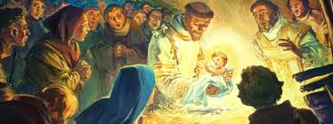

Happy Birthday, Jesus!

Eagerly Awaiting

For the creating waits in eager expectation for the children of God to be revealed.
Romans 8:19 (NIV)

I was digging out a walkway for our front path when I made a gruesome discovery. As I pulled up a shovelful, I realized I had inadvertently severed an earthworm. Even though I’m not a fan of the wiggly creatures, I appreciate them in their own slimy, dirt-aerating way. And no matter what, that earthworm was a living thing – a harmless living thing.
I’d heard that earthworms regenerate themselves, but I couldn’t imagine that having yourself hacked in two could be pleasant, and though I tried to picture a happy, whole new earthworm by morning, I knew it was likely wishful thinking.
Determined to find out the real deal about earthworm regeneration, I did some research. I found that earthworms do grow back their tails. But several other contributing factors – including the species of earthworm and where the amputation occurs – depend on whether the worm will live. For example, worms that lose their digestive tracts could develop life-threatening issues. I read conflicting reports of whether or not an invertebrate can feel real pain and suffering.
Now that I’ve either completely fascinated you or completely grossed you out, I’ll make my point: Creation is as boundless and unique and beautiful as our heavenly Father. No matter what I may deem fit or unfit-slithering or nonslithering-God has a place for it in this world. And at the same time, as with every aspect of creation, there are flaws and imperfections. Every day, we witness creation waiting eagerly for the perfect completion of a new heaven and a new Earth. And while we can enjoy the present, we, too, because we are God’s children, can anticipate a more glorious future. By Heidi Chiavaroli

Heavenly Father, there is not one aspect of your creation you haven’t touched, and not one aspect that hasn’t known the flaws of a fallen world. Thank you for the beauty of your present creation, and the glorious promise of an eternally perfect one.

Excerpt from: All God’s Creatures
Daily Devotions for Animal Lovers

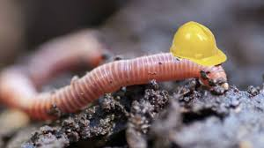

Every 2nd Saturday of the Month, folks from TFP (Tradition Family Property) gather at two locations to pray the Rosary to be a visible sign & witness to our precious Lord Jesus and our Blessed Mother Mary. This month’s emphasis was on praying for America and Keeping Christ in Christmas. December 14th, a few members of St. Maximilian Kolbe Franciscan Fraternity joined TFP to pray the Rosary on the corner of San Felipe & Sage from 12noon to 1pm. The other location is on the corner of Briar Forest and Eldridge. Everyone is welcomed to join in the prayer.

