Secular Franciscan Order January 2020 Newsletter

The Secular Franciscan Order was established by St. Francis of Assisi more than 800 years ago. Our purpose is to bring the Gospel to life where we live and where we work. We look for ways to embrace the Gospel in our lives and try to help others to do likewise.

Wise Men still seek him

our Gathering
January 4th, 2020 Dora led us in the prayer of the Liturgy of the Hours. Fr. Mike led us in our lighting of the candles prayer. Mike led us in the opening prayer found on pg 35 of the Ritual. Alan read to us a Franciscan reading from Simple Way, by Fr. Murray Bodo, OFM. Different thoughts were shared about what this reading on “birthing Christ” & bringing Christ into the world meant to us as Secular Franciscans. Dora shared insights with us about the formation of Epiphany & how the entire world is affected by the birth of Christ. A question was asked; “Do I follow the light-the Star?” In reference to Epiphany, Alan read Rule #14 & Mike pointed out Rule #9 is appropriate as well. We concluded with praying Psalm 72 together.
A break was given to enjoy the goodies everyone brought to share. I must comment on how much we missed Connie’s contribution to our “breaking of the bread” time. She was unable to attend today and we had no coffee! A mad dash to Starbucks to purchase a carafe before 10:00 a.m. was generously made by Phyllis. We conducted a thorough scavenger hunt of the cupboards to supply the table with cups, napkins, & utensils. We have a very resourceful Fraternity, BUT, CONNIE, WE MISSED YOU! As the old saying goes….you don’t know what you have until it’s gone…. It gave us a deeper appreciation of all Connie contributes to our Gatherings. Thank you, Connie.
P.S. The Council met after our Gathering and a new rule has been put into place:
Connie is not allowed to ever miss a Gathering again! (kidding)
We resumed our discussions with Mike, with a little help from his friends, pulling up on our big screen, the OFS website, showing us how to maneuver through the tabs and find pertinent information as well as the multitude of resources available, including all of our Essential Documents. Dora reminded us, #1 Agent in formation is the Holy Spirit. #2 Agent in formation is ourselves. The website has a plethora of information to help us continue our spiritual growth. To show how amazing the information is, Mike pulled up a PowerPoint that was completed for the National Chapter; a rendition of The Lord’s Prayer that St. Francis had expounded on, phrase by phrase. It was beautifully meditative. We were then challenged to do the same with the Hail Mary, phrase by phrase. We took time to share our co-creative insights. It is amazing what the Holy Spirit can bring forth from us when we take the time to listen!
We again listened and reflected on our Blessed Mother and how Francis chose her to be the Protectress of Our Order; and how interwoven she is withing our Rule and Constitution. Within the discussion, Mike referenced an article from a website “Busted Halo”. It shed light on how we, too can continue to say YES as Mary did, throughout the year. and Dora read an excerpt on “What is the Solemnity of Mary”. The author gave her 2020 Resolution of beginning the New Year with Mary, which the feast day appropriately began on January 1st! 1) Capture the small moments. 2) Grow in understanding of others. 3) Say yes to God.
Mike reminded us of future dates to be cognizant of: 2-2-20; 2-29-20; 3-7-20; 4-24-20
(SEE SECTION: SAVE THE DATE FOR SPECIFIC INFORMATION ABOUT DATES)
Mike led us in the closing prayer and Fr. Mike gave the final blessing.

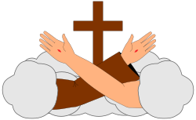

There Is No Vacation From Vacation

I borrowed the above statement from our National Secretary Jane DeRose Bamman who wrote it in her vocations letter. It was also mentioned in Cherryle’s Advent message to all. Imagine if our priests decided to go on vacation without having arranged for another priest to celebrate The Holy Eucharist; or if a married couple decided to go on vacation while their kids were in school without anyone to fulfill their family duties. When we become candidates we are accepted into the Franciscan Order, the Order established by St. Francis himself over 800 years ago. When we profess to Our Rule, we make a permanent commitment and we promise within the Mass, not just once but three times! April 4th, 2020 @ the 8:15 a.m. Mass, Eileen and Phyllis will make their permanent profession into the Secular Franciscan Order. We need everyone there for this joyful occasion. Afterward we will dialogue on profession and what it means, but in the meantime I wanted to include this from Friar Canglelosi OFM Cap. on profession in the Secular Franciscan Order:

There is a widespread opinion among many Franciscan seculars and religious that the Profession of Secular Franciscans is a “second class” commitment, some kind of a “light” Profession.

Indeed, most people have foggy ideas on the value of Profession in the Secular Franciscan Order and because of this many Secular Franciscans do not live the “grace” of Profession for what it really is. A true nuptial alliance with Jesus Christ aimed at a further consecration to God and at accomplishing a closer bond to the Church to reach the perfection of love and the realization of Saint Francis’s mission.

The true and authentic answer is, instead, to be searched in history and in the very nature of our Order as the Sovereign Pontiffs have constantly affirmed:

“…. (Francis) founded a true Order, that of the Tertiaries, not restricted by religious vows, as the two preceding (Orders), but similarly conformed to simplicity of customs and to a spirit of penitence. So, he was the first to conceive and happily carry out, with the help of God, what no founder of regulars (religious Orders) had previously contrived, to have the religious life practiced by all.” (Benedict XV, Encyclical “Sacra Propediem” January 6, 1921).

“… you are also an ‘Order’, as the Pope said (Pius XII): A Lay Order, but a Real Order;” and after all, Benedict XV had already spoken of “Ordo very nominis”. This ancient term – we can say medieval – “Order” means nothing more than your intimate belonging to the large Franciscan family. The word “Order” means the participation in the discipline and actual austerity of that spirituality, while remaining in the autonomy typical of your lay and secular condition, which moreover, often entails sacrifices which are not lesser than those experienced in the religious and priestly life.” (John Paul II, June 14, 1988, General Chapter, SFO).

He mentions many seculars do not live the “grace” of their profession for what it really is. We have truly been given this gift and we are called to serve. We receive so much more than we can ever possibly give. I am so blown away by the overwhelming response from everyone responding to prayers needed. On this earthly journey I have lost my parents, my brother and my sister, yet I have found so many sisters and brothers!
We are Family!

Whoa…… I knew this is what I wanted and told myself right then and there that I would begin prison ministry when I professed. Dora had already started with our newsletter, so why I thought I needed to wait to serve until I professed eludes me, yet I made that commitment to prioritizing the first Saturday of the month for our Gatherings, and the third Saturday for prison ministry. This became my priority and remains so. I had to step back from other ministries and organizations.

Often we do not know what we will be called to do or how to respond, yet if we allow ourselves to be open to His call we are given the gifts of graces to do it. When Gertrude was no longer able to serve as secretary, I agreed to fill in. When the next election rolled around, I agreed to serve as secretary and learned so much from serving. When I was elected minister, I knew I was not even close to those ministers who had come before, such as Rachel, David, and Karen but I committed to serve our fraternity which included traveling to Regional meetings. Once again I can only say, “Whoa!” We truly receive more than we give, even if we spend hours in traffic due to the freeway closing.

When Phyllis and Eileen profess, imagine or remember what you felt during your own profession. Have you lived up to the Promises you made? If you are in initial formation, ask yourself how do I plan to live my vocation?

I will close with the words of St. Francis

“Let us begin, for up to now, we have done nothing.”

Peace
michael

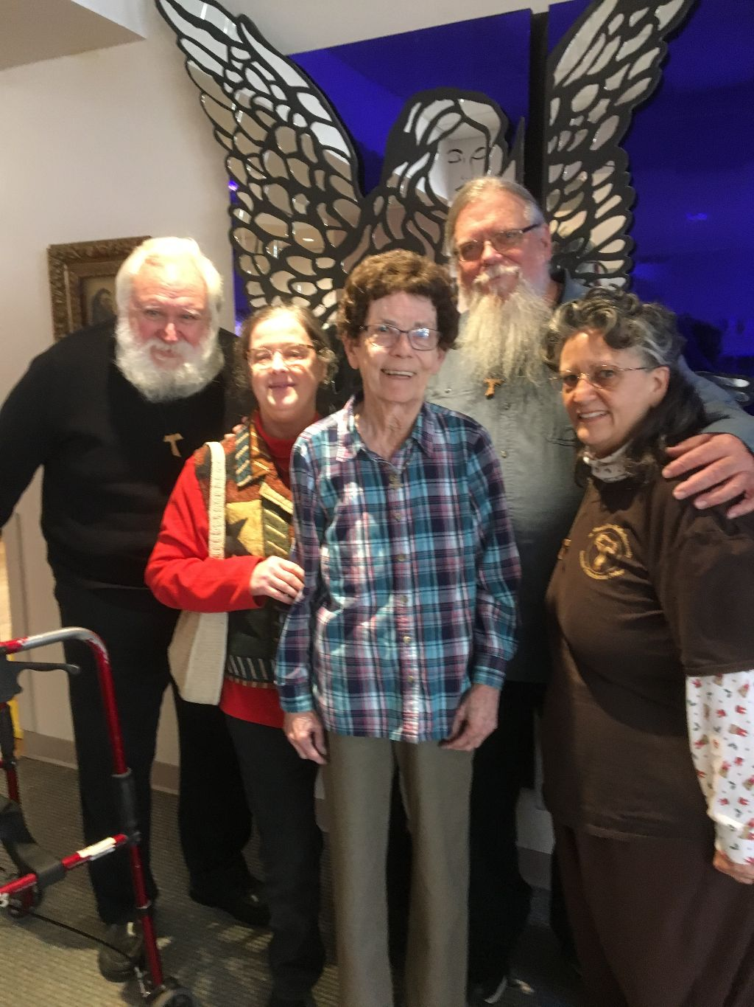
What a blessing it was to visit Adelle at St. Dominic’s! Many of you have not had the opportunity to know her. She professed into the Secular Franciscan Order along with David Schubert on December 8, 1997. She was active with the Kolbe Project even before she became a Franciscan. Her most recent servant leadership position was as Vice Minister with our Fraternity. Let us continue to pray for her, GG & Shelley who are unable to be with us but remain with us in prayer!

Next Meeting: February 1st, 2020 beginning @ 10:00 a.m. in
St. Jerome Catholic Church: In the Outback Building
Bring your Liturgy of the Hours.

The Rite of Profession of Phyllis Prince & Eileen Ike Colleton into the Secular Franciscan Order has been rescheduled due to a previously unknown scheduling conflict. It is now set for April 4th, 2020 to be held at the 8:15 a.m. Mass
St. Jerome Catholic Church Day Chapel

Early Birds: An opportunity to join together in The Holy Mass in the day chapel @ St. Jerome @ 8:15 a.m. Candidates and Inquirers Formation begins @ 9:00 a.m. in the Outback!
See secretary.StMaxSFO@gmail.com for list of items!

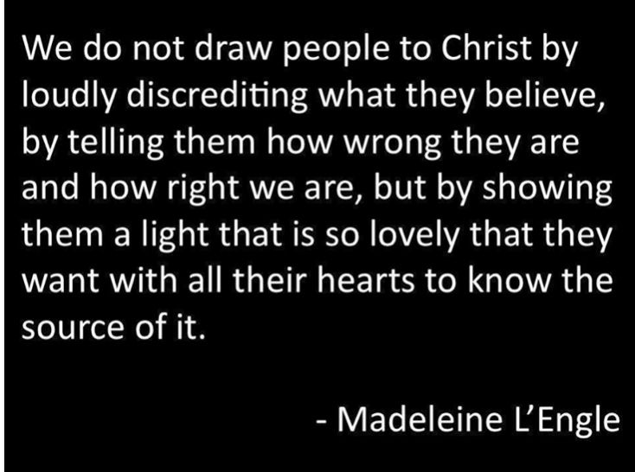

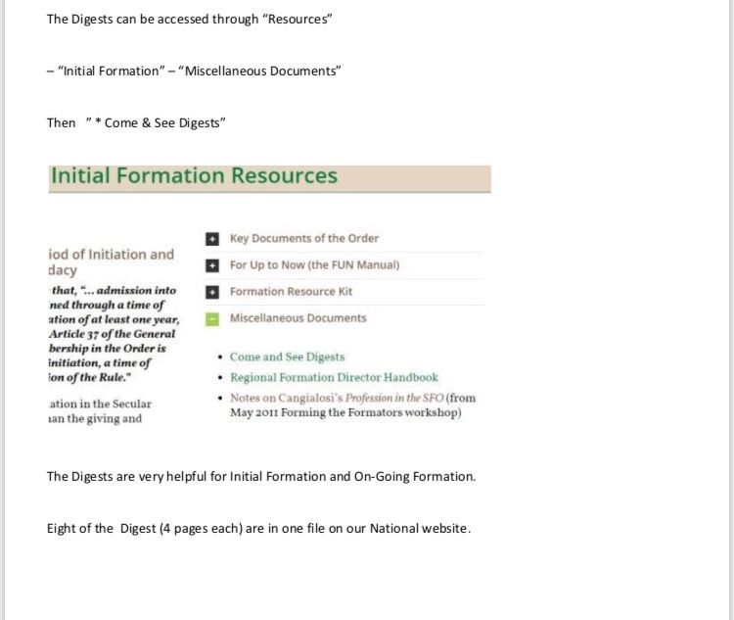

Every 2nd Saturday of the Month, folks from TFP (Tradition Family Property) gather at two locations to pray the Rosary to be a visible sign & witness to our precious Lord Jesus and our Blessed Mother Mary. This month’s emphasis was on praying for America and Keeping Christ in Christmas. December 14th, a few members of St. Maximilian Kolbe Franciscan Fraternity joined TFP to pray the Rosary on the corner of San Felipe & Sage from 12noon to 1pm. The other location is on the corner of Briar Forest and Eldridge. Everyone is welcomed to join in the prayer.

are available in many different colors. If you’re interested in purchasing one, please contact Alba. They are $20/ea. Alba ordered some F.U.N. Manuals (For Up to Now – Foundational Topics for Initial Formation). They do not come with a binder. Purchase price is $13/ea.

$$$ Our contribution bag will be made available at all gatherings. Cash or checks.
Make checks payable to: St. Maximilian Kolbe Fraternity.

Co-Cathedral Caritas Day of Service
February 29th, 2020

Day of Reflection
March 7th, 2020
9:30 a.m. – 4:00 p.m.
@ St. Jerome’s Parish Activity Center (PAC) room “A”.
Join us for 8:15 a.m. Mass. Your help is needed!

St. Joan of Arc Regional Retreat
April 24-26, 2020
St. Charles Retreat Center
Moss Bluff, LA
(April 1, 2020 DEADLINE)

FOR MORE INFORMATION ABOUT EVENTS & FORMS, PLEASE REFER TO E-MAILS FROM secretary.StMaxSFO@gmail.com

Living in the Splash Lane

Call to me and I will answer you and tell you great and unsearchable things you do not know. Jeremiah 33:3 (NIV)

“Can we sit in the splash zone?” My teenage son and his younger cousin looked so eager that I immediately okayed it.
“I’ll sit with them,” I told my parents, handing Mom my purse. “We’ll find you afterward.”
I’d never sat in the splash zone during a killer whale show before – the area of the bleachers where you’re guaranteed to get soaked. This theme park focused on education, so the orcas wouldn’t be performing tricks. How soaked would we get? The answer to that was extremely!
Every demonstration of a whale’s strength and power, every tail smack and fin swish, sent a tidal wave into the splash zone. By the end of the show I was drenched, but I didn’t care. I’d progressed from dreading each splash, wondering, What was I thinking? to accepting them as part of the fun. I’d discovered a benefit of sitting in the splash zone: having low vision, I could see the beautiful orcas as they leaped, beached themselves on the platform, and lifted their mighty tails. Experiencing those amazing creatures up close had been worth the price of getting my hair and clothes wet.
After that afternoon, orcas became my reminder that experiencing God’s power and beauty requires a willingness to sit in the splash zone sometimes. How often does he call his people to stay where it feels comfortable? Sure, he meets us in the mundane, but we miss out on a lot by living there. When we say yes to his calls to be a little adventurous, we might have moments when we wonder what we were thinking, but then his wave hits and we’re so thankful we obeyed.
By Jeanette Hanscome

What is God calling you to do that requires willingness to do something different? Ask a few friends to pray for you as you take this step of courage. Keep a journal of your experiences with Him during the adventure.

Excerpt from: All God’s Creatures
Daily Devotions for Animal Lovers

