Secular Franciscan Order FEBRUARY 2021 Newsletter

The Secular Franciscan Order was established by St. Francis of Assisi more than 800 years ago. Our purpose is to bring the Gospel to life where we live and where we work. We look for ways to embrace the Gospel in our lives and try to help others to do likewise.

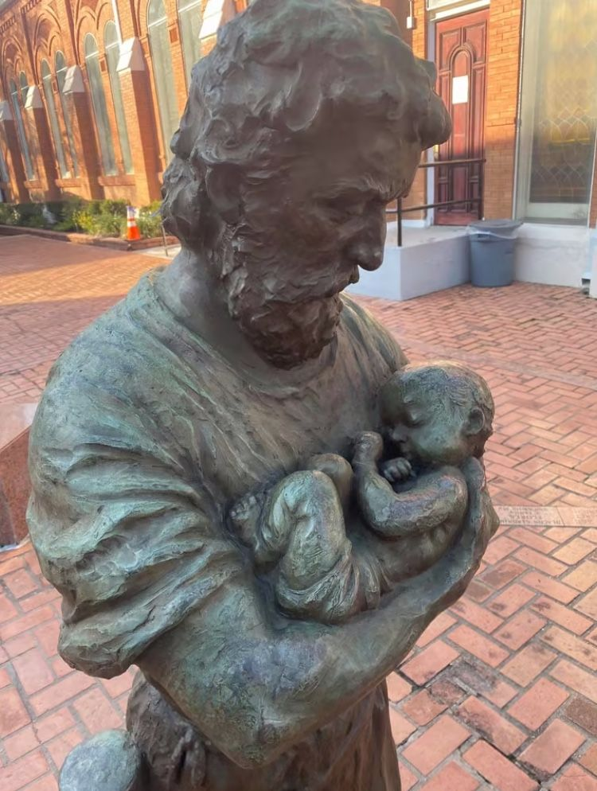
St. Joseph, pray for us! God so loved the world…..
1.
Our Gathering
On February 6, 2021 we met virtually & in person, giving members a choice due to safety concerns relating to the pandemic.

Ike led us in the Candle Prayer as we remembered all past, present and future members of our Franciscan family. It truly brings us all together in harmony.

We lent our voices to a beautifully arranged, composed and sung John Michael Talbot song based on a writing of St. Teresa of Avila, “Christ Has No Body But Yours”. It was a ponder worthy reminder of how precious service is to our Lord and Savior, Jesus Christ.

Dora read The Testament of St. Francis found on page 76 in the Ritual Book. A heartfelt discussion followed with many thoughtful sharing’s. Mike had prepared a closing prayer but it was so appropriately matched to this reading and discussion that he shared it at this time. It was the found next to a dead child at the Ravensbruck concentration camp asking for forgiveness, mercy, & peace.

We were asked to think about a rose and share something beautiful, gleaned from this time of pandemic. What is blooming? Think of the rosebud, what is coming? Roses have thorns. What has been our struggle?
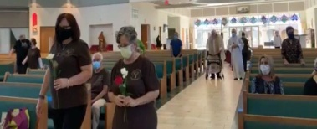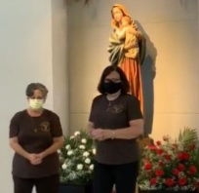

Prior to continuing our discussion of Pope Francis’s third encyclical, Fratelli tutti on fraternity & social friendship, we looked at Article 99 from our General Constitutions (also Article 6 from our rule).

Dora then shared an article by Fr. Dave Pivonka, TOR. In this article he stressed that most issues are moral, of the heart, and not political. Fr. Dave believes if we live our lives as honestly and humbly in the footsteps of Jesus and St. Francis, we have the opportunity to be better evangelizers than priests. People expect the clergy to respond in a certain way, yet those of us in the secular world can have a lasting positive influence when we go from Gospel to Life, Life to Gospel in our day to day lives. We can do as St. Francis did, rebuilding the Church, starting with ourselves and then one person at a time.

We had a traditional closing from our Ritual book.

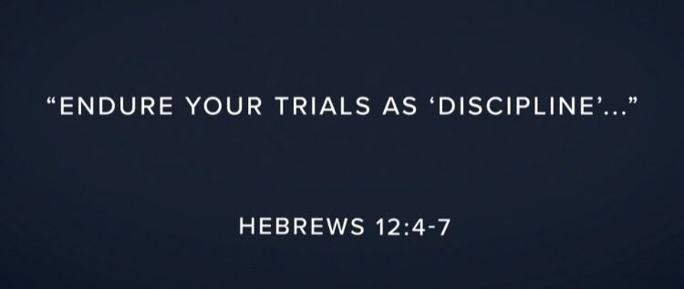

If you don’ heal from what hurt you, you will bleed on people who didn’t cut you…..

2
Greetings Sisters and Brothers
As I sit here in front of my computer I am blown away about this wondrous world our Heavenly Father created. The sun is shining, the sky is blue, and temperatures are fast approaching the mid 30’s. Our 4 legged companion Gypsy spent extra time this morning sniffing around…..no worries at all; joyful she had the opportunity to once again enjoy her own little piece of paradise.
Today is the first Friday of Lent. There are things that I know I must do to try and get back to where we were prior to this winter storm. The freeze clothes are all soaked… I need to spread them out to dry, fold them up and store for the next freeze… you get the point; so many things “to do”…..but what do I “have” to do really? What do I really need?
It has been said that for Franciscans everyday is Lent. We are called to conversion every day, going from Gospel to Life, Life to Gospel. I remember a poem by Lester Bach, OFM in Catch Me A Rainbow, Too, how we can frame each day within two bookends… the first on being Hope as we rise, the other being Gratitude. Everything in between is living the Gospels, following Christ in the footsteps of Francis and Clare.
I am keeping this brief as I want to include the following article. Looking forward to our March gathering!
Peace
Michael

Below is an excerpt from a series of articles by the late Deacon Tom Bello, OFS, former National Minister of the Secular Franciscan Order – USA. “Many of these essays were originally published in TAU-USA, our national newsletter,” said Jan Parker, OFS, current National Minister. “They are excellent for reflection and ongoing formation.” These were messages he sent out as National Minister and Each of them are excellent for reflection and/or ongoing formation,” said Jan Parker, OFS, current National Minister. She Jan helped Tom publish these articles the essays in book form. It is called For All The Saints: St. Francis’s Five-Point Plan for Salvation and is available from Tau Publishing.

3.

Brothers and Sisters of Penance – Five Point Plan pg 19-21
When St. Francis called us into an Order in the very beginning and wrote our Rule, he considered and named us, “Brothers and Sisters of Penance.” Let us spend a few moments in this Lenten Season unpacking our name.
“Brothers and Sisters” are, of course, a family, mutually interdependent, hopefully loving, certainly related by blood, in our case, the blood of the Lamb.
Beyond that, in the Prologue to our Rule, Chapter One, Concerning Those Who Do Penance, we read:
“All who love the Lord with their whole heart, with their whole soul and mind, with all their strength (cf. Mk 12:30), and love their neighbors as themselves (cf. Mt 22:39) and hate their bodies with their vices and sins, and receive the Body and Blood of our Lord Jesus Christ, and produce worthy fruits of penance.
Oh, how happy and blessed are these men and women when they do these things and persevere in doing them, because “the spirit of the Lord will rest upon them” (cf. Is 11:2) and he will make “his home and dwelling among them” (cf Jn 14:23), and they are the sons of the heavenly Father (cf. Mt 5:45), whose works they do, and they are the spouses, brothers, and mothers of our Lord Jesus Christ (cf. Mt 12:50).”
Thus, loving God and our neighbors, hating our sins, receiving the Sacred Body and Blood and producing worthy fruits of penance make us one family in Christ, just as Christ will say, “For whoever does the will of my heavenly Father is my brother, and sister, and mother” (Mt. 12:50).
What then is penance? What are “worthy fruits of penance”?
“Penance” is our Lord’s first call to us, seen in the very first words Jesus utters in what scholars tell us is the very first written Gospel: “This is the time of fulfillment. The kingdom of God is at hand. Repent, and believe in the gospel” (Mark 1:15 NAB revised).
4.
This is the call of Lent. This is that call in our Rule ( Article 7): “United by their vocation as ‘brothers and sisters of penance’ and motivated by the dynamic power of the gospel, let them conform their thoughts and deeds to those of Christ by means of that radical interior change which the gospel calls ‘conversion.’ Human frailty makes it necessary that this conversion be carried out daily.”
This is indeed our Christian journey, and St. Francis in the Prologue to our Rule presents a life of penance, a life spent turning away from sin and living in Christ, as the only possible response to our all-mighty, all-holy, all-loving God.
Living in Christ, living as Christ lived, then, produces the worthy fruits of penance: prayer, praise, humility, charity. For Francis and for his followers, Jesus Christ is the focus for our penance; Jesus Christ is the way of penance. The primary struggle of penance is thus that daily need to turn away from sin and self and to turn toward Christ and the Gospel.
Since Jesus is always present, so the kingdom of God is always present if we only repent and believe the Gospel. This is that third of the marvelous Luminous Mysteries announced by our late Holy Father John Paul II: The Proclamation of the Kingdom and the Call to Penance or Repentance since we need to do it again and again day after day.
When I pray this third Mystery of Light, I try always to offer this decade of the Holy Rosary for us, the Brothers and Sisters of Penance, the Secular Franciscan Order and for all our Franciscan family here and throughout the world. Might I beg you to do the same?
Let us pray: “Heavenly Father, in Your great mercy, You have called us to imitate and grow closer to Christ, Your Son, by following in the footsteps of Sts. Francis and Clare. Help us, please, to turn away from sin and to be faithful to the Gospel as Christ gives us the grace. Help us to go constantly from Gospel to Life and from Life to Gospel. Help us always to pray for and to support our brothers and sisters in our common call to Penance. Help us to offer ourselves as did Your Son in loving service of that kingdom where you live with the Son and the Holy Spirit, one God forever and ever. We pray in Jesus’ name. Amen.”

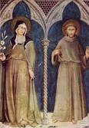
5.
Next Meeting: March 6th, 2021
10:00 a.m.in person & via ZOOM
Candidates & Inquirers in Formation: check your emails for more information
Our Gathering will be IN PERSON & via Zoom
Look for an email from Mike Freeman for log-in information.

(Due to COVID-19, our projected elections date will be pushed forward to May 2021, giving us time to continue our discussion on Fratelli tutti)

Fratelli tutti means “All the Brothers”

The year 2021 has been declared by the International MI Council as the Celebration of the 80th Anniversary of St. Maximilian’s Martyrdom at Auschwitz, August 14, 1941. His martyrdom is honored precisely for
the virtue of charity, not the usual virtue of faith!

We are continuing the SUNDAY Meal Sign Up for Deacon Louis & Jean Horr.
See email on 11-19-20 from secretary.StMaxSFO@gmail.com

Alba ordered some F.U.N. Manuals (For Up to Now – Foundational Topics for Initial Formation). They do not come with a binder. Purchase price is $13/ea.

$$$ Continue to save money for our contribution bag when next we meet in person.
Cash or checks made payable to: St. Maximilian Kolbe Fraternity.

David Schubert has invited us to contribute a meditation, prayerful musing, poem, joke, famous quote, anything that might lift the spirits of the men in prison at the Ellis Unit. He’s been sending a “Newsletter of Encouragement” out monthly since due to the pandemic, they are unable to visit in person. If interested in being a part of this great resource, contact David at (832) 567-7813. He’d be grateful for your contribution.
6.
Regional Crown Rosary will be prayed together via ZOOM each month on the 4th Sunday. If interested in being included in receiving ZOOM information, please contact Cherryle Fruge, OFS, Minister-St. Joan of Arc Region: cherrylefruge@msn.co

A Spanish version of the TAU-USA is now available and being mailed to Spanish speaking members upon request. Email your name, address, fraternity name & region name to:
Cindy Wesley OFS, cw93444@gmail.cm Or mail request to:
Cindy Wesley OFS
846 Calimex Place
Nipomo, CA 93444

Every Day for PRAYER!

The Cross and JPIC
Franciscans in Bolivia: A Case Study
March 27, 2021
1pm-3pm Pacific Time
RSVP: patriciaelizabethgrace7@gmail.com

There are LOTS of ways to become involved.
Reference emails from Ryan @ secretary.StMaxSFO@gmail.com and emails from Michael @ mbigfree@aol.com for specifics!

April 2021 Meeting will be 4-3-2021
Holy Saturday – Easter Weekend

7.
What the Pigs are Having
Do not fret because of evildoers, nor be envious of the workers of iniquity. Psalm 37:1

Mojo stared at the pigs. He knew not to approach the electric fence, but he as as close as he could get without feeling the shock. His tongue hung out, and the look in his eyes was mesmerized longing. On the other side of the fence, my daughter’s two pigs devoured the table scraps she had tossed over to fatten them.

Mojo is her beloved rescue dog (and one of my favorite dogs in the world). He lives inside her house. He sleeps on or beside Hannah’s bed. He’s pampered, petted, and provided the best dog food and treats available.

The pigs aren’t even given names because soon they will meet their intended fate. They sleep in a wooden shelter outdoors and aren’t free to roam the yard the way Mojo does. They rummage in the ground, eat their swill, and enjoy the occasional gift of scraps.

But Mojo envied their lot.

For the first time, I understood how ridiculous it looks to God when I envy the pleasures enjoyed by those outside His family. But even from my secure place inside God’s family, I occasionally envy them the worldly feast in which they indulge.

God showed me my own heart as I watched Mojo, and I felt a new level of humility impress my spirit. I belong to the very family of God and have a place at His table. Whatever makes me sometimes long for more?

Walk of Faith: When I feel tempted to envy the worldly pleasures enjoyed by someone who rejects Jesus, I’ll remember I reside in the house of God. I’ll list the joys that are mine because God counts me a member of His household.

Author: Lori Stanley Roeleveld
Guideposts - All God’s Creatures
Daily Devotions for Animal Lovers
January/February 2021

8.
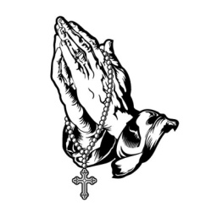
Healing prayers for Michael Freeman & his diagnosis of prostate cancer

Healing prayers for Consuelo Davis

Healing Prayers continue for Joan & Deacon Louis Horr

Fr. Mike requests prayers for all who have been infected with COVID-19 & all who have died.

Claire Dwyer: pray for her daughter Shannon, suffering from anxiety & depression.

Continued prayers for Alan Allen, his fellow coworkers & all seeking sustainable employment! Pray for peace, patience & renewed hope.

Pray for continued success for Alan & Fabiola in their ministry of YouFra.

Ryan Efaw, Caitlyn & child: Expected due date is May 24, 2021! Pray for good health for mother, child and of course, daddy!

Pray for Fr. Stephen Arabadjis & all priests & seminarian in the Society of St. Pius X.
May they recognize God’s Will for their lives & be open to His direction.

Pray for all Priests and Seminarians throughout the world.

Pray for Martha Restrepo (healing of eyes), her Husband Holbein (cancer treatments) &
son in law Deacon Robert Trahan (bypass surgery & good heart health)

Fabiola requests prayer for baby Jacob (twisted intestines) & child Leo (broken nose/hand, punctured liver). May their healing be quick.

Pray for Chuck, Mary Pierson’s husband, for healing & successful treatment for very serious cancer diagnosis. Radiation begins 3-2-2021. Praying radiation will help lessen his pain.

Pray for Amy Le’s daughter-in-law who is pregnant and due 3-5-2021. Pray for good health for both mother and child.

Pray for all who experienced damage due to the recent freeze. Pray damages will be corrected soon and all will be blessed with extra money!!!

Pray for Benjamin Joseph Turk that the ultrasound on his thyroid will show a good report.

Pray for Shelley Barger & GG who are both in scooters, unable to walk. Shelley will be undergoing scans at the hospital. Pray outcome will be a favorable one.

Pray for Carla Lewton’s mother Barbara who has been steadily declining. Pray family will find a wonderful healthcare facility that will be agreeable to Carla, her two brothers & Barbara.

Remember to email Ike ecolleton@comcast.net for prayer requests to be included in Newsletter

Make sure you make room in The Rule for THE RULER! 9.

