Secular Franciscan Order March 2021 Newsletter

The Secular Franciscan Order was established by St. Francis of Assisi more than 800 years ago. Our purpose is to bring the Gospel to life where we live and where we work. We look for ways to embrace the Gospel in our lives and try to help others to do likewise.

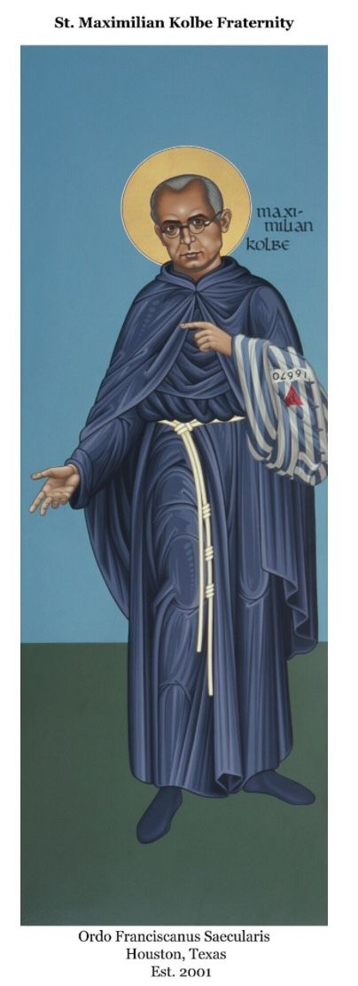
1.
Our Gathering
On March 6th, we met virtually & in person, giving members a choice due to safety concerns relating to the pandemic.

Our Holy Father’s intention for March: Sacrament of Reconciliation
Let us pray that we may experience the Sacrament of Reconciliation with renewed depth, to taste the infinite Mercy of God.

Mike welcomed everyone, reminding us: HAPPY 20th ANNIVERSARY of St. Maximilian Kolbe Fraternity’s Canonical establishment and a big shout out to Fr. Mike Van Cleve on his 20th Anniversary of Priestly Ordination, which was in February!

Connie led us in the Candle Prayer as we remembered all past, present and future members of our Franciscan family. I always appreciate hearing the names of those who have gone before us and calling to mind those who cannot be with us.

We were all given an opportunity to check in and make our presence known as having our Gathering part virtual and part in person makes it difficult to know who all is in attendance. It was great to at least hear voices!

Mike asked Benjamin Turk to read a prayer he had written on becoming a living Tau. Benjamin has a remarkable gift! Then we all participated in our Opening Prayer from our Ritual book, page 35.

Last year at our March gathering we were blessed to have Brother Tim Lamb, OFM come to Houston and lead us into our Lenten Day of Reflection. The topic was the discernment of God’s Will. Little did we know at that time what the pandemic was to bring! Brother Tim had begun his Franciscan journey as a Secular Franciscan right here in Houston!
Mike read a letter he had written years ago to the prisoners of Ellis Unit, of whom our fraternity continues to serve. In this letter he remembers Fr. Dennis Borca, OFM who was one of the original friars who came to Houston and established the Kolbe project. Through his discernment & service to the men in white; for whom he initially thought was for their conversion, God called him to become a Friar. He is now the Vocations Director for the St. John the Baptist Province of the OFM.

While we did not have a Day of Reflection this year due to COVID, we are always called to discern in our day to day lives as Secular Franciscans what it is in each moment our Heavenly Father is calling us to do.

Dora walked us through a calming meditation & used the writings of Fr. Murray Bodo, OFM, excerpts taken from the book “Clare-a Light in the Garden”. We are urged to embrace the Franciscan Way of Life daily. The question was asked: “What manner or way is God calling you to witness?” Sometimes the ways are seasonal, changing with our own growth in the Lord. Discerning the Lord’s call is necessary to visit often; as St. Clare advises, daily!

Mike included an interesting handout on the origins of the Stations of the Cross. Years ago, people were unable to make the Holy Land walk down the Via Dolorosa so a local “way of the cross” was created, allowing us to walk the walk with Jesus. Refer to the handout for more in depth information. Alan Allen presented a unique Way of the Cross from a script that was used with his church’s R.C.I.A. program. We made Christ’s 14 Stations of the Cross journey with Christ through readings, meditations & convicting questions; following along with Mel Gibson’s movie, The Passion of the Christ. It was so moving and definitely thought provoking. One of the best I’ve ever participated in. Thank you, Alan for bringing us this gem.

We then had time for intercessory prayer, lifting up our loved ones and those issues weighing heavily on our hearts for the mercy of God to be felt. Fr. Mike was unable to be with us today as he was with the Pierson Family, ministering to the spiritual needs of Mary & her beloved spouse, Chuck. Mary's heartfelt prayer is God bless Chuck with a miracle healing. Thy Will be done, Oh Lord!

We ended our Gathering with the traditional closing from our Ritual book, page 36.

2
Greetings Good People
Words Matter
Words…..
I do not have actual data to support this but I believe if I had half a dollar for every word I should not have uttered I would be in the same financial category as Warren Buffet. A quote attributed to Bruce Lee speaks volumes” words are energy and cast spells…that’s why it’s called spelling”.
Another adage I have found to be true is words that cause pain are like a nail put into a wooden fence. You can seek forgiveness and pull the nail out, but the hole remains.
Words….
Many things that we say are responses that reflect our conditioning as well as implicit bias. Other times we have taken the time to discern and choose. When I used to interact with administrators and teaches on campuses I would usually choose my words carefully.
When I was in the Church that beautiful day in May of 1975 and said “I Do” I meant it. I chose to marry Dora .The “energy” was, without a doubt, the Holy Spirit in action. We would often joke that God knew exactly what He was doing when he arranged for 2 priests to witness our Marriage as we sure needed it at times!
When I began to discern the Secular Franciscan Order I had several years to choose if this was what I wanted. When I professed during the Mass the Holy Spirit once again guided and animated me. We promise and say not once but 3 times during the Rite of Profession that this is what we want and that we will” be faithful to this vocation and to practice the spirit of service proper to Secular Franciscans” and that we “promise to live all the days of our lives the gospel of our Lord Jesus Christ in the Secular Franciscan Order by observing its rule of life”.
Our National Fraternity has recommended that all Regional and Local Fraternities begin to unpack and study Instrumentum Laboris (IL) this year. (I will resend as we will refer to this document at our April 3rd gathering). The Regional Formation team presented on this recently and we will also be addressing it in the upcoming months
3
In the latest issue of the Tau, our National Minister Jan Parker writes:
“Our General Constitutions states, “The brothers and sisters are co-responsible for the life of the fraternity to which they belong and for the OFS as the organic union of all fraternities throughout the world.” (GC 31.1) Think about this. We are responsible not only for the life of our own local fraternity, but for the entire Order. The IL stresses this point as well, addressing all of us and stating that “in order to achieve our goals, we must deepen our sense of co-responsibility.” All members must be attentive to the call to prophetic creativity. We must ask ourselves⎯ what is my part?
Words Matter. What is my part?
Co-responsibility. We are a true Religious Order. We are not Franciscans only on the first Saturday of the month. In formation we learned (or should have learned) this becomes our priority. This is the main reason we always gather on the first Saturday which allows us to set our calendars.
The Holy Spirit qualifies the called, not calls the qualified. I have long said I was not enough, nor close to being able to be as good a minister nor compare my abilities to Karen, David, or Rachel, but I promised to serve and fulfill my responsibilities as best I could and took this responsibility seriously.
We are to serve, not expect to be served. I am praying that you allow the Holy Spirit to guide you and know you will be supported.
The Secular Franciscan Order needs you.
Say Yes to serving on our Council!
While we are on the subject of elections……
Last year when we enter the pandemic our National Fraternity developed guidelines for all of us to remain safe. We started our adventures on Zoom and have gathered in person as often as safety and protocols from our Arch-Diocese mandated.
For our election in May we all need to gather in person. Safe distancing will be certain as we have the entire Fr. Raye center so we could even be 10 feet apart!
Below is part of the guidelines issued for safety:

Guidelines for Fraternal Life During Social Distancing

4
Fraternity Council Elections
Fraternity members, the appointed Presider and Ecclesial Witness must be physically present for an election. Elections involve voting by secret ballot, and this cannot happen by teleconference, phone or email. Mail in ballots are not acceptable for the following reasons: the reading of ballots must be overseen by the Presider and Ecclesial Witness, and there are multiple elections and a changing slate. Elections that cannot be held safely must be postponed.
Our election was due in February so we rescheduled as it was not safe at that time.
peace
michael

Our local fraternity will be holding our election in May. This cannot be done virtually. We need the entire fraternity to be physically present. The Fr. Raye center is huge; so maintaining a safe distance is easy. Only professed members have a voice in voting yet others are needed.

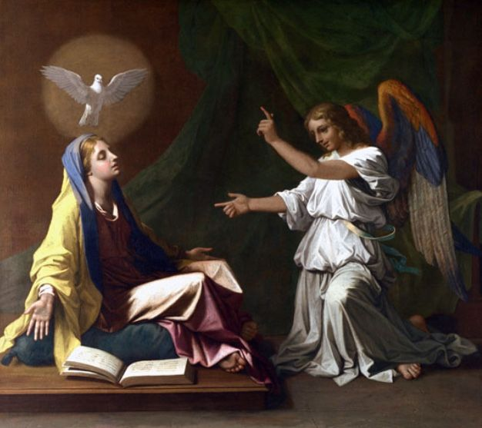
5.
Next Meeting: April 3rd, 2021- Holy Saturday
10:00 a.m.in person & via ZOOM
Candidates & Inquirers in Formation: check your emails for more information
Our Gathering will be IN PERSON & via Zoom
Look for an email from Mike Freeman for log-in information.

We are continuing the SUNDAY Meal Sign Up for Deacon Louis & Jean Horr.
See email on 11-19-20 from secretary.StMaxSFO@gmail.com

Alba ordered some F.U.N. Manuals (For Up to Now – Foundational Topics for Initial Formation). They do not come with a binder. Purchase price is $13/ea.

$$$ Continue to save money for our contribution bag when next we meet in person.
Cash or checks made payable to: St. Maximilian Kolbe Fraternity.

David Schubert has invited us to contribute a meditation, prayerful musing, poem, joke, famous quote, anything that might lift the spirits of the men in prison at the Ellis Unit. He’s been sending a “Newsletter of Encouragement” out monthly since due to the pandemic, they are unable to visit in person (this might have changed. Waiting for an update). If interested in being a part of this great resource, contact David at (832) 567-7813. He’d be grateful for your contribution.

Regional Crown Rosary will be prayed together via ZOOM each month on the 4th Sunday. If interested in being included in receiving ZOOM information, please contact Cherryle Fruge, OFS, Minister-St. Joan of Arc Region: cherrylefruge@msn.co

6
A Spanish version of the TAU-USA is now available and being mailed to Spanish speaking members upon request. Email your name, address, fraternity name & region name to:
Cindy Wesley OFS, cw93444@gmail.cm Or mail request to:
Cindy Wesley OFS
846 Calimex Place
Nipomo, CA 93444

Every Day for PRAYER!

Fraternity Council Elections coming up
May 1st, 2021

Living Franciscan Virtues in our Contemporary World
Secular Franciscan Conference
June 28 – July 1, 2021
$50.00

Funeral Mass for
Gabriel Harkay, OFS
Saturday April 17th, 2021 @ 1:30 p.m.
Prince of Peace Catholic Church (Mary Chapel)
19222 Tomball Parkway – Houston, TX 77070

There are LOTS of ways to become involved.
Reference emails from Ryan @ secretary.StMaxSFO@gmail.com and emails from Michael @ mbigfree@aol.com for specifics!

May 2021 Meeting will be 5-1-2021
7
Tiger, Tiger, Burning Bright

Like newborn babies, crave pure spiritual milk, so that by it you may grow up in your salvation. 1 Peter 2:2

Going to Aunt Sandy’s house is always an adventure. My youngsters never know what sort of critter they might find curled up on her sofa or safely caged in the yard. As an experienced wildlife rehabber, my sister cares for injured fawns and foxes, crippled ducks, and even an ailing wolf. One summer, she took in three tiger cubs. One had been injured by its father at a small zoo and needed medical attention. The others had been taken from their mother at six weeks old to be bottle-fed, so they could get used to human contact. They would be used for educational purposes at schools and other venues.

What fun it was to cuddle on the couch with a tiger cub or romp with the cubs in the yard! Enthusiastic eaters, the cubs latched on to their bottles filled with formula. How cute they were with milk dribbling down their chins. Watching them feed so eagerly brought to my mind the Bible verse urging believers to crave spiritual milk. I paused to consider my own appetite. Did I read my Bible every day with enthusiasm? My sister would never have fed those growing cubs potato chips and other junk food, expecting them to thrive. Why would any of us think our spiritual lives could thrive without being properly nourished too?

I want to grow strong in my faith, so I need to fill myself with God’s Word. Sandy’s cubs drained their bottles and eagerly looked forward to their next meal. I want to be like that, too, when it comes to feasting on God’s Word.

Jesus answered, “It is written: ‘Man shall not live on bread alone, but on every word that comes from the mouth of God.’ “ Matthew 4:4

Author: Shirley Raye Redmond
Guideposts - All God’s Creatures
Daily Devotions for Animal Lovers
January/February 2021

8.
Healing prayers for Michael Freeman & his diagnosis of prostate cancer

Healing prayers for Alan Allen’s 90 yr old Mother-In-Law who had cholecystectomy 3-30-21 & for strength for his Father-In-Law, his wife & her sister. May Alan be given the wisdom words & peace to comfort all his family.

Healing Prayers continue for Joan & Deacon Louis Horr

Prayer request for Elizabeth Kileen, our Regional Vice Minister for a successful kidney surgery.

Claire Dwyer: pray for her daughter Shannon, suffering from anxiety & depression.

Continued prayers for Alan Allen, his fellow coworkers & all seeking sustainable employment! Pray for peace, patience & renewed hope.

Pray for continued success for Alan & Fabiola in their ministry of YouFra.

Ryan Efaw, Caitlyn & child: Expected due date is May 24, 2021! Pray for good health for mother, child and of course, daddy! It’s coming up soon!!!

Pray for Fr. Stephen Arabadjis & all priests & seminarian in the Society of St. Pius X.
May they recognize God’s Will for their lives & be open to His direction.

Pray for all Priests and Seminarians throughout the world.

Pray for Martha Restrepo (healing of eyes), her Husband Holbein (cancer treatments) &
son in law Deacon Robert Trahan (bypass surgery & good heart health)

Fabiola requests prayer for her Confirmation sponsor Ian & his elderly parents (mum:cancer surgery/dad:possible dementia diagnosis & confusion while separated from his wife as she recovers).

Pray for the repose of the soul of Chuck, Mary Pierson’s husband, who died 3-8-21. Mary prayed for a miracle and Chuck received the miracle of Eternity with Christ! Sincere heartfelt condolences to the Pierson Family.

Pray for Benjamin Joseph Turk that the ultrasound on his thyroid will show a good report.

Pray for Shelley Barger & GG who are both in scooters, unable to walk. Shelley will be undergoing scans at the hospital. Pray outcome will be a favorable one.

Pray for Carla Lewton’s mother Barbara who has been steadily declining. Pray family will find a wonderful healthcare facility that will be agreeable to Carla, her two brothers & Barbara.

Is Amy Le a new grandma? Have not received an update……

Remember to email Ike ecolleton@comcast.net for prayer requests to be included in Newsletter

Make sure you make room in The Rule for THE RULER!
9.
The Chick at Baby Animals Day

Therefore, if anyone is in Christ, the new creation has come: The old has gone, the new is here!
2 Corinthians 5:17 (NIV)

Spring felt very far away. Late into March, it was still cold and snowy, and I was feeling as empty and dark as the bare branches outside. I was sick of the chill, but at least I had something good to hold on to – Baby Animals Day at a nearby farm, held each spring around Easter. I don’t know who was more excited – me or my young granddaughters. “Ten more sleeps until baby animals,” I told them one day, just as I counted on my calendar.

Finally, the day arrived, and Grace, Lily, and I rushed into the barn to meet the animals. I leaned over a tidy pen. There in the hay was a muddle of tiny yellow chicks. Their soft feathers puffed over stubby orange legs. “They just hatched,” the farmhand said. “They’re only ten days old.” One of the chicks scuttled over my way, chirping cheerfully. I used one finger to stroke its downy back. Peep! Peep! It jumped into my palm, and I cradled it close to my chest. This brand-new life, from within its hay-strewn pen, lifted the heaviness I had been carrying and brought me joy.

Ten days ago, this chick was safely tucked inside its brown speckled egg. Ten days ago, I was empty and discouraged. I couldn’t see the beautiful new life that was waiting. But it was there. I don’t know why I forget, but every spring I’m reminded – some days seem dark and dreary, but if I’m patient, I will see everything renewed as I celebrate the light of Christ.

Dear Father, in the spring, in baby chicks, and in our eternity with You in heaven, thank You for Your miracle of new life. Amen!

Author: Peggy Frezon
Guideposts - All God’s Creatures
Daily Devotions for Animal Lovers
March/April 2021

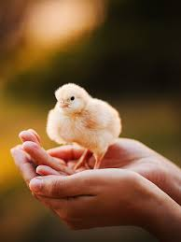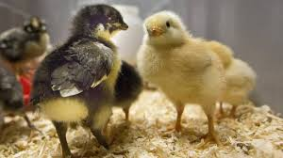
10

