Secular Franciscan Order February 2019 Newsletter

The Secular Franciscan Order was established by St. Francis of Assisi more than 800 years ago. Our purpose is to bring the Gospel to life where we live and where we work. We look for ways to embrace the Gospel in our lives and try to help others to do likewise.

2019 is the 41st year of our current Rule approved in 1978!

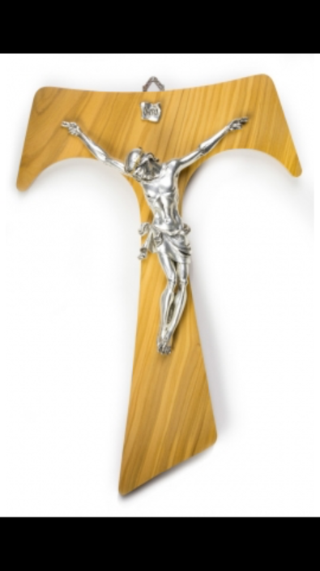
“God So Loved the world…..”

Our Gathering
February 2nd, 2019 We began an exciting celebration of FIVE Professions in the Day Chapel @ St. Jerome’s Catholic Church.
Alan Allen, OFS; Danny Marquer, OSF; Maria Marquer, OSF; Cindy Borgerding, OSF; & Fabiola Cespedes-Pena, OSF. What a beautiful ceremony celebrated during our Holy Mass.
A joyous & Holy occasion to be sure! 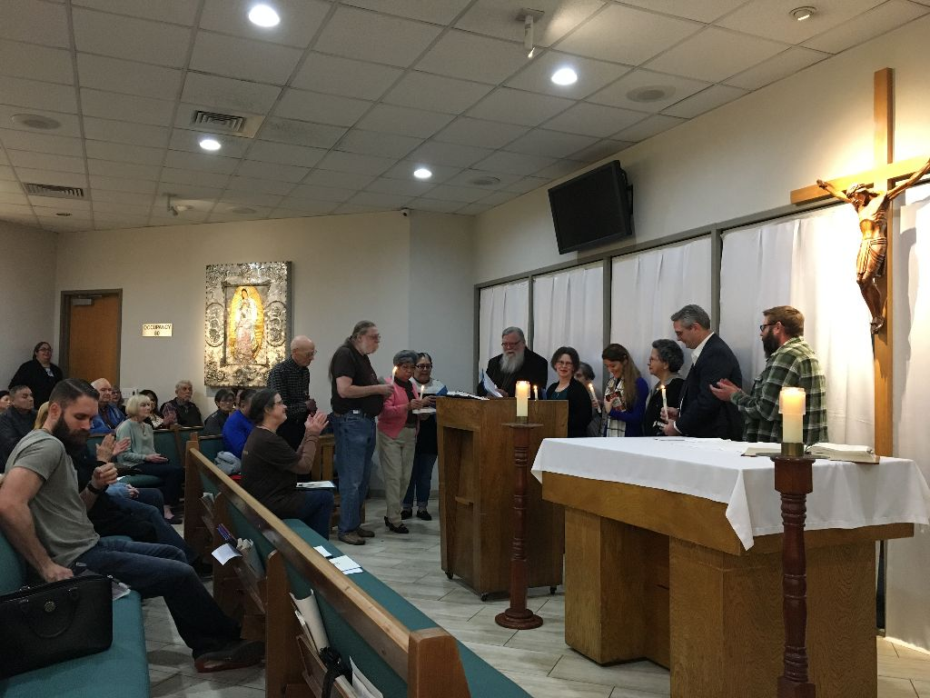
It was beautifully organized, everything ran smoothly. It was all so heartfelt and touching & the beautiful music led by Fe Santiago & Eileen Colleton added so much to it. Our Church, our Order and especially our Fraternity are all so blessed!

Our celebration continued in the Outback building with Agape and delicious goodies we brought to share. Connie, once again, outdid herself with decorating our space. Michael Freeman invited all our guests and visitors that had time, to stay for our short meeting. Alba Hernandez prayed our candle prayer for the three orders of our Franciscan Family; past, present and future. Joe Swonke read a passage from “The Simple Way” by Fr. Murray Bodo, OFM. Much thoughtful discussion followed. Sharing was heartfelt and time was given for each newly professed member to speak about their experiences in Formation and Profession. We all read a Prayer for Healing Victims of Abuse in remembrance of all involved, including their families who are suffering too! Michael Freeman, OFS led us in the Closing Prayer from the Ritual of the Secular Franciscan Order, page 36. The rest of our time was spent in service as we joyfully filled 50 bags of toiletry items for those immigrants who come to Houston seeking help from Casa Juan Diego the Catholic Worker house here in Houston.

AVAILABILITY
This is the word I pulled from the bowl; printed on the little slip of paper that Dora had us choosing from at our last gathering .Availability….a pretty fitting word for someone who has just left a job of 30 years. I folded it up and put it on the end table when I got home. I had given it some thought and realized how appropriate it was for me. I recently realized that my most valuable treasure is time. I could no longer stay in a job that gave me no joy nor can I go to meetings just to meet. I guess I am not a big fan of Roberts Rule of Order nor of a gavel.
It has often been said that God is not looking for ability, but availability. I have found this to be so true and I want to repeat for the sake of our newly professed what I said when I was first elected Minister. I knew I was not as qualified, good, or as holy as my immediate predecessors Karen, Rachel, and David. I was available though. My promise was that I would represent us by traveling to Regional gatherings and perform the responsibilities of this position to the best of my ability. This fraternity at all levels has strengthened me on my journey and I know if I had not been available the Holy Spirit would not have provided me the graces I have been given . I want all to know about availability……..let the seed land on fertile ground!
As we approach this Lenten season let us do the tiling and cultivating of our lives that have become filled with weeds, rocks and clutter that prevent us from doing what we are called to do……Just as Francis was told to repair His Church so too must we; and perhaps the most difficult part is that it must begin with ourselves. When we ask the Holy Spirit to enter our life, when we make ourselves available to doing what we are being called to do we are given the graces to do it.
I am again discerning how best to respond to the Holy Spirit as I approach the two minute warning of my life and my modus operandi must be to respond with a new sense of urgency….Here I am Lord!
When I looked for this little piece of paper today it was gone…was it recycled? Thrown out or just missing like socks that get lost in dryers?
What word did you draw from the bowl?
Let us continue to celebrate the anniversary of our Rule.
In his letter to Secular Franciscans St. John Paul the Second reminded us:
In the meeting I had more than 20 years ago, on 27 September 1982, with the members of the General Assembly of your International Council, I urged you: "Study, love and live the Rule of the Franciscan Secular Order, approved for you by my predecessor Paul VI. You have in your hands a genuine treasure, that agrees with the spirit of the Second Vatican Council, and responds to what the Church expects of you" (Insegnamenti, V/3, 1982, p. 613). I am pleased to be able to direct similar words to you today: study, love and live your General Constitutions! They urge you to accept the help to accomplish the will of the Father which you are offered through the mediation of the Church by those who have been constituted in her in authority and by your confreres.
You are called to make your own contribution, inspired by the person and message of St Francis of Assisi, to hasten the coming of a civilization in which the dignity of the human person, co-responsibility and love may be living realties (cf. Gaudium et spes, n. 31ff.). You must deepen the true foundations of universal fraternity, and everywhere create a spirit of hospitality and of brotherhood. Firmly oppose every kind of exploitation, discrimination and marginalization, and every attitude of indifference to others.
We are called…..let’s be available.
Peace
michael

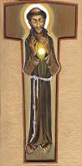

Next Meeting: March 2nd, 2019 beginning @ 10:00 a.m. in
St. Jerome Catholic Church: CHANGE OF LOCATION to The White House; next door to the Outback Building
Bring your Liturgy of the Hours. At 2:00 p.m. that day we will have training for Advocacy Day, presented by the Arch-Diocese & Texas Council of Bishops.
Early Birds: An opportunity to join together in The Holy Mass in the day chapel @ St. Jerome beginning 8:15 a.m.
Candidates and Inquirers Formation begins @ 9:00 a.m. in the Outback AND after our meeting @ noon!

Sophia Lee has a new email address: 20ja0502@gmail.com

Caritas Day 2019: Saturday, March 16th, downtown Houston. Includes Mass, lunch. TIME: 9am-noon

Advocacy Day 2019: Tuesday, March 26th in Austin, TX. Contact Alba Hernandez for more information. We will have a bus leaving from St. Jerome’s…..We need to fill it!

Regional SFO Retreat: Friday May 3rd – Sunday May 5th. Moss Point, LA (registration form below)

FOR MORE INFORMATION ABOUT EVENTS, PLEASE REFER TO E-MAILS FROM secretary.StMaxSFO@gmail.com

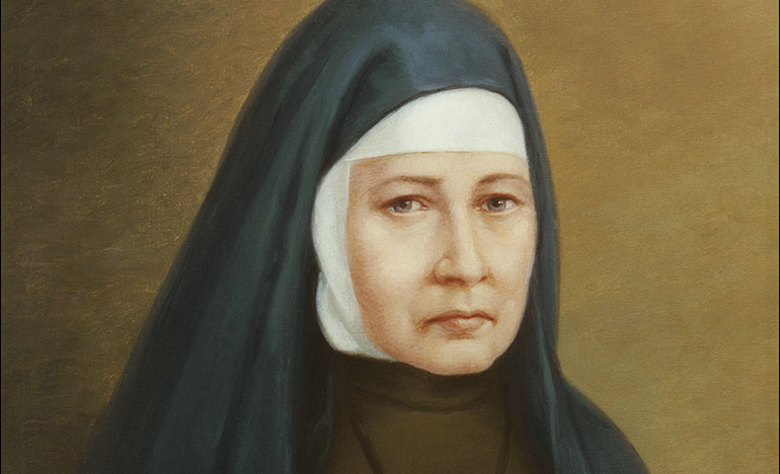

Blessed Mary Angela Truszkowska’s Story
Today we honor a woman who submitted to God’s will throughout her life—a life filled with pain and suffering.
Born in 1825 in central Poland and baptized Sophia, she contracted tuberculosis as a young girl. The forced period of convalescence gave her ample time for reflection. Sophia felt called to serve God by working with the poor, including street children and the elderly homeless in Warsaw’s slums. In time, her cousin joined her in the work.
In 1855, the two women made private vows and consecrated themselves to the Blessed Mother. New followers joined them. Within two years, they formed a new congregation, which came to be known as the Felician Sisters. As their numbers grew, so did their work, and so did the pressures on Mother Angela (the new name Sophia took in religious life).
Mother Angela served as superior for many years until ill health forced her to resign at the age of 44. She watched the order grow and expand, including missions to the United States among the sons and daughters of Polish immigrants.
Pope John Paul II beatified her in 1993. Her Liturgical Feast Day is October 10.

Reflection
Like Saints Francis of Assisi and Ignatius of Antioch, Blessed Mary Angela experienced a conversion while convalescing from an illness. The Lord can use sickness as well as other situations to speak to the heart of an individual. This does not imply that God caused the illness; just that he used the opportunity to speak to Blessed Angela’s heart.
**** EXCERPT FROM FRANCISCAN MEDIA goodnews@franciscanmedia.org ****

