Secular Franciscan Order November 2019 Newsletter

The Secular Franciscan Order was established by St. Francis of Assisi more than 800 years ago. Our purpose is to bring the Gospel to life where we live and where we work. We look for ways to embrace the Gospel in our lives and try to help others to do likewise.

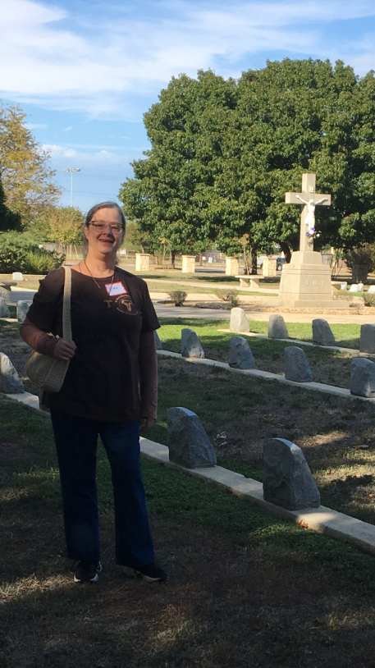
our Gathering
November 2nd, 2019 Joe led us in the prayer of the Liturgy of the Hours. Dora led us in our lighting of the candles prayer. Mike led us in the opening prayer found on pg 35 of the Ritual. Alan read the Prologue to our Rule which is the Exhortation of Saint Francis to the Brothers and Sisters of Penance; Chapter 1: “Concerning those who do Penance & Chapter 2: ”Concerning those who do not do Penance,” followed by discussion.
We remembered our deceased brothers and sisters with a beautiful prayer led by Amy. A very heartfelt sharing about memories of our loved ones was moving. We were invited to take a lit candle and a picture of our loved one(s) and place them on a memorial table created by Amy. It was so beautifully decorated.
Mike created a poster and made available sticky notes to write the names of those who have died and place them on the poster. Ike took the poster home and has been praying all month for your dearly departed loved ones.
Dora gave a thought provoking talk on the Communion of the Saints. The communion of Saints is the Church. St. Paul wrote “None of us lives to himself and none of us dies to himself“. She reminded us of a Plenary Indulgence that can be obtained for our deceased loved ones by following certain criteria. It can be obtained from November 1st through November 11th.
We then discussed article 19 of our Rule in which we are called to be bearers of peace. The last sentence of this article states: Since they are immersed in the resurrection of Christ, which gives true meaning to Sister Death, let them serenely tend toward the ultimate encounter with the Father”.
To help us reflect on this Dora read a passage from Called to Proclaim Christ, by Benet A. Fonck, OFM.
We discussed the upcoming Franciscan All Saints Day and Mike reminded us that within our General Constitutions we are called to be Messengers of Joy and Hope. Please read and continue reflecting on Article 26 and Article 27!
We then took a break to enjoy all the delicious food everyone brought to share.
Dora led us as we chanted the Franciscan Litany of All Saints. It was a great testament to how many have gone before us!
Our concluding prayer from The Ritual was led by Mike.
A Seafarers Items List was passed around to sign up for a particular item to bring next month.

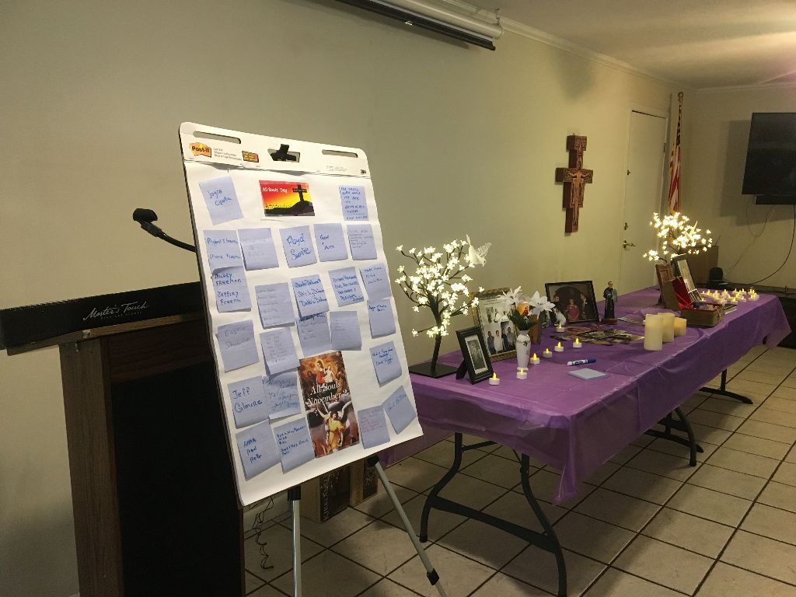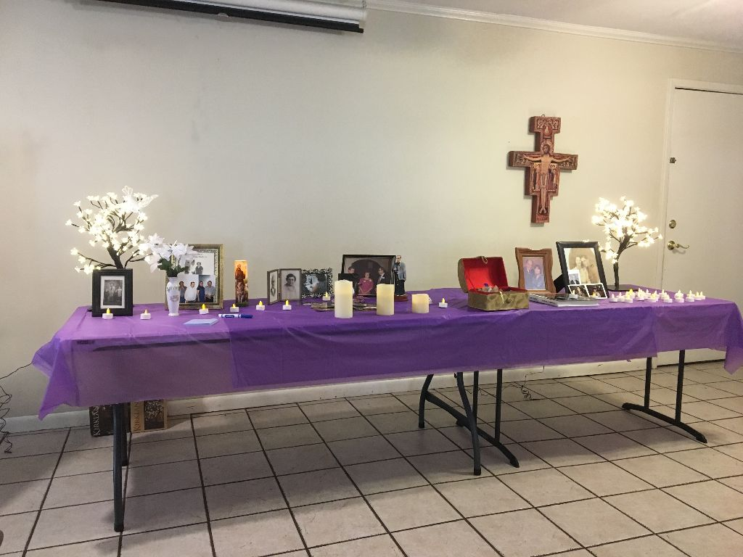
As we approach the end of this not so ordinary Ordinary time and approach Advent I must say, I hate Daylight Savings time and all that goes with it, but I love our Liturgical Calendar ! It’s been written on and studied that daylight savings time has been linked to deaths. Within our Liturgical Calendar we celebrate today Our Lord Jesus Christ, King of the Universe. Christ the King, the visible image of our invisible God.
I am filled with the memories of loved ones who have made their transitus and will not be sharing themselves with us and sitting around the table. Next Sunday will mark the first Sunday in Advent. A child brings joy; and this child Jesus us brings us the Joy of Eternal Life!
Viva Christo Rey!
At our last gathering I mentioned I had the good fortune to meet a wonderful man named Gabriel, who professed under the Leonite Rule (which had been in place until our Pauline Rule, which was one of the last gifts Pope Paul VI gave to us as an Order and to Our Church in 1978). We enjoyed conversation and shared prayer. He has been a Secular Franciscan in the San Diego area for many years. He is now living in Houston at a beautiful facility to be closer to his family and to receive the support he needs as he has developed Parkinson’s and is subject to falling. He also shared with me some of his journey as he is aware his memory is fading and he likes to write things out. I was moved to tears with what he sent me, and I asked if he would allow me to put it in this newsletter which he said yes to. He shares how his decision to profess changed not only his life but that of his family. He concludes with a poem which helped him as he became the caregiver for his wife Gaye.
My Franciscan Life Testimony of Gabriel Harkay, OFS
Sep. 2019
It is amazing to see how a single decision, how the very monastic sounding Poverty, Chastity, and Obedience could be going an active secular family life.
In the early 1960s I was working as a Mechanical Engineer at CUBIC CORP,
San Diego, CA.
A fellow designer at work, Wilbur Brown, was giving me bulletins of the Third Order of St. Francis Fraternity. Meditations there, written by Fr. Geoffrey OFM, touched me. Wilbur kept inviting me to a Franciscan retreat. “I’m not ready for that stuff” was my answer. After 2 years I said OK and he drove 6 of us, in his VW Bus, to the Franciscan Retreat House in Malibu. In that 3-day silent retreat I had to shut up and listen and pray. It was a turning point in my life. I suggested my wife, Gaye that she also should go to a retreat. She did. Shortly after, there was a meeting here, in this hall, with the visiting Provincial, Fr. Brandon OFM. I had Gaye with me and our first baby was in my arms. What I heard about the ideals of Poverty, Chastity and Obedience in the secular life was intriguing. I decided to learn more about it and signed up for the Novitiate (Initial Formation).
Going to daily Mass must have had some effect, because Gaye wanted also what I found. She also signed up for Initial Formation.
We became Third Order Franciscans (today Secular Franciscans). Its lifetime profession established a solid spiritual base. Later we were invited to a Quest, then to a Cursillo. We worked in Cursillo for several years and experienced valuable spiritual growth. We got also involved in Marriage Encounter that provided excellent tools to work on marital difficulties and raising four children. We were constantly seeking improvement and closer relationship with God, going together to retreats and conferences.
THE RULE says in part: “…husbands and wives…should joyfully accompany their children on their human and spiritual journey by providing a simple and open Christian education…”
We decided that Gaye should stay home with the children. As our family grew to three sons and a daughter, the wisdom of this decision became evident. We were a close-knit family. We went camping on our vacations, were active in the Boy Scouts and the Girl Scouts, and I took them to learn what I liked: water sports, target shooting and hunting. Gaye's staying home also meant that we were living on one salary and were always short of money. We could furnish the house only very slowly and simply, we had only used cars and Gaye could not develop her artistic talents. She loved to paint when calm and relaxed circumstances allowed it. That didn't happen too often since my job often took me out of town, sometimes for several weeks overseas. But our children turned out decent individuals, practicing Catholics and we learned more and more to relay on God alone.
We took our kids to some Franciscan activities, like preparing Christmas Baskets for the poor. Our Franciscan sister, Lydia Prudam, who lived in South East San Diego, had the ministry of collecting canned food at our Fraternity meetings and distributing them to poor families. Our kids still remember vividly how they were engaged in Lydia’s pantry in sorting out food items and preparing the baskets, and how glad were the women and children who picked them up.
In the RULES, in addition to attending daily Mass, there was the request to be active in our parish. That led me to become a CCD High School Teacher. While studying for a teaching assignment alone in the woods, the Lord baptized me in the Holy Spirit. What an experience of being loved so much that it blew me away! As one of the gifts I received, the Scriptures becoming alive and meaningful, my teachings became more Bible centered and much more effective.
By the suggestion of a Fraternity friend, Fred Schipper, SFO, we were led to the Charismatic Renewal. What a wonderful, ever present opportunity to grow closer to God and receive His strength!
In my work in foreign lands I had to work with local contractors, so before going to a country I studied the region’s economic, political and religious conditions, and most importantly DOs and DON’Ts.
The story how St. Francis interacted with the Muslim Sultan impressed me and the Lord helped me to develop good relationships with my foreign coworkers. For example in Egypt, once were walking on an airbase when the Muezzin started his call to prayer. The Egyptian Air Force officer said: Mr. Harkay, would you mind if I pray? And he stepped off the sidewalk, from his pocket unfolded a small rug, knelt down and prayed. I was standing beside him and prayed from my heart…
The Lord was powerfully present when I prayed for the monsoon rain to stop for one day so we could finish our assignment in Malaysia, and when the rains did stop, really miraculously, the Muslim contractors were joining me in loudly thanking and praising God for His goodness. ---- A Muslim coworker got me a ticket on a Swiss airplane in a hurry, when in 1978 no American planes were flying to Teheran and the Iranian revolutionaries were harassing Americans.
Gaye had severe dementia. I was doing the little, ordinary things with and for her and tried to be loving. Quite often it was very frustrating, especially when she refused my help and messed up. Sometimes I felt like screaming, Stop the world, I want to get off!
An excellent book is a great help to better understand and deal with someone with serious illness and dementia:
Coach Broyles’ Playbook for ALZHEIMER’S CAREGIVERS
A poem of this Playbook that I have to keep rereading is like Gaye saying to me:
Do not ask me to remember.
Don’t try to make me understand.
Let me rest and know you’re with me.
Kiss my cheek and hold my hand.

I’m confused beyond your concept.
I am sad and sick and lost.
All I know is that I need you
To be with me at all costs.

Do not lose your patience with me.
Do not scold or curse or cry.
I can’t help the way I’m acting,
Can’t be different ’though I try.

Just remember that I need you,
That the best of me is gone.
Please don’t fail to stand beside me,
Love me ’til my life is done.
—Author unknown
Thank you Gabriel !
Peace
Michael

Next Meeting: December 7th, 2019 beginning @ 10:00 a.m. in
St. Jerome Catholic Church: In the Outback Building
Bring your Liturgy of the Hours.

Early Birds: An opportunity to join together in The Holy Mass in the day chapel @ St. Jerome @ 8:15 a.m. Candidates and Inquirers Formation begins @ 9:00 a.m. in the Outback!
REMEMBER to bring your gifts for the Seafarers Shoe Box project.
See secretary.StMaxSFO@gmail.com for list of items!

are available in many different colors. If you’re interested in purchasing one, please contact Alba. They are $20/ea. Alba ordered some F.U.N. Manuals (For Up to Now – Foundational Topics for Initial Formation). They do not come with a binder. Purchase price is $13/ea.

$$$ Our contribution bag will be made available at all gatherings. Cash or checks.
Make checks payable to: St. Maximilian Kolbe Fraternity.

St. Joan of Arc Regional Retreat
April 24-26, 2020

FOR MORE INFORMATION ABOUT EVENTS & FORMS, PLEASE REFER TO E-MAILS FROM secretary.StMaxSFO@gmail.com

The God Who Searches

Suppose one of you has a hundred sheep and loses one of them. Doesn’t he leave the ninety-nine in the open country and go after the lost sheep until he finds it? Luke 15:4 (NIV)

My dog Schroeder is twenty-four pounds of fluffy cocker spaniel adventure. He’s a sensitive soul, fiercely loyal, and full of antics. But he likes to wander off. Now, let me be clear. Schroeder sleeps on blankets and eats grain-free food and gets a new toy on his birthday-which, incidentally, I invented because he’s a shelter rescue. For Schroeder, wandering isn’t about fulfilling an unmet need. He’s curious about what’s on the other side of the fence. Have you ever found yourself curious for the same?
The last time Schroeder escaped, he was gone a full fifteen minutes on a cold night. In that small amount of time, I had posted his photo on social media and called family to search. My heart – every bit of my heart – compelled me to find him. I remember walking around our yard with a flashlight, calling his name and begging him to come home. He doesn’t know the dangers of cars or the woods. I do.
We searched and searched. Finally, after what felt like an eternity but was only a few minutes, my husband called me. All my emotion threatened to empty. “He’s fine,” my husband said as he put Schroeder back in my arms. Tears threaten now, even as I write this story, because I love that little dog so much. And you know what? It’s just a fraction of the love our heavenly Father has for us. Because He leaves the ninety-nine to come for us every time we go wandering. by Ashley Clark

Father, thank you for loving me radically – for leaving the field to go after me when I wander, and for calling me by name. Help me find my security and my identity in your love, and lead me in the path everlasting so I don’t wander off in the first place.
Excerpt from: All God’s Creatures
Daily Devotions for Animal Lovers

