Secular Franciscan Order December 2018 Newsletter

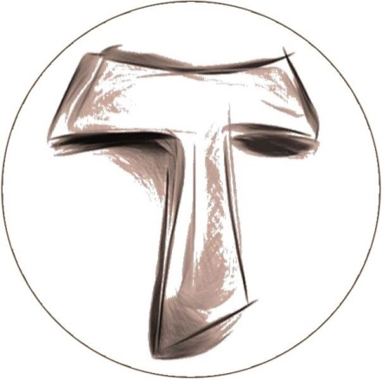
The Secular Franciscan Order was established by St. Francis of Assisi more than 800 years ago. Our purpose is to bring the Gospel to life where we live and where we work. We look for ways to embrace the Gospel in our lives and try to help others to do likewise.

2018 is the 40th year of our current Rule approved in 1978!

Excerpt from Bishop Robert Barron’s Word on Fire

Friends, in today’s Gospel Luke quotes from the prophet Isaiah: "Prepare the way of the Lord, make straight his paths."
Advent is a great liturgical season of waiting—but not a passive waiting. We yearn, we search, and we reach out for the God who will come to us in human flesh. In short, we prepare the way of the Lord Jesus Christ.
This preparation has a penitential dimension, because it is the season in which we prepare for the coming of a savior, and we don’t need a savior unless we’re deeply convinced there is something to be saved from. When we have become deeply aware of our sin, we know that we can cling to nothing in ourselves, that everything we offer is, to some degree, tainted and impure. We can’t show our cultural, professional, and personal accomplishments to God as though they are enough to save us. But the moment we realize that fact, we move into the Advent spirit, desperately craving a savior.
In the book of Isaiah, we read: "Yet, O Lord, you are our father; we are the clay and you are the potter: we are all the work of your hands." Today, let us prepare ourselves for the potter to come.

Our Gathering
December 1st, 2018 St. Maximilian Kolbe Fraternity Meeting was held in The Outback at St. Jerome Catholic Church. The Candidates had the privilege of setting up the Creche together. Oh Joy! Danny Marquer prayed our candle prayer for the three orders of our Franciscan Family; past present and future. Michael Freeman, OFS led us in the Opening Prayer from the Ritual of the Secular Franciscan Order, page 35. He then introduced our visitors, Veronica and Irma.

Rachel Persicano, OFS read a beautiful reflection from the book, Day by Day with St. Francis – A Franciscan Breviary by Gianluigi Pasquale, OFM CAP. A thought provoking discussion followed about the reflection. The discussion turned toward the viewing of St. Francis: Sign of Contradiction. It was such a great documentary! I hope everyone has had a chance to view it. See “SAVE THE DATE” below for another opportunity to view the movie!

Dora Freeman, OFS led us in “Lectio Divina for the First Week of Advent” which was taken off the U.S.C.C.B site. Mark 13:33-37 was the Scripture. Heartfelt discussion followed.
Michael Freeman, OFS spoke about the movie, hoping we’ll be able to view it again using the worship aid to guide our discussion and learning. The discussion naturally led to the homeless and what opportunities there are for being of service. Every night in Houston there are 4,000 of our Brothers and Sisters sleeping on the streets.
Danny Marquer made a comment that is worth sharing: “Just do the next right thing. If you don’t know what the next right thing is, just do whatever you are doing, right!” Great thought, Danny – thanks!
We shared personal intercessory prayer and included the intentions that had been used in the Interfaith Service at Temple Emmanuel for the homeless who died on Houston streets last year.
Several folks have made individual contributions to support our Franciscan Family members who have suffered in California because of the wildfires. We were blessed by the outpouring of support after Hurricane Harvey from all over the country and OFS-USA. Along with these contributions; we will be sending a check to our Region for $3,000 to send to NaFra to go towards those in California.
Our gathering ended with our closing prayer from the Ritual. We then had our Agape time enjoying the delicious food generously shared by all. We spent the rest of our time filling the 50 boxes for the Seafarers!
A BIG Shout Out to Consuelo Davis, OFS who so creatively and beautifully decorated and enhanced the ambiance of the Christmas Spirit. Thank you, Connie! It was lovely!
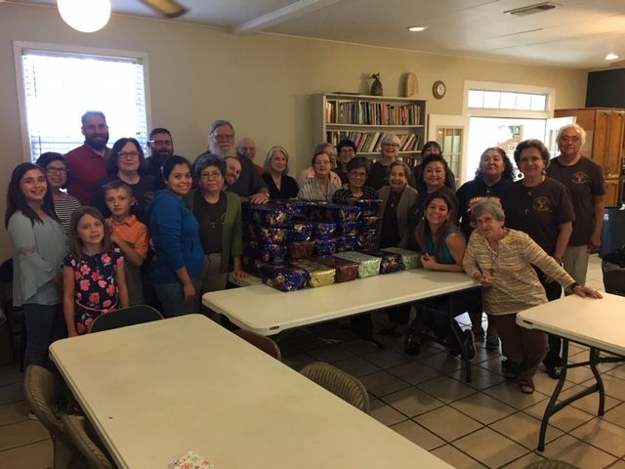
A Very Merry St. Maximilian Kolbe Fraternity Christmas!

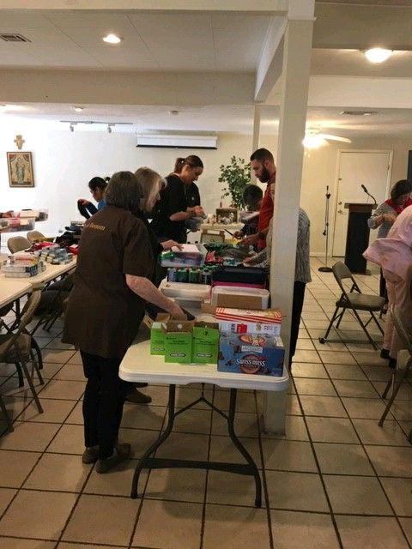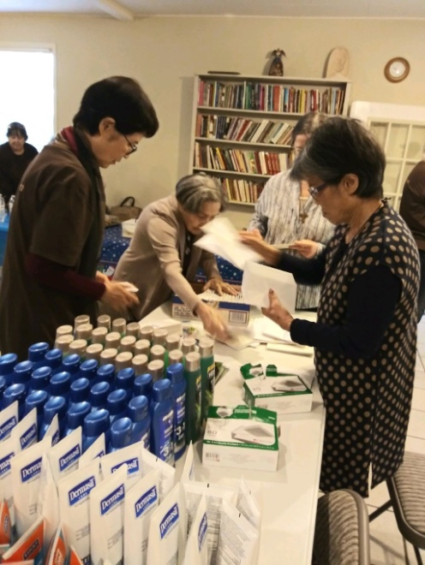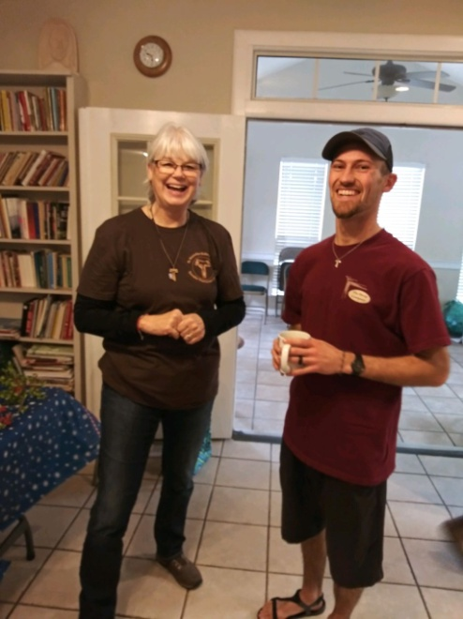
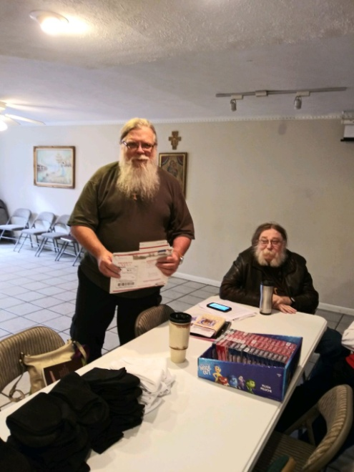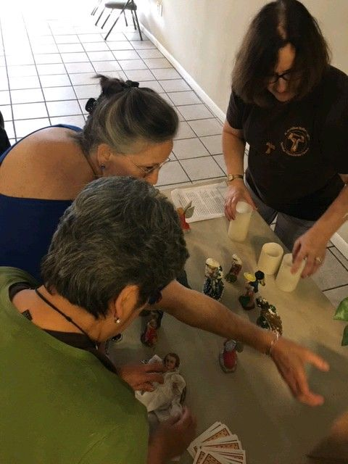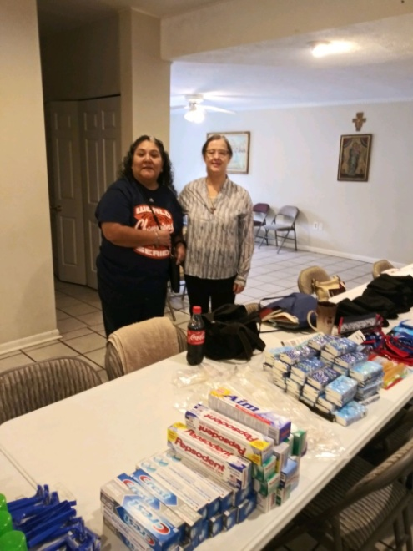
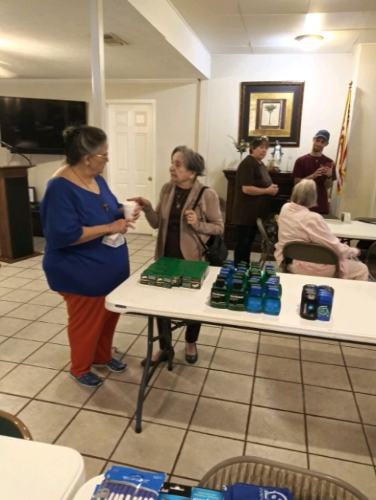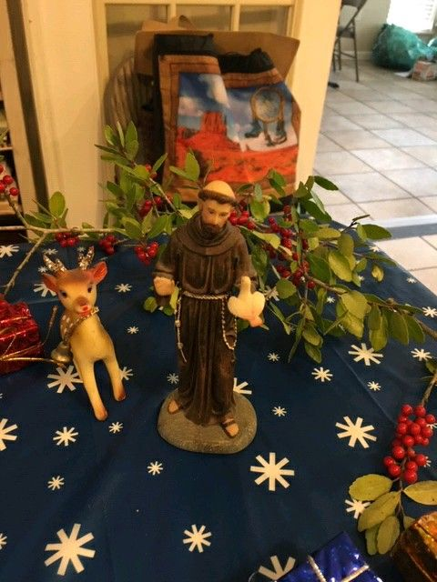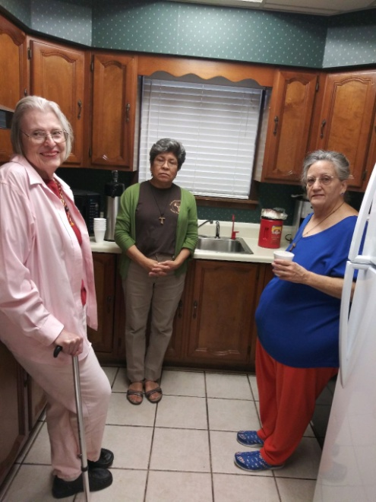
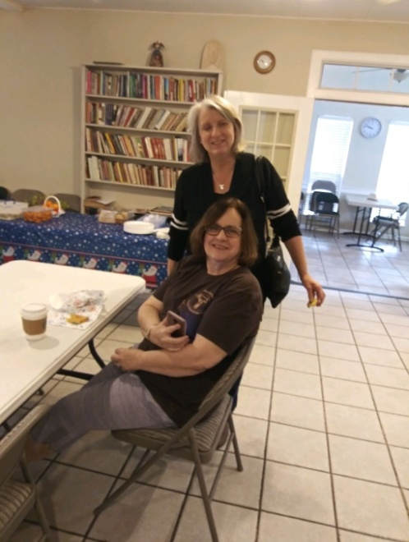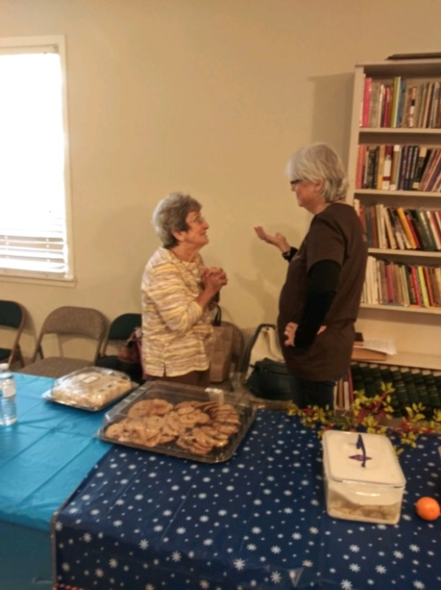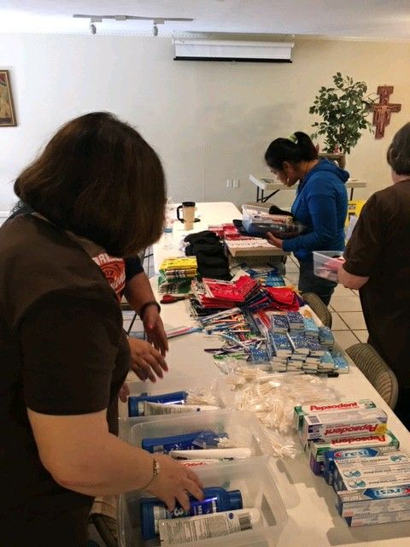

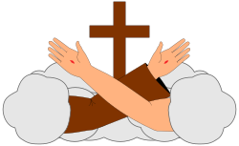
Joy to the World
Yesterday we celebrated the Third Sunday in Advent, commonly referred to by its Latin name of Gaudete Sunday indicating it is a day of rejoicing as we are almost to Christmas.
Deacon Gil gave a homily which spoke to me. He talked about the state of affairs in our country…in the oval office; on the borders; and in our Church worldwide. He recounted how upset he was seeing on the media police going into our Chancery seeking records even after they had been promised full cooperation by our Bishop. Not very much joy in any of this.
Yet as Christians we are to be joyful. I am reminded of the story of Francis and Brother Leo on what is perfect joy. We cannot confuse joy with fleeting happiness or comfort.
He continued about the joy he felt as his wife and he were making preparations for the birth of his daughter. They bought a house, cleaned it repeatedly; bought a crib and changing table for the nursery, and cleaned some more. Finally the day came when she was born and he recollected after the nurse cleaned her she handed this precious baby to him to hold and he was overwhelmed with joy.
This is what Advent is; preparing ourselves for the incarnation of Love. We have so much to be grateful for, starting with our lives. We need to be grateful and with that will come the joy.
In his Angelus address on the third Sunday of Advent, Pope Francis emphasized the joy of the Christian message . This was on Zenit:
“The Christian message is called the ‘gospel,’ that is, ‘good news,’ an announcement of joy for all people; the Church is not a shelter for sad people, the Church is the house of joy!”
“Christian joy, like hope, has its foundation in the faithfulness of God, in the certainty that He always keeps his promises,” explained the pontiff. “In the liturgy, the invitation to rejoice, to arise, resounds repeatedly, because the Lord is near, Christmas is near. Like a mother, the Church encourages us to follow faithfully the spiritual path in order to celebrate the feast of Christmas with renewed exaltation.
“May the Virgin Mary help us to hasten our steps toward Bethlehem to meet the Child that is born for us, for the salvation and joy of all men,” he encouraged.
“.”The joy of the gospel is not just any joy,” the pontiff explained. “It is the joy that comes from knowing you are welcomed and loved by God.
Mary, the mother of Jesus, “helps us to live the joy of the Gospel in family, at work, in the parish and in every environment,” he commented.
The Holy Father described a Christian’s joy as “an intimate joy, with wonder and tenderness,” like that of “a mother when she looks at her newborn baby, and feels that it is a gift from God, a miracle for which there is only thanks!”

The Coming of Christ is pure love and Joy. Our Heavenly Father gave us the Gift of Life. Let us remember and to always be grateful. We are known, welcomed, and loved by God
Let us prepare a place for Him and let our lives reflect the love of Our Father; and have a Merry Christmas every day as we go from life to gospel, Gospel to Life.
To paraphrase the traditional song; And they’ll know we are Franciscans by our love, by our love and they’ll know we are Franciscans by our love.

Peace
michael

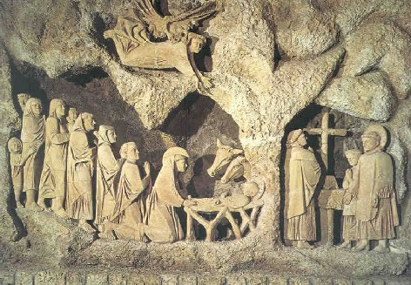

Next Meeting: January 5th, 2019 in the Outback @ St. Jerome Catholic Church beginning 10:00 a.m.
Early Birds: An opportunity to join together in The Holy Mass in the day chapel @ St. Jerome beginning 8:15 a.m.
Candidates and Inquirers Formation begins @ 9:00 a.m. in the Outback AND after our meeting @ noon!

FOR THOSE WHO MISSED Francis:Sign of Contradiction – here is another opportunity!
1/5-11 :: Sign of Contradiction Screening at St. Bartholomew in Katy - Thank you, Barbara for encouraging your parish to screen the film! (Flyer attached)
English: Wed. Jan. 9th & Thurs. Jan 10th @ 6:30 PM in the FLC Hall
Spanish: Sab. 5 de Enero 4:30 PM in Salon Familiar; Viernes 11 de Enero 7:00 PM in Edificio de Jovenes
Questions: Joan Summers joan@st-bart.org 281-391-4758
Preguntas: Maggie Lopez maggie@st-bart.org

FOR MORE INFORMATION ABOUT EVENTS, PLEASE REFER TO E-MAILS FROM secretary.StMaxSFO@gmail.com

Pray that God catches you in the act of excellence!

“I’ve found the still point around which the whole country revolves without knowing it!”
Thomas Merton: his thoughts on the Mass.

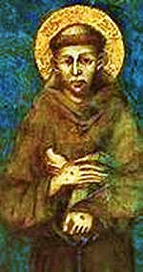 Did you know this picture is a close replica of what St. Francis really looked like?
God is all about communication. He speaks through all creation BUT, even though I can commune with God in nature, that is like texting God versus going to Adoration and being face to face with Him, or receiving Him at Mass in the Eucharist! etc

The First Letter to the Custodians – Francis
– In every sermon you give, remind people about penance and that no one can be saved without receiving the most holy Body and Blood of the Lord. When it is sacrificed on the altar by a priest and carried anywhere, let all peoples praise, glorify and honor on bended knee the Lord God living and true. May you announce and preach God’s praise to all nations in such a way that praise and thanks may always be given to the all-powerful God by all people throughout the world at every hour and whenever bells are rung. (1LtCus 6-8)

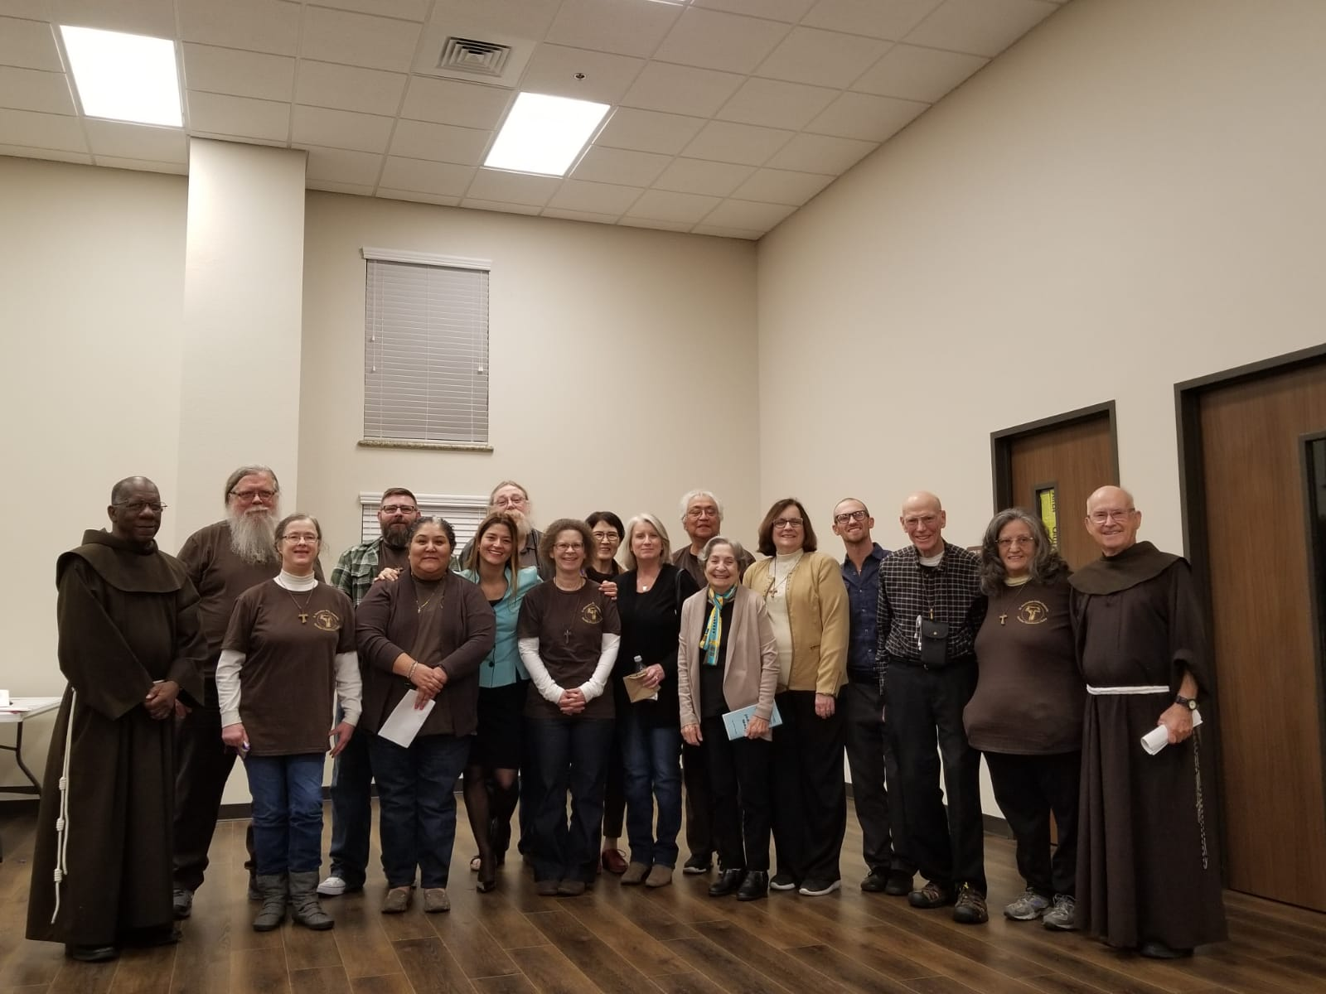

The screening of Sign of Contradiction by Fr. Dave Pivonka TOR ,which we brought to Houston, was by all accounts highly successful !
We had almost 130 people in attendance including our former Regional Spiritual Assistant (who is still the Provincial Spiritual Assistant), Brother Juniper OFM (far right); and Father Robert OFM (far left).

Thanks to all who helped and kept us in prayer and also thanks to the Texas Catholic Herald and Guadalupe Radio who allowed me into their studio to record a PSA which they ran. Thanks also to 4PM Media who distribute videos for Fr. Dave and his Wild Goose ministries for donating the film for us to use in our prison ministry.

