Secular Franciscan Order March 2020 Newsletter

The Secular Franciscan Order was established by St. Francis of Assisi more than 800 years ago. Our purpose is to bring the Gospel to life where we live and where we work. We look for ways to embrace the Gospel in our lives and try to help others to do likewise.

Remain in prayer for:
The repose of the soul of Jaime Gomez & for the peace of Patricia, his wife and their family.
Continued healing for Dexter, Phyllis Prince’s nephew & Godson
Continued prayers for Rachel Persicano’s grandson

Praise Report for Karen Parsons, Dan & Amy!
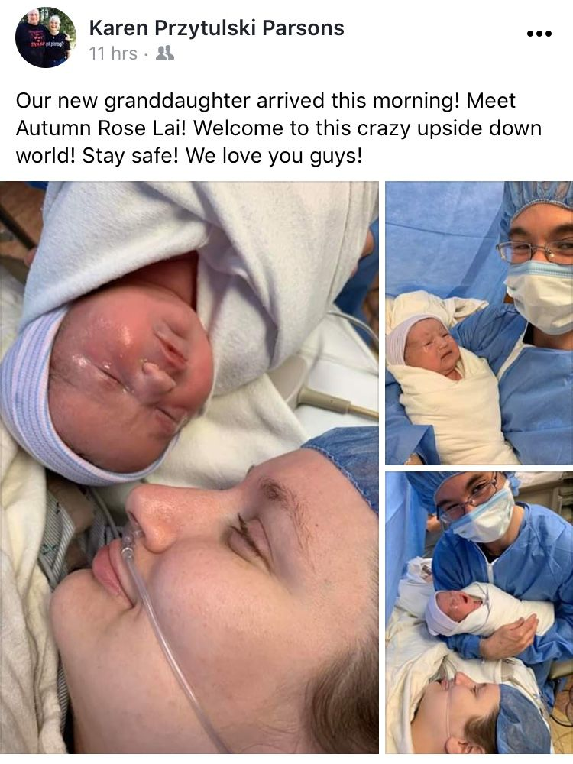
our Gathering
March 7, 2020
Our Gathering began with a beautiful Holy Mass @ 8:15 a.m. in the main sanctuary at St. Jerome Catholic Church. Participants then headed over to the Parish Activity Center (PAC). Everyone was given a free copy of Lent with Maximilian Kolbe by Carol Ann Morrow. A feast of breakfast goodies was beautifully displayed for our choosing. Once again, Connie waved her magic wand, and with the help of many hands, set up the lovely room décor.
Br. Tim Lamb, OFM spoke words of both encouragement & conviction to all our hearts. Some points my heart heard:
What is my question? What does God want of me? Who does God want me to be? Listen for God’s answer. If I hesitate to heed God’s answer, why? What consequences do I fear? Sometimes I need to take time off from “my question”, stepping away from it, trusting that God will answer and show me what direction I need to take.
As Franciscans, we recognize that we are Incarnational beings, made in His image. Is the Christ within being proclaimed without? Don’t underestimate what people notice when they are watching you!
Distractions can be annoying. If I surrender to the distraction, it loses its power. Mindful walking helps clear the mind. It is good for the body and soul.
Ways to deepen my walk with Christ, following the path of Francis:
- Go inward
- What needs to change in me? How can I change-how do I go about it? What corrections do I need to make?
- Go local: Be congruent in my walk. Integrity is having the outward appearance matching the inward being.
- Family
- Community
- Parish
- Go Global
- Accept people as who they are. Who are the lepers in my life?
Br. Tim allowed time for questions and answers, sharing insights and stories. It went way too quickly, though. Somewhere in between the above, we did break for a delicious Jason’s Deli box lunch and time to visit with old and new friends. I know God blessed each set of ears with what they needed to hear that day. I enjoyed the sharing time. It was interesting how others heard things I missed. A final blessing & dismissal was given. Many hands made clean-up go quickly. Thank you! It was a glorious day, indeed! A much needed renewal of mind—learning new things about ourselves and Franciscan ways; body--hugs that are, at the present time, missing; and spirit—journeying with Br. Tim along the Franciscan road to Christ with each other!

Journey Together in Love and Compassion
The title above was adopted by our national Secular Franciscan Fraternity as the theme for 2019-2020 at the OFS National Chapter held in October in Corpus Christi. What an appropriate choice, chosen while in the city on the bay named for The Body of Christ! Equally as significant, it was held at the Pax Christi Liturgical Retreat Center. There are no coincidences.
While we are temporarily not able to wish each other the Peace of Christ during our Mass we continue this in our prayers. We know the Lord hears our prayers as we journey together in Love and Compassion.
What you do is so beautiful. There are so many examples. One of our sisters has a sister in Florida who had looked into becoming a Secular Franciscan. She explained she was blind so would need someone to go through the formation materials with the reading, etc. Whomever she spoke with in Florida told her words to the effect of no way.
Whoa, I won’t even go there.
Yet within our fraternity we are Blessed….Dori and Delores are doing this! Thank you!
What each of you do is amazing. We pray “Thy Will Be Done” as we remain open to what The Holy Spirit is calling each of us to do. I am sure that all of us share the idea that this is the most unusual Lent we have ever experienced, yet there is so much to be grateful for. We have been forced to simplify.
With every passing day I see how we in our Church and Franciscan Family are truly united together in Love and Compassion. What is the Holy Spirit calling you to do? How are we to respond?
Discernment: Listening to God’s Call. This was the theme for our Lenten Day of Reflection which was held on March 7, 2020 provided by Br. Tim Lamb OFM. It was amazing. We had 44 people in attendance. Most were Secular Franciscans from all 4 of the Houston area fraternities in the St. Joan of Arc Region; as well as two from the Los Tres Companeros Region. I am sure others took better notes than I and look forward to our next gathering to discuss this. I did write a note to self:
What does God want of me?
Who does He want me to be?
How do I serve?
We can only know by listening and calling on the Holy Spirit to guide us. Br. Tim related a story of how he became a missionary. I had heard from another Friar who was at this same Chapter gathering where the Minister General had asked for volunteers to serve as missionaries. Granted, some were not in good enough health to serve. However to say the response was not overwhelming amongst those who could would be an understatement. Br. Tim prayed on it, listened to what the Holy Spirit was calling him to do, and acted upon it. When we respond with Love and Compassion it is always building the Kingdom of God.
It was so nice to come together as a family. Although it was Lent we still managed to have plenty of food to go around; even had left over’s which the teens who were doing a car wash for their Teen Acts retreat got some! Like many parishes St. Jerome’s participates in Operation Rice Bowl and we had those on boxes on each table. Thanks to all we had $131.44 donated.
I have been told that Br. Tim will be back in Houston in October as the Retreat Master for the Annunciation Fraternity Retreat at the Carmelite House of Prayer which I believe will be the first weekend in October. When I get more details I will send along.
Sadly we say good bye to Dustin. After he moved to La Grange it became harder to get here for our gatherings so he has transferred to a fraternity in Austin. Thank you Dustin for everything you brought us and may God Bless you, Loretta and kids!
Our next gathering will not be in person but in cyberspace. Details to come!

Peace
Michael

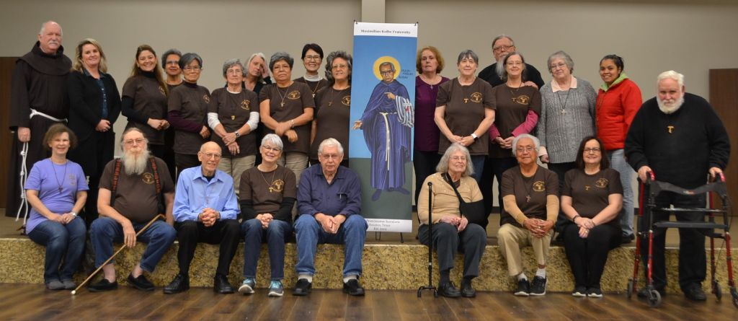

Next VIRTUAL Meeting: April 4th, 2020 via ZOOM!
To be held in the COMFORT OF YOUR OWN HOME!
TIME: 10:00 a.m.

The Rite of Profession of Phyllis Prince & Eileen Ike Colleton into the Secular Franciscan Order has been rescheduled due to COVID-19. It is now set for
May 2nd, 2020 to be held at the 8:15 a.m. Mass
St. Jerome Catholic Church Day Chapel
Phyllis & Ike hold the title OFW (Order of Franciscan Wannabees)

“Avoid Sadness and worry, because there really is no reason to be sad. Is the world not governed by divine Providence? Yet, sometimes I am scared of suffering and the thought of calamities…but even Jesus in the Garden of Gethsemane was afraid. This comforts me.”

T-Shirts are available in many different colors. If you’re interested in purchasing one, please contact Alba. They are $20/ea. Alba ordered some F.U.N. Manuals (For Up to Now – Foundational Topics for Initial Formation). They do not come with a binder. Purchase price is $13/ea.

$$$ Since we are not meeting in person as a Fraternity, perhaps, if the Holy Spirit moves you, set aside your contribution & doubly bless our Fraternity when we eventually come together again! Cash or checks made payable to: St. Maximilian Kolbe Fraternity.

Every Day for PRAYER!

John Michael Talbot online Concert for Healing and Hope
Begins 3-31-2020 and can be viewed through April 31, 2020
Cost: $10.00
For more info, see emails from secretary.StMaxSFO@gmail.com

St. Joan of Arc Regional Retreat
POSTPONED TILL ???
St. Charles Retreat Center
Moss Bluff, LA

FOR MORE INFORMATION ABOUT EVENTS & FORMS, PLEASE REFER TO E-MAILS FROM secretary.StMaxSFO@gmail.com
An Annunciation Message of Hope from the
Texas Catholic Conference of Bishops
On this Feast of the Annunciation of the Lord, the Catholic bishops of Texas offer some words of living faith and hope to our people in this extraordinary time of anxiety and illness. While we are facing so many unknowns, we can be certain of God’s faithfulness. The Annunciation of the Lord is a feast of hope in God's goodness and power to intervene on our behalf.

The Magnificat, the song of praise sung by our Lady at the Visitation with her cousin Elizabeth, is a song of hope. Our Blessed Mother is filled with God’s grace. Her prayerful proclamation of complete dependence on and communion with God at the Annunciation inspires us all to rely on his grace, which will sustain us during this pandemic.

Together with our brothers and sisters around the world, we are threatened by the effects of this disease, and we must be united in our efforts to mitigate its spread. Our faith calls us all to follow Mary’s example of trust and reliance on the Lord, and, most importantly, her living faith in the Lord.

The Blessed Virgin Mary sings of the fear of the Lord in her Magnificat, “He has mercy on those who fear Him in every generation.” As Pope Emeritus Benedict XVI wrote, “Perhaps this is a phrase with which we are not very familiar or perhaps we do not like it very much. But ‘fear of the Lord’ is not anguish; it is something quite different. It is the concern not to destroy the love on which our life is based. Fear of the Lord is that sense of responsibility that we are bound to possess for the portion of the world that has been entrusted to us in our lives.”

Our actions to stay at home, to maintain safe physical distancing, and even to withdraw from public life during this time are a tangible witness of our reverence for life and our solidarity with the community. We do this, not because of servile fear, but because of Christian hope – we are sure of God’s steadfast love and the promise of our salvation. By sacrificing for others and isolating ourselves for the common good, we witness our Christian hope that God will see us through the present darkness.

In their journey from the slavery of Egypt to the Promised Land, the people of Israel were rescued by passing together through the Red Sea. This moment is like our Red Sea. Only by trusting in God and remaining in solidarity with one another can we cross over and leave the terrible foe.

Remember, “Nothing is impossible for God.” Along with Mary in her Magnificat, we can all proclaim, “He has shown the strength of his arm and has scattered the proud in their conceit; he has cast down the mighty from their thrones and has lifted up the lowly; he has filled the hungry with good things and the rich he has sent away empty; he has come to the help of his servant Israel for he has remembered his promise of mercy, the promise he made to our fathers, to Abraham, and his children forever.”

Hope and living faith in Jesus Christ are the antidote for all our fears, the answer to our futility and limitations, and opens the door to free us from the prison of our powerlessness and lack of control. We cannot love without hope.

As a people of hope, we know we have a future beyond this crisis. At this time of pandemic, we, the Catholic bishops of Texas, place our hope in the Lord and invite all the faithful to do the same.

We wait in joyful hope for the blessed day when the Church can return to the public celebration of the Mass with renewed appreciation for its divine beauty and power. We are grateful for the sacrifices all Texans are making for the common good. In a special way, we praise the dedicated efforts of medical personnel, first responders, caregivers, custodians, cashiers and clerks, family members, and charitable service volunteers. We celebrate and we are grateful for your efforts to protect one another as acts of agape, of genuine self-giving love. Through the grace of God, may our common sacrifice this Lent lead to new life in the victory of Christ.

Posted in Bishop statement, News releases

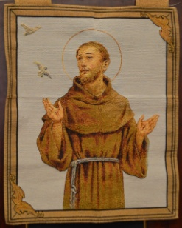 The following poem has been widely circulated. Fr. Dan sent it out to folks at St. Jerome’s, Anderson Cooper read it; it has been posted and reposted on Facebook. It has been taken off the author’s blog: Brother Richard
I am a Capuchin Franciscan priest-friar, living and working in Ireland (mostly). Currently I am the Guardian of Ards Friary in Donegal which includes a large residential retreat centre. (More at www.ardsfriary.ie) I also teach Christian meditation and mindfulness and work with the Sanctuary Spirituality Centre in inner city Dublin. www.sanctuary.ie

It was sent out recently via Ryan’s Thursday communication but some may not have read it and it is certainly worth reading.

Here it is:
Lockdown
Yes there is fear.
Yes there is isolation.
Yes there is panic buying.
Yes there is sickness.
Yes there is even death.
But,
They say that in Wuhan after so many years of noise
You can hear the birds again.
They say that after just a few weeks of quiet
The sky is no longer thick with fumes
But blue and grey and clear.
They say that in the streets of Assisi
People are singing to each other
across the empty squares,
keeping their windows open
so that those who are alone
may hear the sounds of family around them.
They say that a hotel in the West of Ireland
Is offering free meals and delivery to the housebound.
Today a young woman I know
is busy spreading fliers with her number
through the neighbourhood
So that the elders may have someone to call on.
Today Churches, Synagogues, Mosques and Temples
are preparing to welcome
and shelter the homeless, the sick, the weary
All over the world people are slowing down and reflecting
All over the world people are looking at their neighbours in a new way
All over the world people are waking up to a new reality
To how big we really are.
To how little control we really have.
To what really matters.
To Love.
So we pray and we remember that
Yes there is fear.
But there does not have to be hate.
Yes there is isolation.
But there does not have to be loneliness.
Yes there is panic buying.
But there does not have to be meanness.
Yes there is sickness.
But there does not have to be disease of the soul
Yes there is even death.
But there can always be a rebirth of love.
Wake to the choices you make as to how to live now.
Today, breathe.
Listen, behind the factory noises of your panic
The birds are singing again
The sky is clearing,
Spring is coming,
And we are always encompassed by Love.
Open the windows of your soul
And though you may not be able
to touch across the empty square,
Sing.

A Franciscan Prayer as We Confront Coronavirus
Dear Father, Almighty Healer and Physician, we bring our fears, anxiety and petitions to you during this outbreak of coronavirus. Please restore our inner peace so that we can be a shining light to those stuck in the darkness.

And let us pray for
+ All those who have the virus and fear the outcome, may they find their peace in you.
+ All the medical staff who cannot work from home but need to be in the ‘trenches’ taking care of the sick, may they have the stamina and good health to continue to serve.
+ For all the working parents who are suddenly faced with their childrens’ schools being closed. Help them to find a solution that does not impact their earnings too greatly.
+ For all those who are worried, please grant them the peace to get through this time.
+ For all those working extra hours to provide more test kits, masks and sanitizer, shower them with the ability to keep up their difficult schedule.
+ And for all the rest of us, please help us make good decisions about where we go and when to stay home, what supplies we buy and how much/many, and most especially keep us calm and filled with Your grace so that we are able to reach out to others in need.

We ask these things through the Sacred Heart of Your Son, Jesus. May we be open to Your Ministering to us so that we are equipped to minister to others. Amen

by Kate Kleinert, OFS,
Minister of St. Katharine Drexel Regional Fraternity

Devoured
Be alert and of sober mind. Your enemy the devil prowls around like a roaring lion
looking for someone to devour. 1 Peter 5:8 (NIV)

One warm, lazy morning, I sat on my porch watching the birds. I gloried in the nest of squawking sparrow babies in a branch low enough that I could see their little heads (mouths, really) pop up at mama sparrow’s approach. Sipping my coffee, rocking, and watching, I enjoyed the thought that life was good.
I was even privileged with a sighting of a magnificent red-tailed hawk. Its shadow on the lawn was my first clue to its presence, but it circled overhead several times, allowing me a long, luxurious view of this majestic creature. Its wingspan was breathtaking, its coloring brilliant, and its grace in flight inspiring.
Suddenly, the hawk swooped toward the branch with the sparrow family and scooped up one of the wide-mouthed babes before the sound of my gasp reached my ears. I was heartbroken watching the chain of life displayed before me as the wild hawk glided off with mama sparrow’s offspring in its grasp.
I spent the rest of the morning praying for my own children. The hawk reminded me how often we find danger mesmerizing, hypnotic, even beautiful right up to the moment it strikes. If the spiritual dangers of this world all appeared evil at first glance, more of us would be safe from them. But, most often, sin and evil can appear as engaging and attractive as that powerful hawk, swooping in with sharp talons we don’t see until we’re moments from their grasp.
by Lori Stanley Roeleveld

Father, help us to trust you enough to follow your ways and
teach our children, too, to live in obedience. Open all our eyes to sin,
poor choices, character weaknesses, and spiritual dangers that make us
easy prey for the enemy. Instead, protect us under your own wings until we
are home with you. Amen

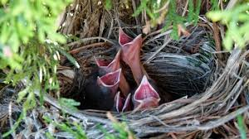

Guideposts - All God’s Creatures
Daily Devotions for Animal Lovers

