Secular Franciscan Order JUNE 2019 Newsletter

The Secular Franciscan Order was established by St. Francis of Assisi more than 800 years ago. Our purpose is to bring the Gospel to life where we live and where we work. We look for ways to embrace the Gospel in our lives and try to help others to do likewise.

2019 is the 41st year of our current Rule approved in 1978!

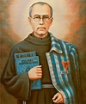

our Gathering
June 1st, 2019 Joe Swonke, OFS began our gathering by leading us in The Liturgy of the Hours. Dora Freeman, OFS prayed our candle prayer for the three orders of our Franciscan Family; past, present and future. Michael Freeman, OFS lead us in our opening prayer from the Ritual of the Secular Franciscan Order, page 35.

Dustin Greenwood, OFS provided us with our Franciscan reading found on page 79 in the Ritual of the Secular Franciscan Order “True and Perfect Joy.” Many shared what this reading meant to them and how challenging it is to follow.

Mike & Dora led us in a Ceremony of Introduction & Welcoming for Carla Lewton. Our Fraternity is so blessed to have continued growth. Welcome, Carla!

Fr. Mike Van Cleve gave a presentation on Pentecost reminding us we will be celebrating on June 9th. He focused on the fellowship of the Holy Spirit and how it puts us in communion with one another. We need to continue to ask ourselves the question: “How do we make our love of God real in our daily life?” Dora continued the subject by reading St. Peter’s discourse from Scripture which is actually a quote from the Book of Joel. Many believe Pentecost was the end of the very first Novena. After Jesus ascended into heaven, the faithful waited for 9 days in the Upper Room for the gift of the Holy Spirit. She shared thoughts from Fr. Dave Pivonka, TOR from The Wild Goose video from the Upper Room. Fr. Dave gave 7 “S” words to help us ponder the gifts of the Holy Spirit. Surrender, Silence, Senses, Sensitivity, Sifting, Saturation, & Sent or Stepping Out.

Dustin and his daughter graced our taste buds with a special cookie recipe they found. The recipe was for an almond cookie that St. Francis requested the brothers make for him before he died. They were delicious! I guess you could say, “Those cookies are to die for!” ha ha

Alba Hernandez, OFS, our Treasurer provided us with an overview of “Fair Share” and an update on our finances. We practice “FAIR SHARE” which means we each look at our personal budgets and discern what donation we can prayerfully contribute to our Community Purse. Some months might be more than others, depending on our personal current situations. We can remain to be anonymous if we choose. For tax purposes, get with Alba for details on how to contribute. There was discussion on how best to keep all informed…some thought in the newsletter yet others are concerned since that ends up on the website. Council will discuss at our next meeting. Seeing our budget will help us better discern our needs and see how our money is spent. You can designate where your money goes; for example, scholarships or supplies, etc… Our contribution bag will be made available at all future gatherings. Make checks payable to: St. Maximilian Kolbe Fraternity.

T-shirts are available in many different colors. If you’re interested in purchasing one, please contact Alba. They are $20/ea. Alba ordered some F.U.N. Manuals (For Up to Now – Foundational Topics for Initial Formation). They do not come with a binder. Purchase price is $13/ea.

Fabiola Cespedes, OFS gave a talk on Marian Devotion. She shared her beautiful testimony on developing her personal relationship with Our Blessed Mother, Mary. Fr. Michael Gaitley, MIC wrote a book that has become a bestseller, 33 Days to Morning Glory. It is a 33 day Retreat in preparation for Marian Consecration that can be done privately or in a group setting. Joe, Dustin & Eileen spoke about other opportunities to become involved. Our Fraternity’s patron saint, Fr. Maximilian Kolbe had a deep devotion to Our Lady & started the Militia of the Immaculata. Mary, our Queen, always points to her Son, our Savior, Jesus Christ!
Michael Freeman, OFS led us in the Closing Prayer from the Ritual of the Secular Franciscan Order, page 36.
Let us become builders not consumers
Greetings Good People
We received confirmation from the St. Joan of Arc Region that we will have our fraternal and pastoral visitation on August 3, 2019. This will happen during our scheduled monthly gathering. Additional information will be coming out as visitations are a vital part of our order which allow us to grow.(This will be the third one I have been through and it still causes a lot of anxiety.) I have copied the following information off the OFS USA site which certainly helps reduce my stress:

GUIDELINES FOR VISITATION
From: HANDBOOK FOR SPIRITUAL ASSISTANCE TO THE SECULAR FRANCISCAN ORDER (p. 369 to 377)

Part 1. Guidelines for Pastoral and Fraternal Visitations of Local Fraternities
I. Goals of the Visitation (cf. Articles #11 and #26 of the Rule)
A. to promote fidelity to the Franciscan Charism
B. to promote observance of the Rule
C. to provide support in the life of the fraternity

II. Ways to Achieve the Above Goals Through a Visitation
A. by helping the fraternity to evaluate itself
B. by providing inspiration and information
C. by providing an experience of unity with the Province and the Order
For the past year we have been studying our Rule. Fraternity is so important; not only us as Secular Franciscans, but to the entire Franciscan family in fact. The entire Chapter 3 of Our Rule addresses Life in Fraternity.
On June 17, 2019, in the Clementine Hall of the Vatican Apostolic Palace, Pope Francis received in audience the participants in the General Chapter of the Order of Friars Minor Conventual. The Holy Father stressed the importance of fraternity, formation, and “minority” in their lives.
While speaking of fraternity Pope Francis wrote:
“Fraternity”, which Francis considered a gift: “The Lord gave me brothers” (Testament, 14). Fraternity is a gift to be received with gratitude. It is a reality that is always “on the move”, under construction, and therefore asks for the contribution of all, without anyone excluding himself or being excluded; in which there are no “consumers” but only builders (see General Constitution OFMConv, 55, 5). A reality in which we can live out paths of continuous apprenticeship, of openness to the other, of mutual interchange; a welcoming reality, ready and willing to accompany; a reality in which it is possible to take a break from everyday life, to cultivate silence and the contemplative gaze and thus recognize in it the imprint of God; a reality in which you all consider yourself brothers, both ministers and other members of the fraternity; an experience in which everyone is called to love and nurture his brother, just as a mother loves and nurtures her own child (see Saint Francis, Regula non Bullata, IX, 11). I urge you to nurture your fraternity with the spirit of holy prayer and devotion “to which all other temporal things must serve” (Id., Regula Bullata, V, 2). “
August is also the month of the Feast Day of St. Maximilian Kolbe OFM. Typically at the August gathering we focus on this and have viewed movies and folks have presented on him. While surfing the internet I came upon an amazing Diocesan site in Poland which has an English language site…whoa!
I clicked on a few links and made contact with a professor who had the amazing opportunity to travel and live with Friars, some of whom knew St. Maximilian Kolbe. He has written several plays about this great saint and has given permission for us to use here in our fraternity to help honor St. Maximilian. I do not think we could do it justice as a play; yet I pray we can successfully present it as a reading. My theory is, if I do not focus completely on the visitation but give myself something else to stress over I will be forced to quit worrying about it and allow the Holy Spirit in.
I want to recommend all go to the OFS USA site https://secularfranciscansusa.org It is packed with so many treasures! They are still in the process of migrating things from the old NAFRA site yet what they have already is incredible. For example, under the Resources tab you can click on Formation and Spirituality.
Looking forward to the Feast Days of St. Junipero Serra on the 1st and on the day of our gathering St. Maria Goretti!

Peace
Michael

Next Meeting: July 6th, 2019 beginning @ 10:00 a.m. in
St. Jerome Catholic Church: In the Outback Building
Bring your Liturgy of the Hours.
Early Birds: An opportunity to join together in The Holy Mass in the day chapel @ St. Jerome @ 8:15 a.m.
Candidates and Inquirers Formation begins @ 9:00 a.m. in the Outback!
Rachel Persicano celebrated her 28th Franciscan Profession Anniversary on May 11th!

+=+=+=+=+=+=+=+=+=+=+=+
Diocese of Laredo (300 miles away, 5 hour drive from Houston) is receiving about 1,500 immigrants per week and is in urgent need of volunteers to commit for 3 to 6 days at a time this summer. Free food & logging will be provided. They are also in need of the following items:
Baby bottles, trash bags 30 & 13 gallon, trash cans 13 gallon, detergent, Clorox, bath towels, baby powder formula 0-6 months & 6 months +, women’s products, underwear all sizes, plastic eating utensils.
If your group would like to donate some the items below please bring to my office by not later than
July 12th (between 9am-4:30pm).
Gabriela Karaszewski
Director, Office of Young Adult & Campus Ministry
Archdiocese of Galveston-Houston
2403 Holcombe Blvd. | Houston TX | 77021
P: 713.741.8780 | F: 713.741.8775
e-mail: gkaraszewski@archgh.org
www.archgh.org/yacm

33 Days to Morning Glory: Class to Prepare for Marian Consecration
Tuesday: July 9th, continuing through August 20th, 2019
For your convenience: 2 sessions available!
10:00 a.m. morning session AND 7:00 p.m. evening session
St. Bartholomew’s Catholic Church in Katy, TX
COST: $25.00 for materials
CONTACT: Joan Summers at joan@st-bart.org or call (281) 391-4758, ext # 437

10-12-19 Fiesta Franciscana in San Antonio, TX – 9:00 a.m. – 3:30 p.m.
with Fr. Daniel Horan, OFM
“All God’s Creatures: Rethinking Franciscan Theology of Creation”
Registration $20 plus $15 for the optional lunch.
For more information, contact Stan Whitener, OSF @ (210) 827-5309
See last page of Newsletter for more info.

FOR MORE INFORMATION ABOUT EVENTS & FORMS, PLEASE REFER TO E-MAILS FROM secretary.StMaxSFO@gmail.com

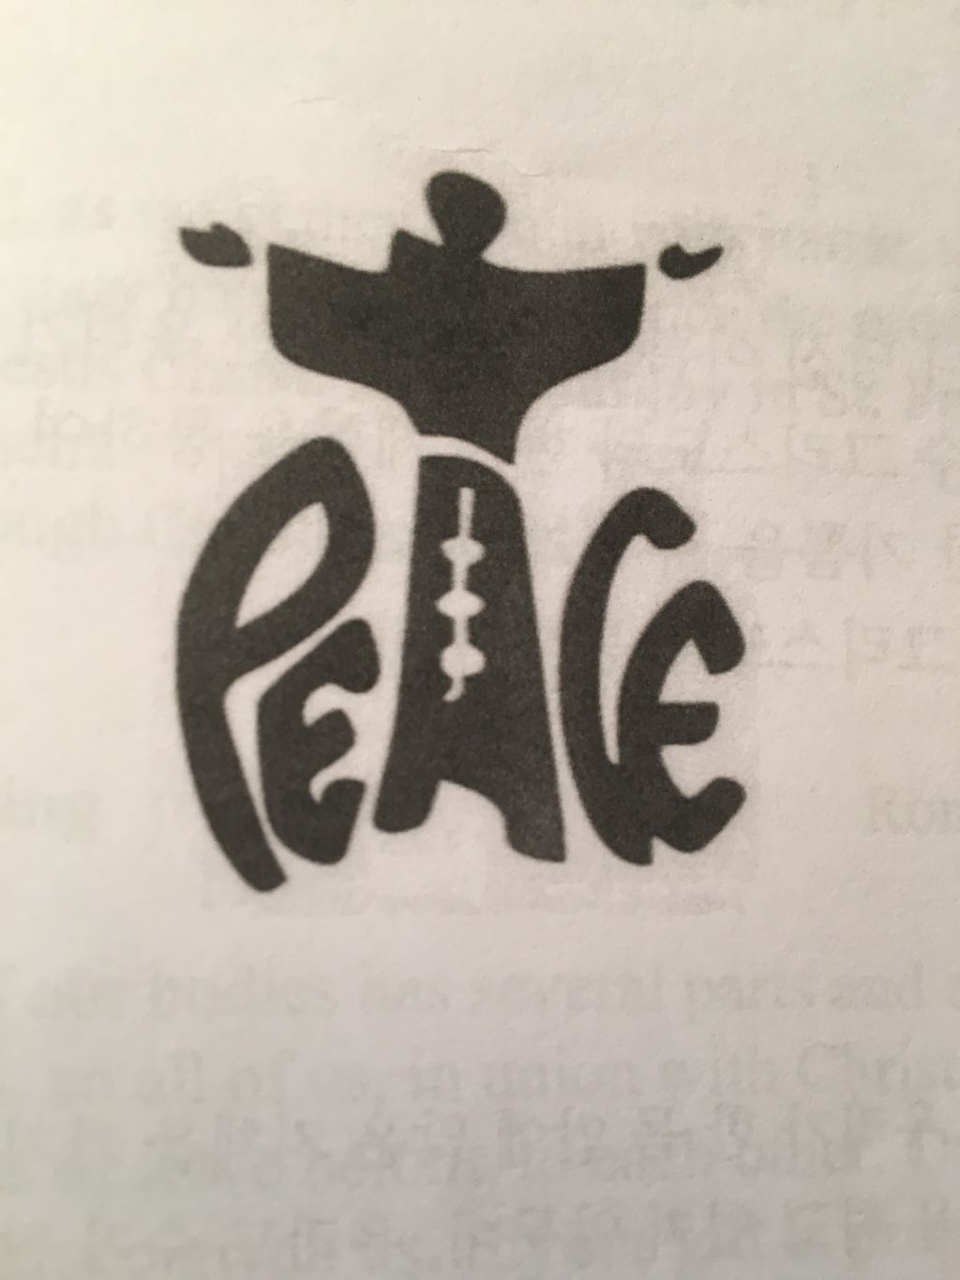

Intentional Waiting
If we could for a moment see the cosmic implications of our waiting with and for God, we would be astonished at the glory of “ordinary” things in our lives, and the significance of other people.
Isabel Anders, AWAITING THE CHILD
If you have difficulty relating to God, Mary can help. As St. Maximilian Kolbe put it, “God sends to us the one that personifies his love: Mary, the spouse of the spirit – a spirit of maternal love – immaculate, all beautiful, spotless, even though she is our sister, a true daughter of the human race, God confides to her the communication of his mercy to souls.”
IF YOU WANT TO KNOW GOD, GET TO KNOW MARY!
Loving as God Loves
There is a character in The Plague by Albert Camus who says that he is tired of hearing about men dying for an idea. He would like to hear about a man dying for love for a change. He goes on to say that men have forgotten how to love, that all they seem to be thinking of these days is learning how to kill. Man, he says, seems to have lost the capacity for love.
What is God but love? What is religion without love? We read of the saints dying for love, and we wonder what they mean. There was a silly verse I used to hear long ago: “Men have died from time to time, and worms have eaten them, but not for love.” It comes from As You Like It. And nowadays…we would agree, except for the saints. Yes, they have died for love of God…
Love and ever more love is the only solution to every problem that comes up. If we love each other enough, we will bear with each other’s faults and burdens. If we love enough, we are going to light that fire in the hearts of others. And it is love that will burn out the sins and hatreds that sadden us. It is love that will make us want to do great things for each other. No sacrifice and no suffering will then seem too much.
Yes, I see only too clearly how bad people are. I wish I did not see it so. It is my own sins that give me such clarity. If I did not bear the scars of so many sins to dim my sight and dull my capacity for love and joy, then I would see Christ more clearly in you all.
I cannot worry much about your sins and miseries when I have so many of my own. I can only love you all, poor fellow travelers, fellow sufferers. I do not want to add one least straw to the burden you already carry. My prayer from day to day is that God will so enlarge my heart that I will see you all, and live with you all, in his love.
Servant of God Dorothy Day
Co-founder of the Catholic Worker Movement

